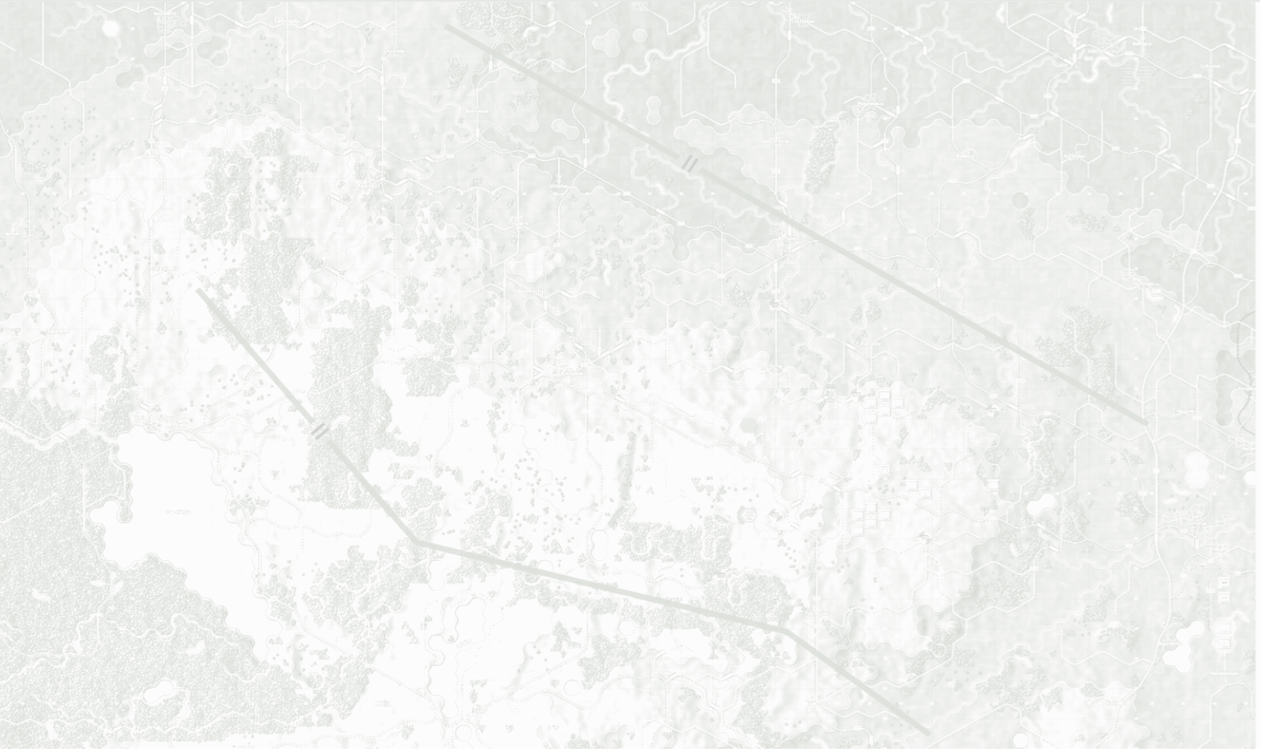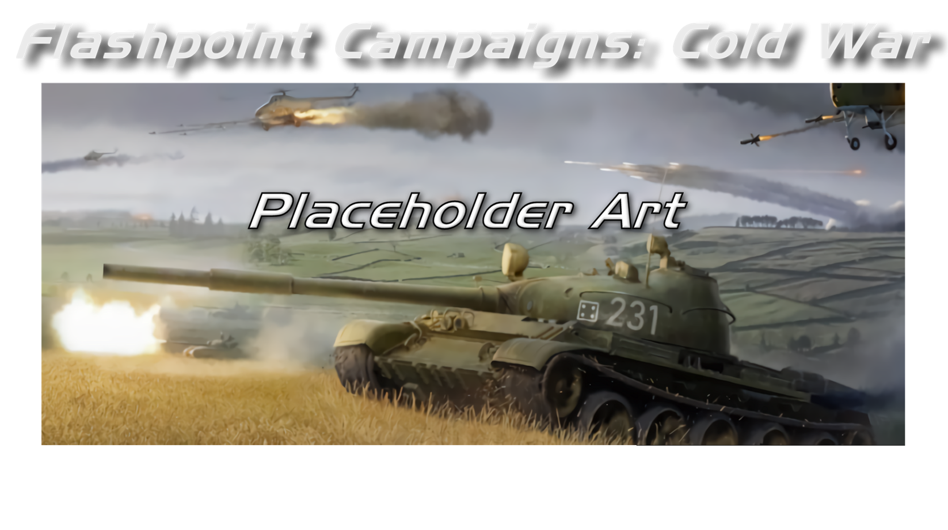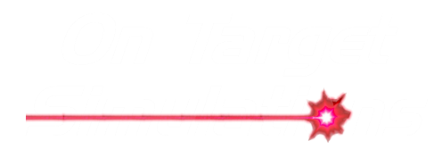

Game Operation

Field Manual FCCW-01/R0

**© 2025 On Target Simulations, LTD. All Rights Reserved. The images used and OTS Logo are property of On Target Simulations, LTD. All other marks and trademarks are the property of their respective owners.**

Table of Contents

1 Introduction 9

1.1 What's in This Document 9

1.2 Manuals 10

1.2.1 The Field Manuals (FM) 10

1.2.2 What’s New 10

1.2.3 FPC Hotkeys 10

1.2.4 Flashpoint Campaigns: Cold War FAQ 10

1.3 Gender Pronouns and Inclusion 10

2 Welcome Commander Screen 11

2.1 Main Menu 11

2.1.1 Start New Group 11

2.1.2 Resume Group 12

2.1.3 Edit Group 12

2.2 Useful Buttons and Information 12

2.2.1 User Preferences 12

2.2.2 What’s New 13

2.2.3 Exit Game 13

2.2.4 License Information 13

2.2.5 On-Target Simulations (OTS) Logo 13

2.2.6 Game Engine Version 13

2.2.7 Credits 13

2.3 Common User Interface Buttons 13

2.3.1 Apply 13

2.3.2 Back 13

2.3.3 Cancel 13

2.3.4 Proceed 13

2.4 Confirmation Dialogs 14

3 User Preferences 14

3.1 General Tab 14

3.1.1 Customize 14

3.1.2 Weather Unit Preferences 15

3.1.3 Display Rank Information 15

3.2 Scrolling and Sound Tab 15

3.2.1 Map Scrolling Parameters 16

3.2.2 Sound Volumes 16

3.3 Turn Resolution Tab 16

3.3.1 Combat Resolution 16

3.3.2 Additional Settings 17

3.4 Game Colors Tab 17

4 Start a New Scenario 18

4.1 Scenario Selection Dialog 18

4.1.1 Selection Criteria 18

4.1.2 Select a Scenario 19

4.2 Play Mode Selections 19

4.2.1 Style of Play 19

4.2.2 Which Commander will you be 19

4.3 Battle Planning Options 19

4.4 Difficulty Settings 20

4.4.1 Presets 20

4.4.2 Game Options for the Players 21

4.4.3 Fog of War for Map Markers 21

4.4.4 Proceed to Scenario 21

4.5 Scenario Load and Announcements 21

5 Start a New Campaign 22

5.1 Campaign Selection Dialog 22

5.2 Difficulty Settings 23

6 Start a PBEM++ Game 23

6.1 Login to an Existing PBEM++ Account 24

6.2 Register New PBEM++ Account 24

6.3 The PBEM++ Game Lobby 25

6.3.1 Games in Progress 25

6.3.2 Challenges 26

6.3.3 Creating a Challenge 27

7 Starting a PBEM Classic Game 28

7.1 Getting Started 28

7.2 Difficulty Settings 28

7.3 Set the Initial Orders 28

7.4 Play by Email Parameters 29

7.5 Upload Notice and Exit 29

7.6 Recovering a Dropped PBEM++ Game 30

8 Resuming Games 31

8.1 Saved Scenario 31

8.2 Saved Campaign 31

8.3 PBEM++ Multiplayer 32

8.4 PBEM Classic (PBM) 32

9 Game Launch and User Interface 33

9.1 Scenario Start-Up 33

9.2 Setting Up the UI 33

9.3 Manual Sections Covering the UI 34

10 Announcement Dialog 34

10.1 In-Game Announcements 35

11 Main Menu Bar 35

11.1 Game Menu Items 35

11.2 Counters Menu Items 36

11.3 Info View Menu Items 36

11.4 Staff Menu Items 37

11.5 SOP Items 38

11.5.1 Set SOP 39

11.5.2 Adjust SOP 40

11.6 Unit Overlay Menu Items 41

11.7 Multi-Unit Overlay Menu Items 45

11.8 Terrain Overlay Menu Items 53

11.9 Options Menu Items 57

11.9.1 Unit Counter Color Schemes 59

11.9.2 Map Contrast Options 60

11.9.3 Map Zoom Options 62

11.9.4 Mission Graphics Transparency Options 62

11.10 Help Menu Items 62

12 Status Bar 62

12.1 Speed Buttons 63

12.2 Hex Information 63

13 Core Game Panels 63

13.1 Game Control Panel 63

13.2 Commander Panel 64

13.3 Spotlight Panel 65

13.3.1 OOB Tree View 65

13.3.2 Detailed Unit Information View 65

13.3.3 Combined Spotlight View 66

13.4 Mini-Map Panel 66

14 Info View Panels 67

14.1 The Unit Popup Menu 67

14.1.1 General Menu Layout 67

14.2 Unit Dashboard 67

14.2.1 General Layout 68

14.2.2 Orders Tab 68

14.2.3 Subunits Tab 69

14.2.4 Staff Tab 70

14.2.5 Log Tab 70

14.3 Sub-Unit Inspector (SUI) 71

14.3.1 General Layout 71

14.3.2 Platform Tab 72

14.3.3 Weapons Tab 73

14.3.4 Sensors Tab 74

14.3.5 Systems Tab 74

14.3.6 Transport Tab 75

14.3.7 Further Information on Capabilities 75

14.4 Command/Unit Log 75

14.4.1 Log Capabilities 75

14.5 Off-Map Assets 76

15 Staff Dialogs 77

15.1 Scenario Information 77

15.1.1 Scenario Description 77

15.1.2 Victory Status & Conditions 78

15.2 Operations 79

15.2.1 Mission Briefing 79

15.2.2 Map Overlay 79

15.2.3 SITREP 80

15.2.4 Transport 81

15.2.5 Engineering 82

15.2.6 Air Support 83

15.2.7 Emitters 84

15.2.8 Unit Logs 84

15.2.9 Mission Capability Subunits 84

15.3 Intelligence 85

15.3.1 Threat Assessment 85

15.3.2 Enemy SITREP 86

15.3.3 Reported Kills and Claims 87

15.3.4 Weather Forecast 87

15.3.5 EW Report 88

15.3.6 Enemy Off-Map Assets 88

15.4 Personnel and Logistics 89

15.4.1 Staff Alerts 89

15.4.2 Detailed Unit Status 90

15.4.3 Reinforcements and Withdrawals 90

15.4.4 Ammunition 90

15.5 Fire Support 91

15.5.1 Fire Support Assets 91

15.5.2 Fire Missions 93

15.5.3 Fire Support Control Center (FSCC) 93

16 The Game Map 94

16.1 Moving the Map 94

16.2 Zooming the Map 94

16.3 Flyout Panel/Unit Hint 94

16.4 Elevations 95

16.5 Terrain 95

16.6 Roads 96

16.7 Railroads 96

16.8 Water Obstacles 96

16.9 Bridges 96

16.10 Map Markers – Full Hex 97

16.11 Map Markers – Hex Edge 98

16.12 MCOO Map Legend 98

16.13 Animated Fire Lines 99

16.13.1 Classic Fire Lines 99

16.13.2 Main Gun Fire Animation 99

16.13.3 Autocannon/Machine Gun Animation 100

16.13.4 Anti-Tank Guided Missile Animation 100

16.13.5 Surface-to-Air Missile (SAM) Animation 100

16.13.6 Fire Line Colors and Scaling 101

17 Unit Counters 101

17.1 Counter Information Layout 101

18 Specific Unit Roles 103

18.1 Recce Role 103

18.2 Main Effort and Line Roles 103

18.3 Overwatch Role 104

18.4 Support Role 104

19 Special Unit Types 106

19.1 Weapons of Mass Destruction (WMDs) 106

19.2 Inactive Units 106

19.3 Logistical Units 106

19.4 Unmanned Aerial Vehicles (UAVs) 107

20 Order of Battle (OOB) Tree 107

20.1 Unit Resubordinate 107

20.2 Unit Reorder 108

21 Issuing Orders 108

21.1 Open the Unit Menu 108

21.2 Primary Unit Orders 109

21.3 Indirect Fire-Specific Orders 110

21.4 Engineering Specific Orders 110

21.5 Helicopter Specific Orders 110

21.6 Aircraft Specific Orders 111

21.7 Unit Orders Delay Factors 111

21.8 Involuntary Orders Changes 111

21.9 Issuing Group Orders 111

22 Plotting Movement and Fires 112

22.1 Movement 112

22.1.1 Chaining Different Movement Orders 114

22.1.2 Altering Waypoint Timing 115

22.1.3 Lost Transport Indicator 116

22.2 Fires 116

22.3 Calling in Airstrikes 118

23 Standard Operating Procedures (SOP) 119

23.1 Scope 120

23.2 Stance 120

23.3 Combat 121

23.4 Movement 121

23.5 Transports 121

23.6 Recovery 121

23.7 Inspect and Apply 122

23.8 Copy SOPs via the Spotlight Panel 122

24 Spotting and Line of Sight (LOS) 123

24.1 Spotting Units 123

24.2 Line of Sight (LOS) 123

24.3 Time of Day and Weather Impact 124

25 Combat Operations 124

25.1 Unit Postures 124

25.2 Unit Facing 125

25.3 Direct Fires 125

25.4 Indirect Fires (IDF) 125

25.4.1 Fire Support Control Center (FSCC) 126

25.4.2 Observed Versus Blind Fire 127

25.5 Air Defense (AD) 127

25.6 Air Strikes 127

25.7 Helicopter Hunting 128

25.8 NBC Warfare 128

25.9 Electronic Warfare (EW) 128

25.10 Air Superiority 129

26 Combat Soft Factors 129

26.1 Readiness 129

26.2 Morale 129

26.3 Training 129

27 Supply and Logistics 129

27.1 Ammo Loadouts 130

27.2 Resupply 130

27.3 Automatic Emergency Resupply 131

27.4 Why No Fuel Tracking? 131

28 Time of Day 131

28.1 Dawn 131

28.2 Day 131

28.3 Dusk 131

28.4 Night 131

29 Weather 132

29.1 Clear 132

29.2 Cloudy 132

29.3 Overcast 132

29.4 Light Rain 132

29.5 Moderate Rain 132

29.6 Heavy Rain 132

29.7 Snow 132

29.8 Fog / Mist / Haze 133

29.9 Weather and Movement 133

30 Victory Conditions and End Game 133

30.1 Game End and Mission Post-Mortem 133

30.2 Final Report 134

30.3 Butcher’s Bill 134

30.4 Victory Status and Conditions 136

30.5 Sudden Death 137

31 Campaign Game Play Overview 137

32 Designer Notes 141

32.1 Infantry 141

32.2 Planning 141

32.3 Mobility 141

32.4 Tempo 142

32.5 Initiative 142

32.6 Recon and Intel 142

32.7 Survival 142

32.8 Artillery 142

32.9 Lethality 143

32.10 Ammunition 143

32.11 Dispersion 143

32.12 Line of Sight and Line of Fire 143

33 Flashpoint Campaigns Credits 144

33.1 On Target Simulations 144

33.2 On Target Simulations Content Team 144

33.3 Cold War Beta Testers 144

33.4 Matrix Production Support 144

34 OTS on the Web 145

# A military tank in a field AI-generated content may be incorrect.Introduction

Welcome to FLASHPOINT CAMPAIGNS: COLD WAR

This is a grand tactical combat simulation on the Cold War battlefield. As the force Commander, you will plan and then issue orders and Standard Operating Procedures to your battalion, brigade, or regimental forces, shaping the fight by maneuver and your intent. Your forces will engage the enemy on rendered real-world map locations. Each hex is 500m of militarily significant terrain. Each battle can last 4 to 24 hours of in-game time. Your troops will meet their foes any time of day and in any environment.

The game engine is based on asynchronous WEGO turns. This means you will issue orders and then watch a variable amount of time unfold on the battlefield. Then, issue or adjust orders to react to what has happened as you execute your battle plan.

***Flashpoint Campaigns: Cold War*** is a deep simulation of combat operations where your forces are arranged in maneuver units of companies, platoons, and sections of tanks, infantry fighting vehicles, infantry squads and teams, recon forces, engineers, air-defense and anti-tank systems, helicopters and more. As the Commander, you must use available off-map assets like long-range artillery, rockets, or airstrikes.

Your efforts in this complex battlespace will be constantly challenged by modeled features like Electronic Warfare, Air Superiority, Realistic Weather, Line of Sight and Fire, Terrain and Elevation, Smoke and Mines, and Human Factors like training, morale, and readiness. All these elements must be considered if you are to be victorious on the battlefield.

The game is packed with information dialogs, map overlays, and range rings to aid you as Commander, master the situation, and understand your force’s capabilities.

***Flashpoint Campaigns: Cold War*** is a data-rich simulation where each nation has information on National Characteristics, Command Parameters, and Orders of Battle. Data Tables are packed with era-specific equipment and troops. Weapon Systems of the time, such as guns, missiles, precision munitions, small arms, and much more, are comprehensively modeled.

As a toolkit, you can create your own scenarios and campaigns. You can also dive deeper and create or modify game data, artwork, and sound effects as you see fit. All these modding capabilities are supported by detailed documentation

## What's in This Document

We created this document to help players new to this genre of warfare and this game engine understand all the different elements in the user interface (UI) and how to perform various actions to play the game.

This document is laid out to run you, as the player, through the various steps to start the game, load new or existing scenarios or campaigns, navigate the UI, explain how to order your units into action, where to find various information or overlays to help you better understand the situation on the map. Until you get comfortable with the game, it may be a good idea to open this document so you can refer to it if you have questions.

**NOTE:** Areas of interest or buttons on form pictures are outlined in red.

**NOTE:** Some images in this manual are from other game versions. While your maps and units may differ, all the information and how it is used and displayed will match the information in this manual.

## Manuals

We have chosen to go with many living manuals to cover game interface/play, learning the game, basic tactics, Content Creation, and Game Modding for the Cold War game engine. We also have guides that cover that area of operations. The affected manuals and guides will be updated as the game is updated, and PDFs of these changes will be included with the new patches.

### The Field Manuals (FM)

These are the core manuals on how to play, create content for, and modify data for the Cold War game engine. Before jumping into Content Creation, we strongly recommend you review the first three manuals, **Game Operations**, **Battlefield Primer**, and **Tutorial Operations,** if you are new to this type of game and warfare. Returning Flashpoint Campaigns players should review **Game Operations** to get details on new features, as there are many.

These documents are found in the Documents\FMs folder.

* FM01: Game Operations – ***This Manual*** – Detailed information on the game, its interface, and how to use it
* FM02: Battlefield Primer – Fighting in the Cold War
* FM03: Tutorial Operations – How to learn and play the game
* FM04: Scenario Design – How to make or edit scenarios
* FM05: Battle Planning – How to create or edit battle plans
* FM06: Campaign Design –How to make or edit campaigns
* FM07: Map Construction –How to make simple maps for the game
* FM08: Game Engine Modifications - How to mod elements of the game engine
* FM09: Data Structures and Editing–How to edit or build data sets
* FM10: Weather Setup – How to add in weather from other locales

### What’s New

The What’s New PDFs summarize any changes and fixes when updates are released.

These can be found in the Documents\WhatsNew folder.

### FPC Hotkeys

This PDF document lists all the unique game key presses for Function keys and all hotkey definitions. Due to the large number of functions in the game, rebinding is not possible.

This document is in \Documents folder.

### Flashpoint Campaigns: Cold War FAQ

To stave off forum-clogging threads on various topics we either don't control or can't support, we created this FAQ document with the answers to those specific topics.

Please review the FAQ for answers to several game topics related to the game but not on how to play the game.

This document is in the \Documents folder.

## Gender Pronouns and Inclusion

We understand that users of all genders will play our simulation. We try to keep language in the game and manuals gender-neutral, when possible, but sometimes use the pronoun “he” to refer to the user. This is merely to streamline the writing, not to exclude anyone or note a specific gender.

The On Target Simulations team supports the inclusion of all people in the field of wargaming.

# Welcome Commander Screen

After starting the game and seeing the splash screen, you will see the following dialog with many selections. There are welcome statements, the Main Menu area, and under that, some useful buttons and information that we will cover shortly.

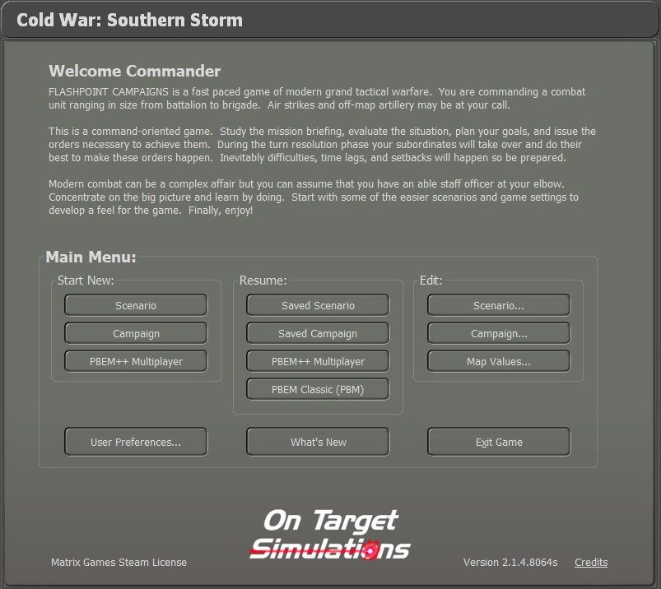

## Main Menu

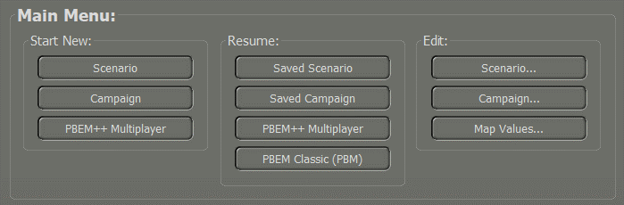The Main Menu has all the buttons to Start New games, Resume a game in play, or jump into one of the Edit functions to create game content.

### Start New Group



* **Scenario** - Clicking on the Scenario button will launch the Scenario selection screen, where the player can choose one of the single battles included in the game. Scenarios have a few options as to how they are played. You can play scenarios versus the Artificial Intelligence (AI) and choose which side you are, Launch the game in a two-player head-to-head mode, launch the game in AI versus AI mode, or choose a side and start a Standard Play by Email (PBEM) game. See Section 4 below for more details.
* **Campaign** - Clicking on the Campaign button will launch the Campaign selection screen. The player can review the provided campaigns and select one to play through.
* Campaigns take a core force of units and run them through several scenarios during the war. See Section 5 below for more details.
* **PBEM++ Multiplayer** - Clicking on the PBEM++ Multiplayer button will start the process of playing a scenario via the Matrix Game’s PBEM++ service. This allows you to set up or join a game versus someone else using the PBEM++ service across the globe. See Section 6 below for more details.

### Resume Group



This group of options allows you to browse the various save files you have for the different types of games you have played and Resume them. See Section 8 below for more details on Resuming Play for these types of games.

* **Saved Scenario** - Opens a dialog to review all the single battle games you have started and saved or autosaved.
* **Saved Campaign** - This opens a dialog to see all your campaigns that are in progress.
* **PBEM++ Multiplayer** - Clicking the button will take you to the PBEM++ login system and then into the current games selection tab of the PBEM++ lobby.
* **Classic PBEM** - Click the PBEM Classic button to see all your ongoing games and choose one to continue.

Saved games can also be deleted in the dialog that pops up. See Section 8 below for more details.

### Edit Group



Three buttons start in-game editors for Scenarios, Campaigns, and Map Values Scanner. Each of these editors is covered in detail in other field manuals (FMs), as noted in Section 1.3.1 above.

## Useful Buttons and Information

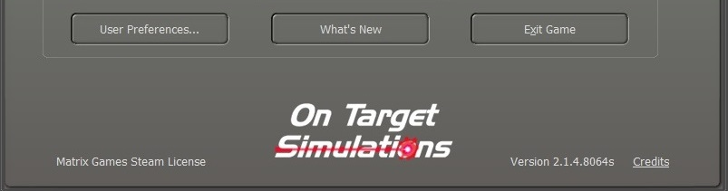

### User Preferences

Clicking on the “User Preferences...” button will open a dialog box with four tabs of settings information for various game functions, information display sound, and looks. See Section 3 for the details of all the Preference settings.

### What’s New

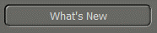Clicking on the “What’s New” button will bring up a PDF document that summarizes any new content, updates, bug fixes, or game engine tweaks we have made in the latest version of the game. More detailed information will be found in the noted and revised game field manuals (FMs).

### Exit Game

If, for some reason, you need to stop playing and return to your operating system, clicking the Exit Game button will fully close out the game and return you to your main computer screen.

### License Information

Any licensing information, if needed, will be found in the lower left of the Welcome Commander Screen.

### On-Target Simulations (OTS) Logo

Our glorious team logo is on display in the bottom middle of the panel.

### Game Engine Version

At the bottom of the screen, the game engine version is shown. Make sure you have the same version of the game as your opponent when you play multiplayer.

**NOTE:** It is recommended to exit the game if you do work in the various editors and then restart the game to play a scenario. This helps to make sure new values are correctly initialized and avoids the possibility of odd gameplay issues from occurring.

### Credits

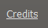Clicking on the Credits hyperlink will take you to a dialog that lists all those hard-working people who brought you this deep and detailed wargame.

## Common User Interface Buttons

Throughout the game, we have a few buttons that have the same essential functions. Those buttons are as follows.

### Apply

If you have made any setting changes that turn on or off functions or adjust the values of settings, then this button will commit and save those changes to the game while keeping the dialog open.

### Back

This button will move you back to a previous dialog or menu so you can change game parameters, and settings, or select other gameplay options.

### Cancel

If you have made any setting changes that turn on or off functions or adjusted values of settings and do not wish those to take effect, then this button will revert those changes in a dialog.

### Proceed

This button will move you forward to the following dialog or menu. If there is no Next dialog (as in User Preferences), this button will Apply, then close the dialog.

## A screenshot of a computer Description automatically generated with low confidenceConfirmation Dialogs

There are several times in the game when changes made will require confirmation. Selecting “Yes” will accept any changes. Selecting “No” will decline any changes. Selecting “Cancel” will place you back into the dialog so additional changes can be made.

# User Preferences

Clicking on the “User Preferences...” button will open a dialog box with four tabs of settings information for various game functions. Once applied, these settings will be remembered from game to game. These settings can be changed at any time via this button on the Welcome Commander screen or in-game from the Main Menu Bar.

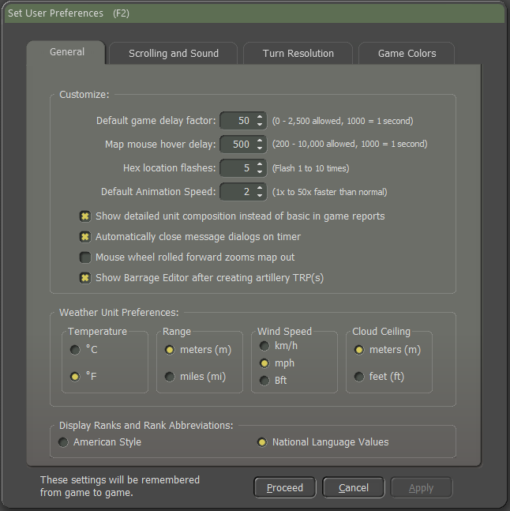

## General Tab

The General Tab allows the player to Customize basic game engine performance parameters, set Weather Unit Preferences and set the Display Rank and Abbreviation languages.

### Customize

* **Default Game Delay Factor** - This value controls the pacing of the game during turn resolution. If you find that the resolution is happening too quickly to follow, then use a larger number. If it is too slow, then use a smaller number.
* **Map Mouse Hover Delay -** The length of time needed to trigger the map flyover panel showing the objects in the hex.
* **Hex Location Flashes –** Set the number of times the hex of an active unit flashes to alert the player.
* **Default Animation Speed** – Sets how fast the in-game animations are shown during combat resolution.
* **Show Detailed Unit Composition** - If checked and when known various in-game displays will show the actual platform names (“T-72M”) in the description window instead of generic descriptions (“Tank”).
* **Close the ‘Secure Transmission’ message dialog** **on a timer** – If this option is checked, dialogs use a timer (displayed in the dialog box) to close. If not enabled, then the Secure Transmission dialogs will remain on screen until the user clears them by selecting the Proceed button.
* **Mouse wheel rolled forward zooms map out** – If checked, scrolling the mouse wheel forward will zoom the map out to see more of it. Scrolling backward will zoom the map in. The zoom IS NOT centered on the cursor. Unchecking will flip the direction of the zooming.
* **Show Barrage Editor after creating artillery TRP(s)** – If checked, after the player plots any Artillery Target Reference Points (TRPs), the Barrage Editor dialog will automatically open so adjustments to the fire missions can be made.

### Weather Unit Preferences

These settings change how information is displayed throughout the game.

* **Temperature** – You can set this to either Fahrenheit (degrees F) or Celsius (degrees C).
* **Range** – Distances can be referred to in Meters (m) or Miles (mi).
* **Wind Speed** – Speeds can be in Kilometers Per Hour (km/h), Miles Per Hour (mph), or Beaufort Wind Force Scale (Bft).
* **Cloud Ceiling** – The cloud ceiling can be shown in Meters (m) or Feet (f).

### Display Rank Information

You can choose to see ranks in the American (US Army) rank names or in the National language of the country.

## Scrolling and Sound Tab

The player can alter different values regarding Map Scrolling Parameters and Sound Volumes on this customization tab.

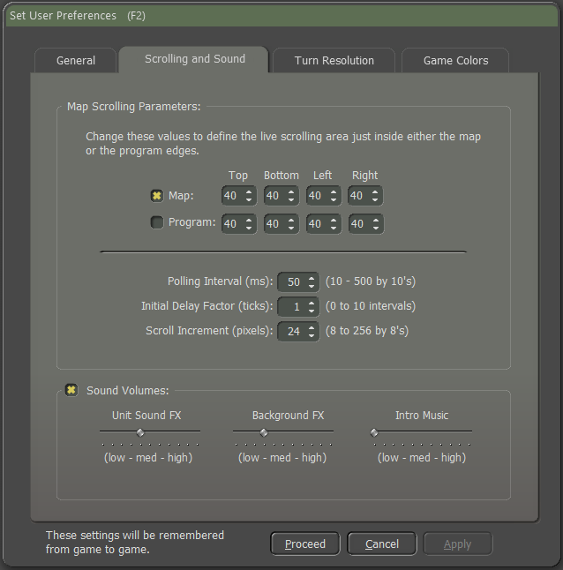

### Map Scrolling Parameters

* **Map Edge or Game Edge -** The map is scrolled by hovering the mouse cursor in a sensitive zone of the game. This zone can either run along the inside edge of the map or the inside edge of the entire game (program) screen. Be aware that if you choose the game edge, then there may be unwanted scrolling when trying to access specific information controls. This effect may be more pronounced on multiple monitors or extremely widescreen displays.
* **Effective Border Areas** - Define the top, bottom, and sides of the sensitive area independently of each other. The value is the number of screen pixels of the sensitive zone for scrolling.
* **Polling Interval** - This is the length of time between checks for a map scroll measured in thousandths of a second. The polling interval defines one ‘tick.’
* **Initial Delay Factor** - This is the number of ticks before a scrolling action is initiated. A certain delay may be desirable to prevent unwanted scrolling when moving through these zones to other areas of the screen.
* **Scroll Increment** - is the number of pixels that are scrolled for each tick. Use a lower value for faster/smoother scrolling.

### Sound Volumes

* **Check Box** – This check box turns off all sounds without changing the settings below it when sounds are required.
* **Unit Sound FX** - This is the volume control for unit movement and firing sounds.
* **Background FX -** This controls the volume of the ambient background battle noise during turn resolution.
* **Intro Music** - Controls the volume of the beginning and endgame music themes.

## Turn Resolution Tab

Here, you can tweak various settings that influence how the turn resolution is displayed (these are not rule changes). Should you wish to speed up the progress, you can disable some settings here.

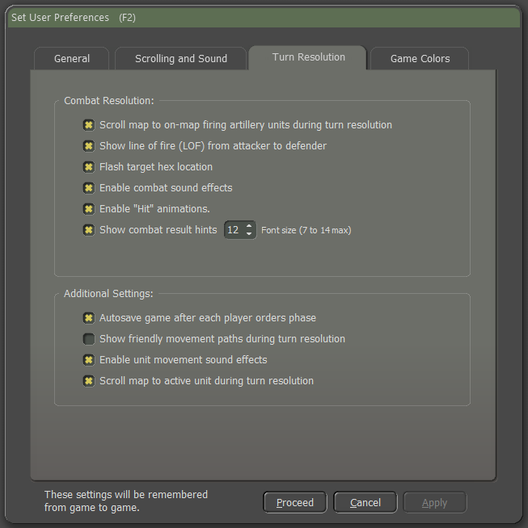

### Combat Resolution

* **Scroll Map to On-Map Firing Artillery Units during Turn Resolution** – When checked, the game will scroll to the firing on-map indirect fire unit and then the target. Disable to speed up the resolution of combat.
* **Show Line of Fire (LOF) from Attacked to Defender** - If checked, a line is drawn on the map from the attacker to the target to show the current direct fire attack being resolved.
* In some cases, the attacker may not be spotted, but the general area of fire may be noticed.
* **Flash Target Hex Location** - When checked, the hex of the target unit in combat will flash the number of times set in the General tab to help locate the action.
* **Enable Combat Sound Effects –** When checked, a few of the current weapon shooting/launching sound effects will play. Disable to speed up combat resolution.
* **Enable “Hit” Animations** – When checked, attacks on units that hit will cause an explosion(s) graphic on the counter. Disable to speed up combat resolution some.
* **Show Combat Result Hints -** If this item is checked, the results of combat actions will be displayed as hints next to the affected unit. Here, you can also alter the Combat Hint Font Size: The size of the combat hints displayed during the game can be increased or decreased by changing the value.

### Additional Settings

* **Autosave game after each player orders phase -** When checked, this will save the game immediately before turning resolution into the \Saved folder under the name of the scenario and with a percentage complete number. These are regular saved games and maybe reopened and resumed if desired.
* **Show friendly movement paths during turn resolution** – When checked, all friendly units with plotted movement show those moves on the map with plot lines. Disable to speed up combat resolution a bit.
* **Enable Unit Movement Sound Effects** – When checked, the game plays various types of movement sound effects like tracks, wheels, rotors, etc. Disable to speed up combat resolution a bit.
* **Scroll Map to Active Unit during Turn Resolution** - When checked, the map will center on the active unit during turn resolution.

## Game Colors Tab

A color selection dialog exists so that individual map overlays, fire lines, and other helpful color markers can be edited by the player and established as new game defaults. 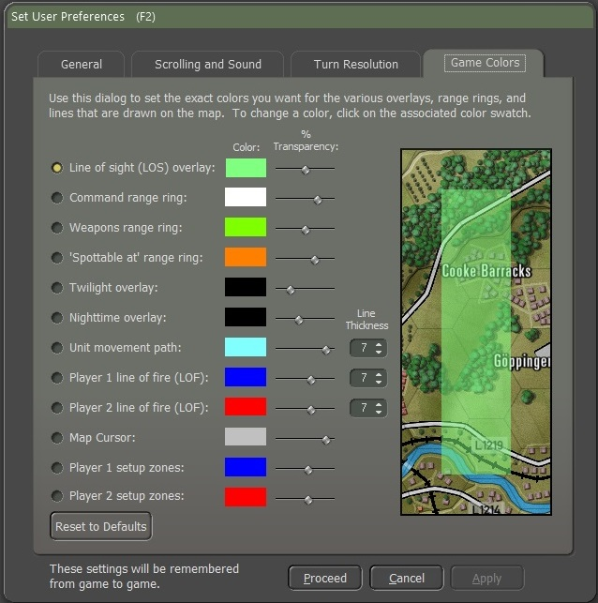

The level of color transparency can also be changed. This will allow the player, for example, to create a distinctly different hue for each kind of overlay so that he can easily tell which is in effect at any given time. The effect of these changes can be seen in the terrain sample to the right of the selections.

**Reset to Defaults -** Thisbutton will return all color options back to the game’s default settings for color size and transparency.

**NOTE:** It is possible to create unsightly or even invisible colors. If you want to experiment with this, you might want to consider backing up the original “overlays.ini” file.

# Start a New Scenario

To start a new Scenario, click on the Scenario button in the Main Menu.



## Scenario Selection Dialog

This will launch the Scenario Selection dialog, as seen below. In the list, you can review all the scenarios that are available in the module. Selecting a scenario by clicking on it will also show a description of the scenario’s meta-data details. The details state the map and forces used (nation and the number of units) in the selected scenario. Lastly, you can read the Scenario Summary to get an idea of the mission and historical context of the battle.

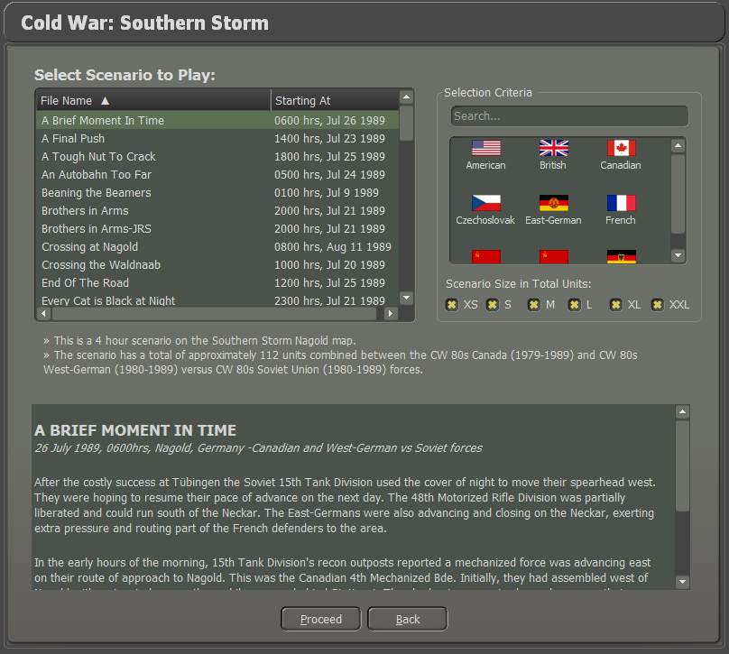

### Selection Criteria

To the right of the Scenario Selection List is a Selection Criteria panel where you can search for a scenario by entering names or other scenario details in the text box.

Below the Text box for Criteria Search are flags of all the nations in the current module. Clicking on one will filter the scenario list to include only that nation.

There is also the option to filter the scenario selection list by the size of the scenario based on total units. You can check any or all boxes to set the list (filtered or otherwise) to show only scenarios of the given size(s).

### Select a Scenario

Click on a scenario name to show the information and select it to play.

Hit Proceed to start the scenario selected and move on to the Play Mode and Battle Plan Options.

## Play Mode Selections

When you start a new scenario, the next thing to do is to decide how the game will be played and what side, if any, you will play as the player.

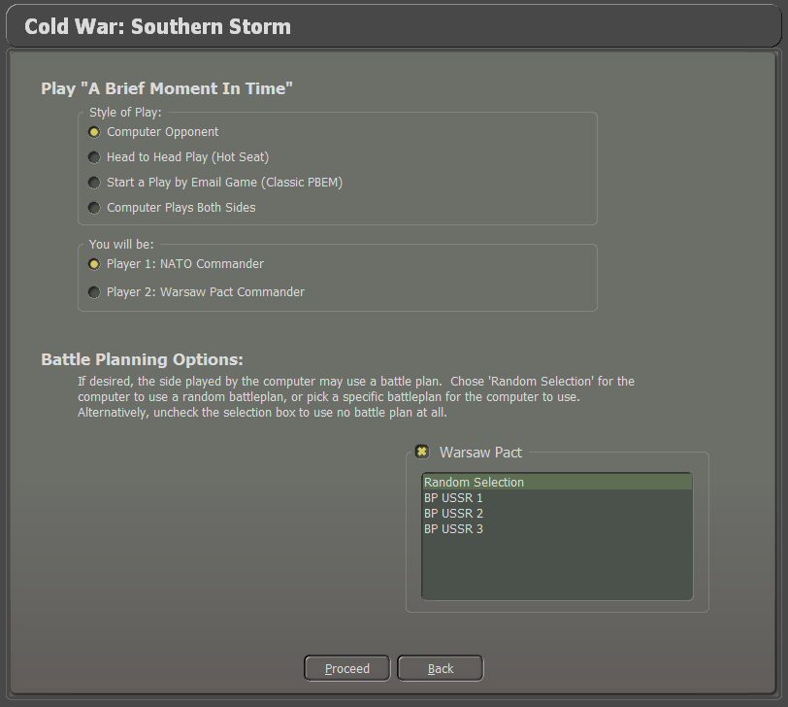

### Style of Play

Currently, the game system offers four styles of play for you to choose from.

* **Computer Opponent -** Play against our AI using either a random or set Battle Plan (See Section 4.3 below).
* **Head-to-Head Play (Hot Seat) -** Play against another human on the same computer in hot seat mode, taking turns issuing orders and then watching the resolution phase together.
* **Start a Play by Email Game (Classic PBEM)** – Load up a scenario to play against another human using the classic Play by Email (PBEM) system, where you send the game file to your opponent via email or, these days, a cloud service. See Section 7 below for more details.
* **Computer Plays Both Sides** – The computer AI plays both sides and uses a Battle Plan, if set, to fight out the scenario.

### Which Commander will you be

This selection will determine which side you will command in a human-played game mode.

* **Player 1: NATO Commander –** You will play, for example, as an American, Canadian, French, or West German commander.
* **Player 2: Warsaw Pact Commander –** You will play, for example, as a Czechoslovakian, East-German, or Soviet commander.

## Battle Planning Options

At the bottom of the Start, a Scenario Screen is the option to set the AI Battle Plan or have it randomly determined to add to the unknown nature of the enemy’s locations and routes of travel at the start of the scenario. Some scenarios may not have a Battle Plan, and the selection box will be greyed out.

Additional Battleplans can be added to scenarios to increase the replayability of a given scenario further.

Hit the Proceed button to move on to the Difficulty Settings dialog.



## Difficulty Settings

While most games have difficulty settings that make the game easier to win by raising and lowering various values, our game does not do that. There are a few adjustments you can make to make things easier to learn the game, and in that way, the game is “easier” to play, but not necessarily easier to win. No gameplay values are modified, so if tank A shoots and can kill tank B, this will always be the case regardless of these settings.

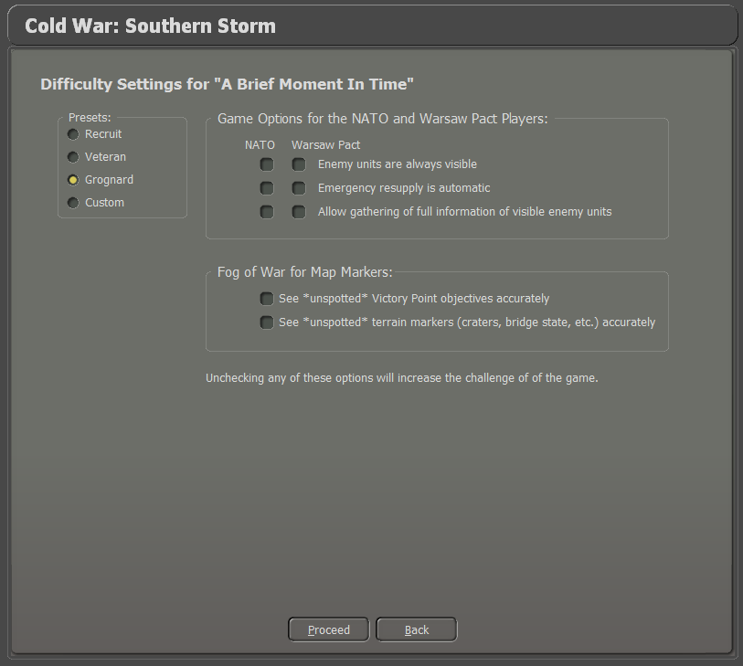

### Presets

There are three presets to set the various difficulty options. The Custom option will be set if you make your settings. These are saved and active on reloading.

* **Recruit** - Set this if you are new to the game system to turn on all the options to make learning the game easier.
* **Veteran** - Set this if you are familiar with our game system and want more of a challenge.
* **Grognard** - The ultimate in realism. No options are set. Good hunting!
* **Custom** - You can set your options to play the game the way you want.

### Game Options for the Players

There are three settings that you can adjust for each side of the game. These will change how you see various information in the game. Checked options will make gameplay easier for the player.

* **Enemy Units are Always Visible** – When checked, this is the most potent option, as you will always see all the enemies on the map. Combat still requires the units to “see” the enemy, but you do not need to locate hidden enemies by recon or fire. When unchecked, units will have to use their sensors to spot enemy units and take time to identify them before they will be displayed on the game map. **NOTE:** If checked units that are spotted will have a white spotting dot on the lower right of the counter. These dots will not be shown if unchecked.
* **Emergency Resupply is Automatic** – When checked, this setting allows units with low ammo to resupply an amount of ammo to keep fighting automatically. When unchecked, you, as the commander, must order units to resupply or set resupply parameters.
* **Allow Gathering of Full Information of Visible Enemy Units** – When checked, the player can get more detailed information on a unit by double-clicking and seeing a Read-Only version of the enemy unit’s Dashboard. It is also possible to right-click and see several of the overlays from the Show menu item. **NOTE:** Experienced players should unselect this option for the enemy as it gives away too much information on the enemy and its units.

### Fog of War for Map Markers

* **See “Unspotted” Victory Point (VP) Objectives Accurately** – When checked, this setting provides perfect information on the markers. So, if a hostile unit seizes a VP, that information appears immediately on the map. When unchecked, the map won't reveal hostile triggered VP ownership changes until your units have line-of-sight to them. Friendly triggered changes are visible.
* **See “Unspotted” Terrain Markers Accurately** - When checked, this setting provides perfect information on the markers.

So, if a hostile unit builds a bridge, that information appears immediately on the map. When unchecked, the map won't reveal hostile triggered marker changes (like bridges or obstacles) until your units have line-of-sight to them. Friendly triggered changes are visible.

### Proceed to Scenario

Hit Proceed to load the selected scenario.

## Scenario Load and Announcements

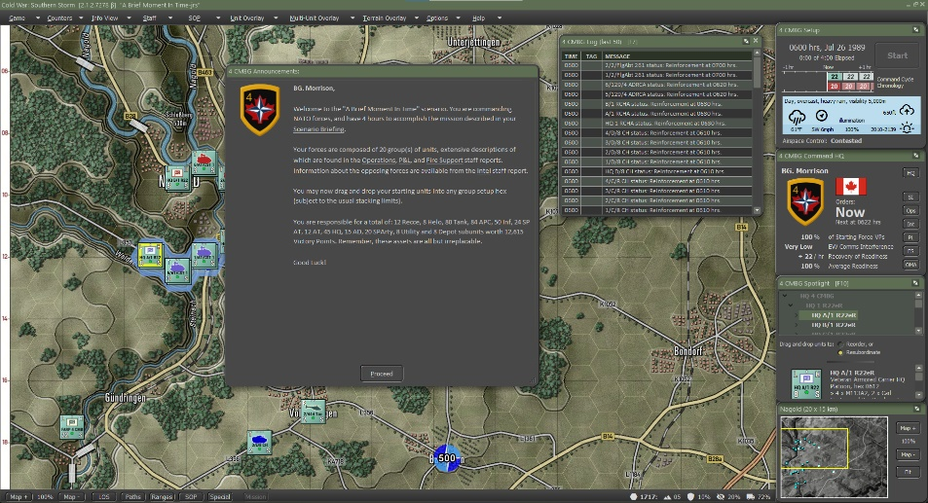

At this point, the selected scenario will load, and you will get the Announcement Screen (click on it to disable the timer countdown) that gives you the mission overview. Head to Section 9 below to see information on what all the User Interface (UI) elements are on the screen in detail.

# Start a New Campaign

A campaign is a sequence of scenarios from one nation’s perspective where the result of one scenario may influence the subsequent scenario. The player will be able to carry over core forces from scenario to scenario. This means that campaign scenarios might play out very differently from single scenarios because it is of vital importance to preserve your force as you try to win your part of the war.

To start a new Campaign, click on the Campaign button in the Main Menu.



## Campaign Selection Dialog

This will launch the Campaign Selection dialog, as seen below. In the list, you can review all the campaigns that are available in the module. Selecting a campaign by clicking on it will also show an overview of the campaign in the bottom text box so you can get an idea of the overall mission and historical context of the campaign.

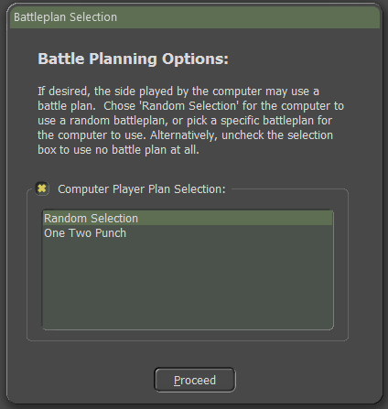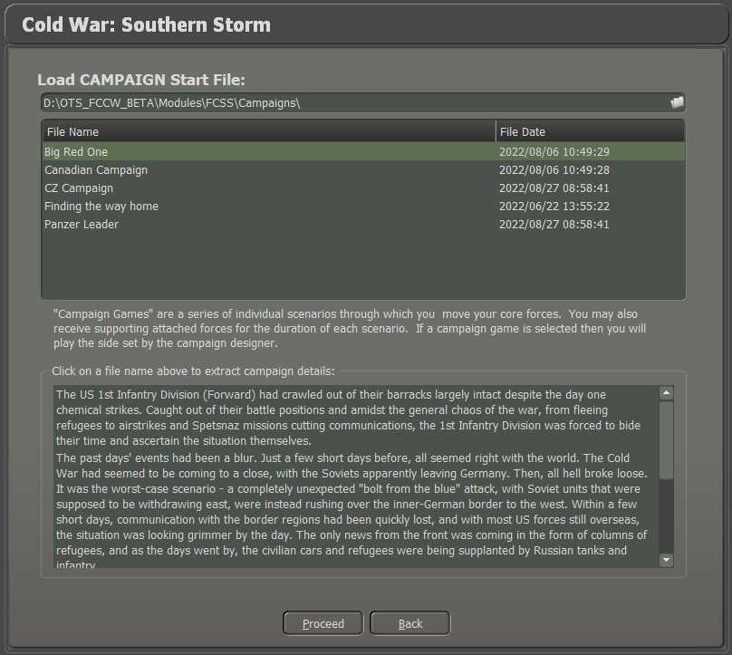

## Difficulty Settings

After selecting the campaign, you are sent to the Difficulty Setting dialog. The settings here are covered above in Section 4.4.

After hitting Proceed, you can then select the enemy Battle Plan that will be used in the first scenario of the Campaign.

Selecting Proceed will then finish the loading of the selected campaign, and you will get the Announcement Screen for the first scenario (click on it to disable the timer countdown) that gives you the mission overview. Head to Section 9 below to see information on what all the User Interface (UI) elements are on the screen in detail.

For more details on Playing a Campaign, see Section 31 below.

# Start a PBEM++ Game

PBEM++ is a more advanced and user-friendly way to do the standard PBEM game. In this case, the games are sent back and forth via servers at Slitherine Games automatically as you finish turns and send them. The game file resides on the Slitherine server, so you can technically log in to your account from any computer and pick up and play your games with your friends.

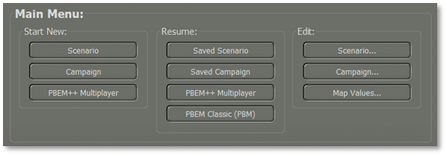

## Login to an Existing PBEM++ Account

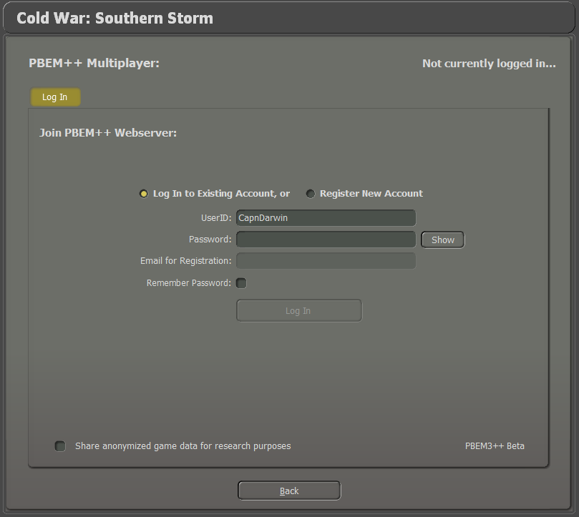

On the Login tab, if you have an established Matrix/Slitherine account, you can log in using your UserID and Password.

Clicking the Show button will reveal your password so you can verify it if you need to.

You can check the box to Remember Password so it will auto-populate on the next login.

If you wish to help with game data analytics, you can click the Share anonymized game data for research purposes.

Clicking the login button will display the message below as the game contacts the servers.

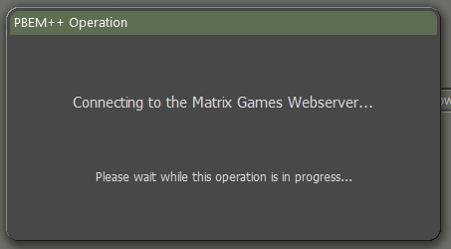

## Register New PBEM++ Account

If you would like to create a new Matrix/Slitherine PBEM++ account, you can select the Register New Account option and then fill in your User ID (alphanumeric with no spaces), a Password (something you will remember), and a valid email address.

If you want the game to remember your PBEM++ password the next time you load the game, check the box next to Remember Password.

When all that is complete, you can click on the Register button. It may take a few moments to send the information to the servers. If everything works out, you will be presented with the PBEM++ Game Lobby. If there is an error, a dialog box will pop up with information that you can use to contact Matrix support to see if they can resolve the problem.

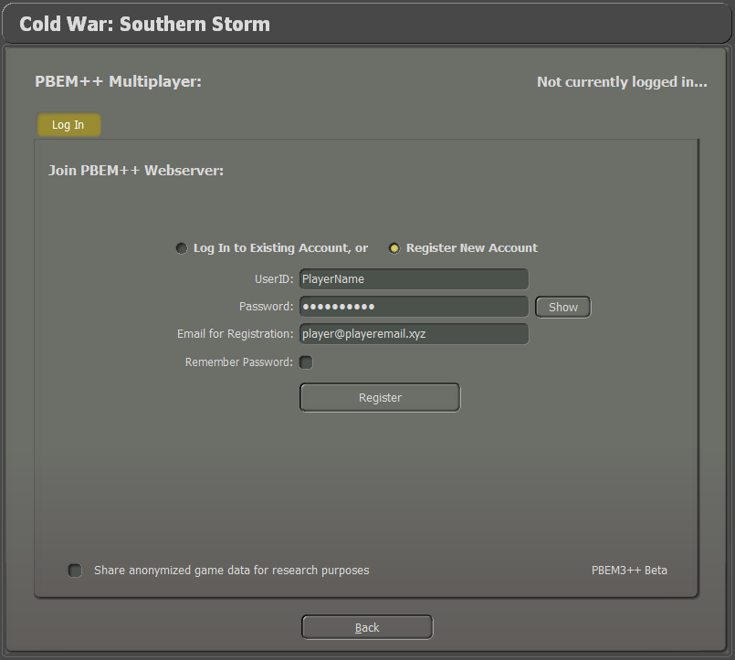

**NOTE:** If you already have a Matrix/Slitherine account, please use that as your login.

**NOTE:** If you want a new account for PBEM, you must have an unregistered email to make a new account.

## The PBEM++ Game Lobby

Once you have signed into the PBEM++ system and the server has validated your credentials, you are placed into the Flashpoint Campaigns Game Lobby. Here there are a couple of options to either continue a game pick a new challenge or start a challenge of your own.

### Games in Progress

This tab shows you all the games ready for you to continue, view game details, resign from a game, or upload a game turn ready for your opponent to play.

The top window shows all the games you are currently playing with others. This information includes the Scenario being played, Turn Number, Status, Opponent being played, and the date of the Last Update for the game.

The bottom window will show any messages for the currently selected PBEM++ game in the top window.

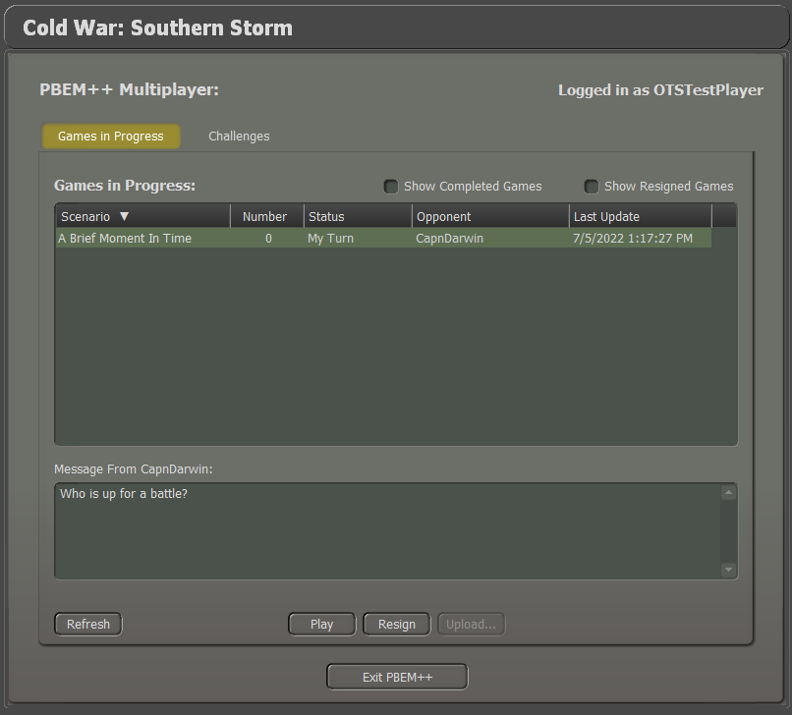

You can also see completed games by checking the Show Completed Games box.

You can check the Show Resigned Games box to see all the games you have resigned from.

The Refresh button will update all games from the server if needed.

### Challenges

This tab shows you all the games ready to be played with another player.

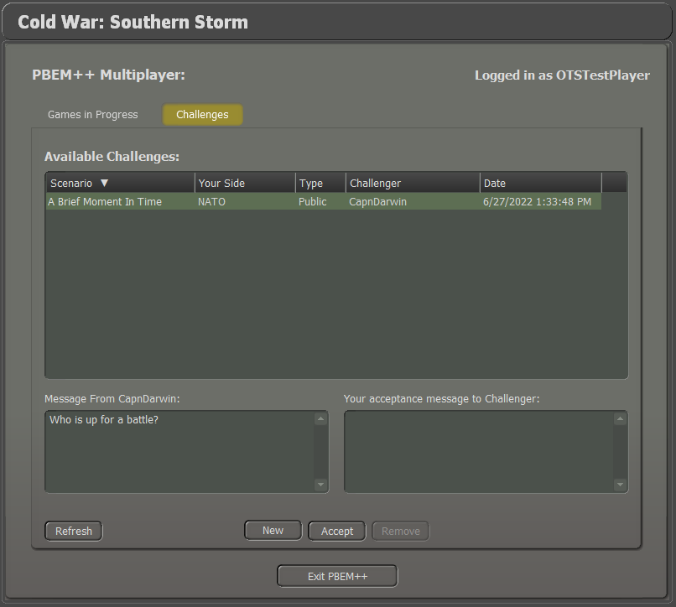

The top window will show all available challenges. The information displayed includes the Scenario name, the Side you will play in the game, the Type of game, which the Challenger is, and the date the challenge was issued.

The type can be one of two choices. The first is Public. Anyone can accept a public challenge and play the game. The second type is Private. Private challenges are those created by a player with a password. To accept the challenge, you need to know the password. These types of challenges are usually between friends and are set up, so the other player knows the password.

Once you select a challenge and click on the Accept button, you are given a chance to send a message to your opponent before the action starts.

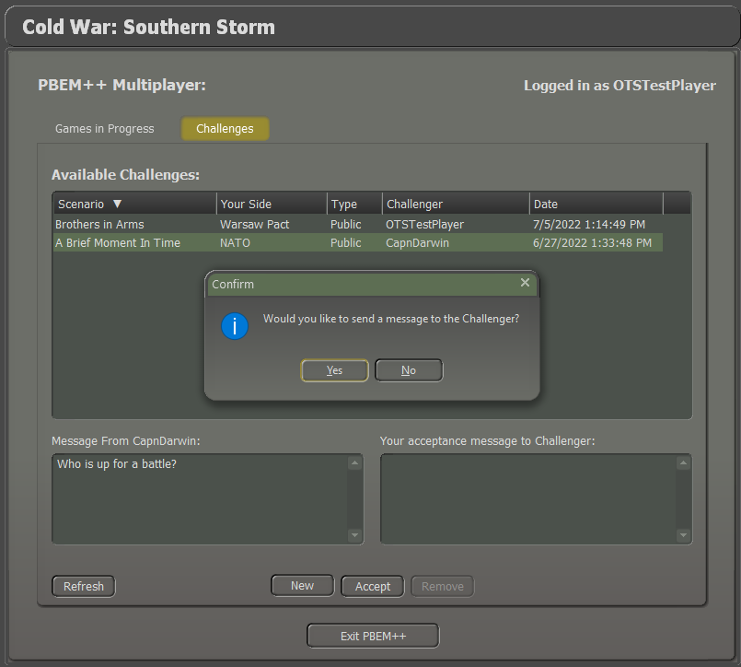

After sending a message or not, you will get the following message stating you have accepted the challenge.

Hit Play to start the game and set up for the first turn.

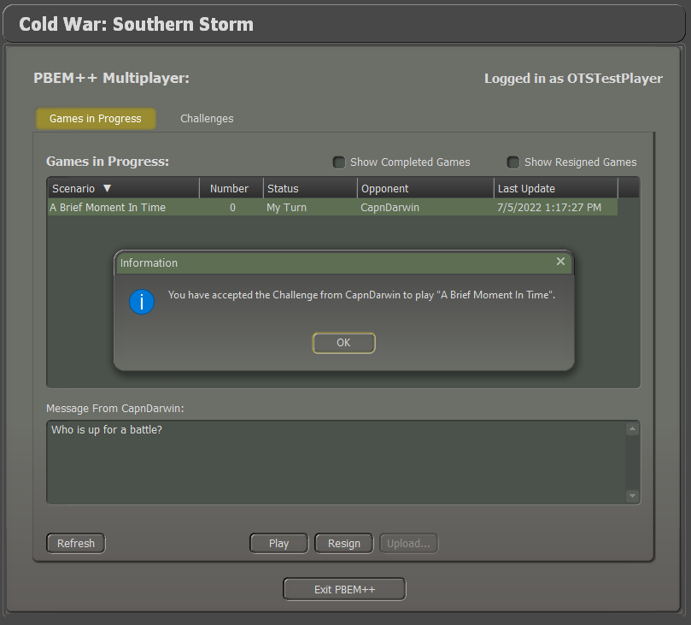

### Creating a Challenge

To start a new challenge for someone to play against you, you need to select the New button at the bottom of the Challenges tab. You will see the following screen. Perform the following actions to issue a new challenge.

* Click the Scenario button to open the Scenario Selection dialog.
* Choose a scenario to play and click Proceed.
* Select if your challenger will play as NATO or the Warsaw Pact commander.
* If you wish for your challenge to be with a friend instead of open to anyone, then place a password in the Optional Password field. You will need to give this password to your friends for them to accept the challenge and start playing. This will show up as a Private challenge in the Challenges lobby. Do not place the password in the Comment box, as that is seen by everyone.
* In the Your Comments text box, you can place any message (don’t do a private challenge password). This can be info on the scenario, a friendly greeting, or any other relevant information.
* Checking the Share email address box will share your PBEM++ email address with the opponent who accepts your challenge.
* Next, set the Game Options to be used in the scenario challenge. Refer to Section 4.4 above for details on these settings.
* Finally, click the Upload the Challenge button to pass the information on to the PBEM++ server, where it will show up in the Challenges tab.

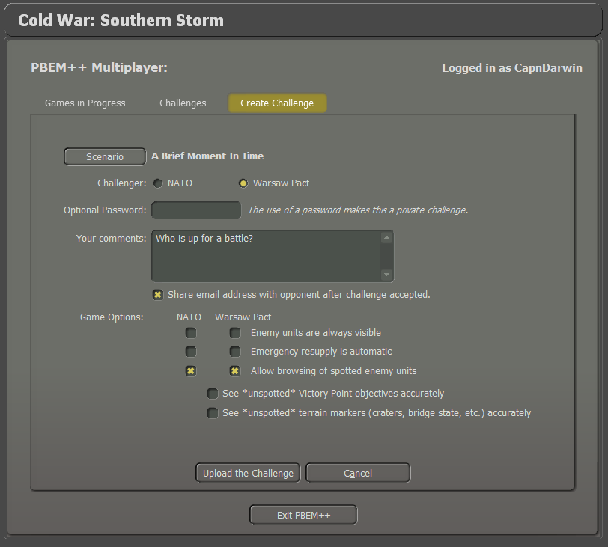

# Starting a PBEM Classic Game

This is the classic play-by-email mode. Players will play through a scenario by playing turns and submitting them via email or a file-sharing service like Dropbox to each other.

## Getting Started

At the Main Menu, select Start New: Scenario. Then select a scenario that you wish to play with your opponent and click Proceed. In the following dialog (below), select the Start a Play by Email Game (Classic PBEM). Next, choose which side you will command in the scenario and click the Proceed button.

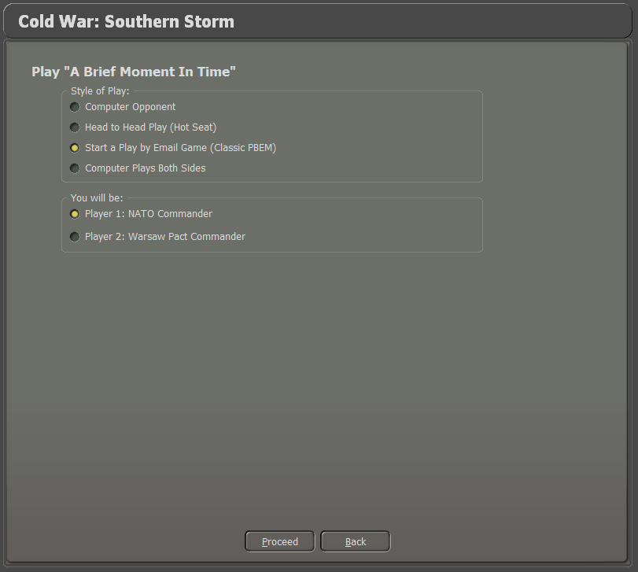

## Difficulty Settings

In the next screen, select the Difficulty Settings (refer to Section 4.4 above) to be used for the scenario and click the Proceed button.

## Set the Initial Orders

The scenario will load, and you will see the game interface (Refer to Section 8 below for details on the interface). Next, issue initial orders for your forces and click the Start button. You will get the following dialog alerting you that your opponent needs to do initial orders.

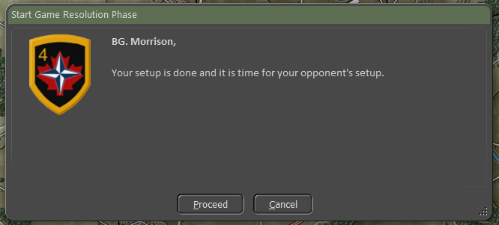

Click Proceed, and you will get the following dialog to enter information for the Classic PBEM file.

## Play by Email Parameters

The following items are displayed, and some require inputs:

* **Game Name**: This is the scenario name. You can edit this name, and it will automatically change the File Name.
* **Password**: You can add a password to the file for extra security. Please make sure your opponent knows it to open the supplied game file.
* **Increment File**: Check this box to add a “00X” number to the filename to keep a better track of game turns.
* **File Name**: This is automatically generated from the Game Name and increment (if selected).
* **PBEM File Destination Directory**: This is the folder on your computer where the generated Play By Email (*.PBM) files will be placed. You can change the folder location by clicking on the Folder icon on the right of the panel.
* **Game Text Message**: You can write a short message for your opponent in the bottom window that will be displayed to them at the start of their game turn.

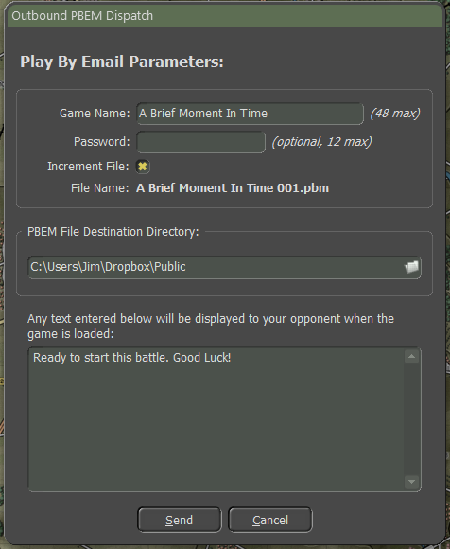

Click the send button to save the game file.

## Upload Notice and Exit

Next, you will see the following notice. Click Proceed when you are done reading it.

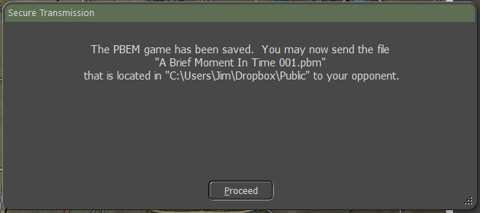

Next, you will see the following message, and you can Exit the game or go back to the Main Menu and start another game from the game’s Main Menu. Clicking Proceed will close the dialog.

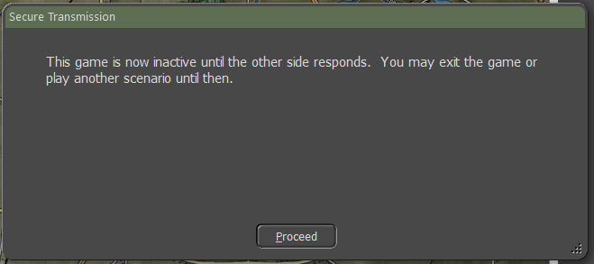

## Recovering a Dropped PBEM++ Game

If there is a dropped connection to the PBEM++ servers, the game engine will create a save file that allows you to retry a load back to the server later when the servers are online.

The following dialog will show if the connection drops when trying to upload your game turn. It notes the name of the file created and where it is located.

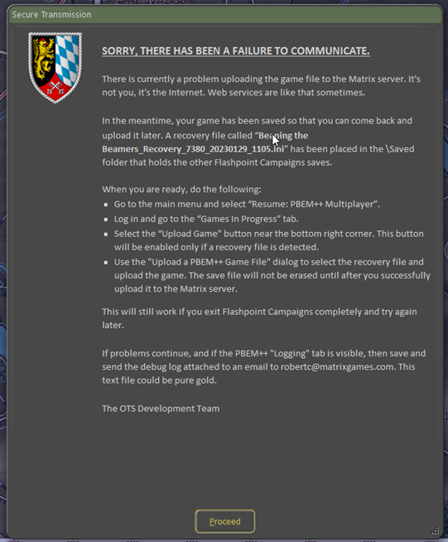

If there was a loss of connection to the server, once you Resume a PBEM++ game, the following dialog will be shown, offering you the chance to recover a failed upload.

Select the file you want to resend to the server and click Upload.

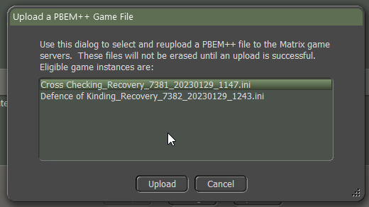

# Resuming Games

On the Main Menu, there are four options for resuming gameplay. The following sections will detail how you resume one of your games.



## Saved Scenario

Selecting and clicking the Saved Scenario button will bring you to the dialog shown below.

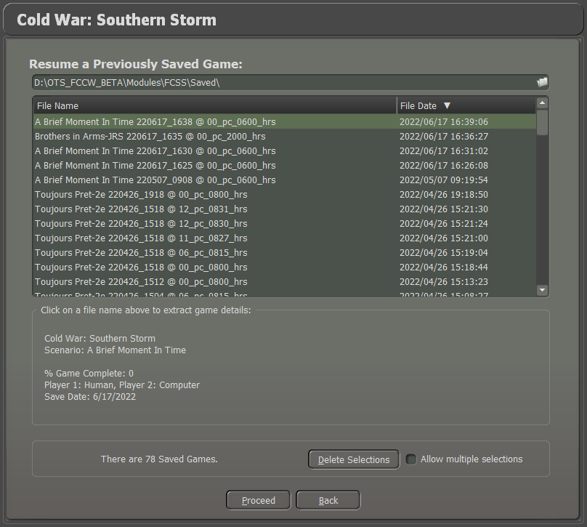

The top text box shows you the folder in which the saved scenarios are located. If you need to change this folder, you can click on the folders icon at the right of the text box and switch locations.

Next is an extensive list box showing all the saved scenario games in the selected folder. Clicking on one to highlight it will bring up details in the panel below the list box.

Below the Detail panel is a panel that tells you the number of saved scenario games and a button to delete the highlighted save. Clicking the Delete Selections button will remove the highlighted save or save if you check the box for Allow multiple selections.

Click the Proceed button to start the saved scenario.

## Saved Campaign

Selecting and clicking the Saved Campaign button will bring you to the dialog shown below.

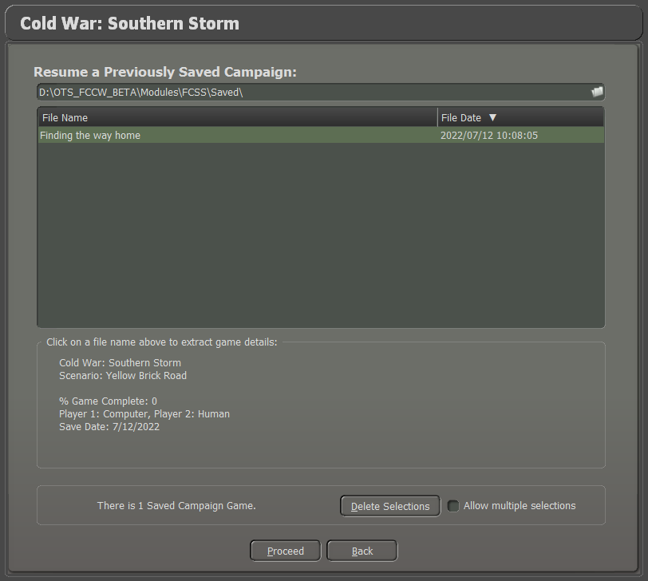

The top text box shows you the folder in which the saved campaigns are located. If you need to change this folder, you can click on the folders icon at the right of the text box and switch locations.

Next is a large list box showing all the saved campaign games in the selected folder. Clicking on one to highlight it will bring up details in the panel below the list box.

Below the Game Details panel is a panel that tells you the number of saved campaign games and a button to delete the highlighted save. Clicking the Delete Selections button will remove the highlighted save or save if you check the box for Allow multiple selections.

Click the Proceed button to start the saved Campaign game.

## PBEM++ Multiplayer

To continue a PBEM++ challenge, click the PBEM++ Multiplayer button, and that will launch the PBEM++ login screen.

Refer to Section 6 above on how to log in and then continue a challenge.

## PBEM Classic (PBM)

Clicking on the PBEM Classic (PBM) button will take you to the following dialog.

The top text box shows you the folder that the saved Play by Email Classic saves are located in. If you need to change this folder, you can click on the folders icon at the right of the text box and switch locations. Refer to Section 7 above on the setup of a Classic PBEM game.

Next is a large list box showing all the saved Classic PBEM games in the selected folder. Clicking on one to highlight it will bring up details in the panel below the list box.

Below the Detail panel is a panel that tells you the number of saved Classic PBEM games and a button to delete the highlighted save. Clicking the Delete Selections button will remove the highlighted save or save if you check the box for Allow multiple selections.

Click the Proceed button to start the saved Classic PBEM game turn.

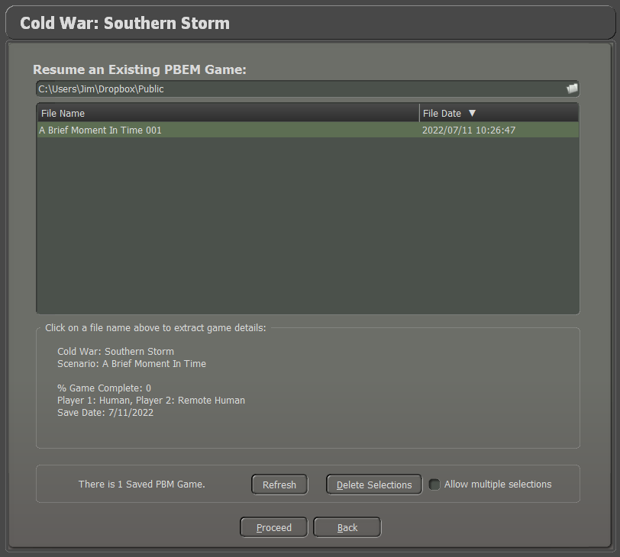

# Game Launch and User Interface

This section will cover the basics of launching a scenario and the basics of the new User Interface (UI) in the game.

## Scenario Start-Up

Once you have selected a scenario to play by one of the means noted earlier, you will get a screen where you will wait for a few seconds (or more on slower computers or larger scenarios) for the game to load the map and data.

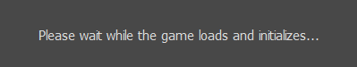

Once that is complete, you will get the main game screen, as seen below.

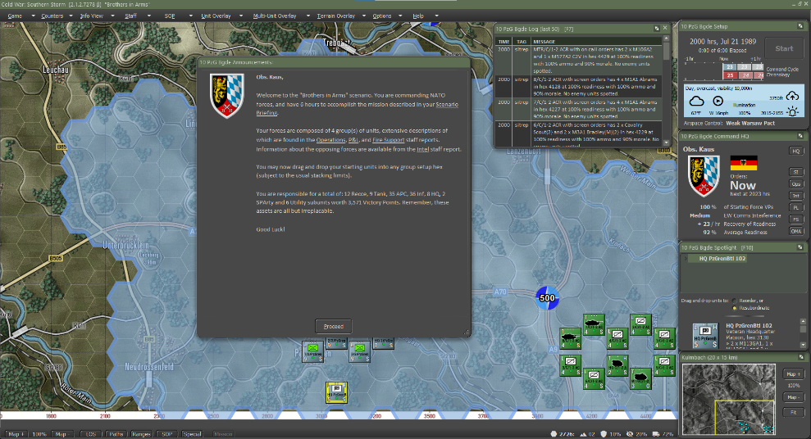

## Setting Up the UI

Before we dive into the details of all the various User Interface (UI) elements, there are a few new capabilities for how you can set up the UI to suit your taste.

* All the dialogs and panels that are shown, except for the Main Menu Bar at the top of the screen and the Status Bar at the bottom of the screen can be moved around on the screen or onto other screens.
* Dialogs and Panels with this symbol in the lower right can be resized. Most have a minimum and maximum size.
* Dialogs and Panels with this symbol in the upper right can be collapsed to the title bar or expanded to full size. Useful if you want to see more of the screen.
* A few of the Staff Dialogs have active maps that will update with information as the game is played.
* Most of the dialogs and panels will remember the last location they were placed on the screen and will be in those positions the next time you play a scenario.
* The Dashboard can be locked to display information on one unit, and more dashboards can be opened. The dashboard can also collapse to a smaller size if you need it, and they also will dock against each other.
* The UI should work well with ultra-wide screens and scale well with 4K monitors.

**NOTE:** If you have multiple monitors with different font scaling levels and drag dialogs to another screen with a different scale, the dialogs and other menu panels may not display correctly. This is something we are looking into and hope to correct in the future.

## Manual Sections Covering the UI

The following sections cover all the various parts of the game interface and what they do.

* See Section 10 below for information on the Announcement Dialog.
* See Section 11 below for information on the Main Menu Bar.
* See Section 12 below for information on the Status Bar.
* See section 13 below for information on the Core Game Panels.
* See Section 14 below for information on the Info View Panels.
* See Section 15 below for information on the Staff Dialogs.
* See Section 16 below for information on the Game Map.
* See Section 17 below for information on Unit Counters.

**NOTE:** If you know the interface or want to jump to the how-to-do things portion of the manual, then head for Section 21 below on Issuing Orders.

# Announcement Dialog

When a scenario first starts, there is a dialog that pops up in the center of the screen with basic information about the scenario. It gives you the Commander’s name, the side played, and then a few links to Staff Reports that you can bring up and review (see Section 15 below for details on those reports).

The dialog also tells you that you can set up your forces on the map and tells you a general breakdown of those forces. As noted in the dialog, I wish you the best of luck with the upcoming battle.

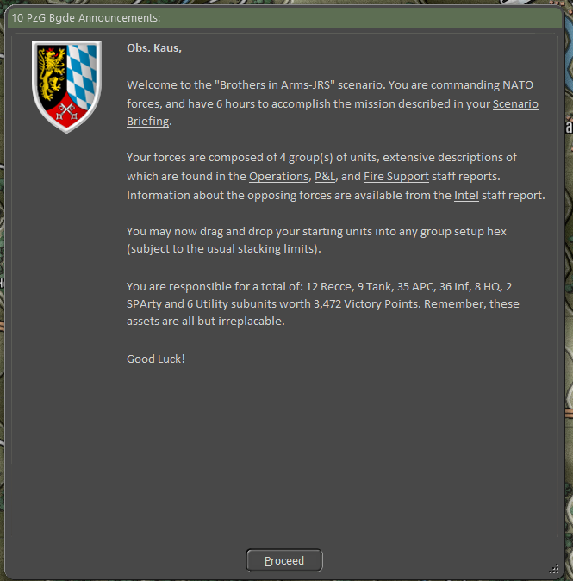

## In-Game Announcements

In-game announcements bring you information in the form of small dialogues that pop up when specific events happen. Information that may be received includes:

* Weather Updates and changes in visibility
* Changes in time of day and lighting conditions
* Reinforcements and withdrawals of specific units
* Leader killed
* HQ intercepts
* Electronic Warfare level changes
* Off-map Events like strike aircraft intercepts
* Detection of on and off-map enemy artillery assets
* Losses of friendly off-map artillery assets
* Scenario or Campaign Game has ended

Other messages may also be displayed. You can dismiss them by clicking the Proceed button.

# Main Menu Bar

At the top of the screen is the Main Menu Bar for the game. The following sections will go over each menu and function in detail. Hotkeys are shown in brackets (**[*hotkey*]**) for each item that can be used.



## Game Menu Items

The Game Menu covers those functions that relate to the overall playing of the scenario.

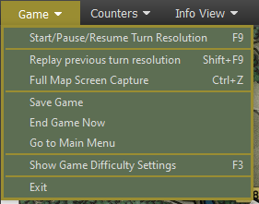

* **Start/Pause/Resume Turn Resolution [*F9*]** – This menu item will start turn resolution after you issue orders or pause the turn resolution if it is running and then resume resolution when you are done looking at information.
* **Replay Previous Turn Resolution [*Shift-F9*]** – This menu item will replay reset the turn that was just resolved and start it over with a VCR dialog for control (See Section for details on the VCR dialog functions). You can only replay the last turn resolved.
* **Full-Screen Map Capture [*Ctrl+Z*]** – Captures the entire game map and all counters and markers on it with no UI shown in the specified folder.
* **Save Game** – This opens the Save Game dialog, and you can save the current turn and return to the game. The Cancel button will exit the save dialog back into the game.
* **End Game Now** – Depending on the confirmation dialog, Yes will stop the current scenario, score the outcome, and display the end of the scenario post-mortem. Once invoked, you cannot restart the game and would need to reload a previous save. If you wish to continue the game, select No from the Confirmation dialog.
* **Go to Main Menu** – When this action is selected, a confirmation dialog to save the scenario will appear. Selecting Yes will save the game via dialog and then return to the Main Menu. Selecting No will end the game and return to the Main Menu.

Finally, selecting Cancel will abort the action and return to the game.

* **Show Game Difficulty Settings [*F3*]** – Selecting this action will open a read-only display of the Difficulty Settings of the scenario for you to review.
* **Exit** – Exits the game back to the desktop without saving the game.

## Counters Menu Items

The menu items in this tab relate to actions to better see specific units or to show/hide counters and markers on the map.

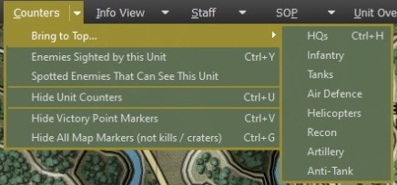

* **Bring to Top** – For all your units in the stack, selecting a particular unit type will bring the unit type to the top of the stack to make them visible.
* **Enemies Sighted by this Unit [*Ctrl+Y*]** – For the selected unit on the map, this action will remove all the enemies from the map that are not spotted by the unit, only showing those enemies this unit can see. It can be toggled on and off.
* **Spotted Enemies That Can See This Unit** – For the selected unit on the map, this action will only show those known enemies that can see the selected unit. It can be toggled on and off.
* **Hide Unit Counters [*Ctrl+U*]** – Selecting this action will hide all the counters on the map, both friendly and the enemy, so the map and markers are visible. It can be toggled on and off.
* **Hide Victory Point Markers [*Ctrl+V*]** – Selecting this action will hide all the Victory Point (VPs) markers on the map. It can be toggled on and off.
* **Hide All Map Markers (not kills/craters) [*Ctrl+G*]** – Selecting this action will hide all map markers except the kills and craters so the map and unit counters can be seen more easily. It can be toggled on and off.

## Info View Menu Items

The menu items in this tab open or close several helpful dialogs, toggle the Spotlight Panel look, or change the look of the Core Panels.

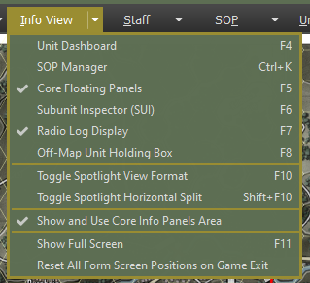

* **Unit Dashboard [*F4*]** – Selecting this action brings up the Unit Dashboard for the currently selected unit on the map. See Section 14.1 below for the details of this dialog. You can have more than one of these open at a time on different units.
* **Core Floating Panels [*F5*]** – These are the four primary panels you see on the left side of the screen (default locations). These are Game Control, Commander, Spotlight, and Mini-Map panels. This is on by default. These are covered in detail in Section 13 below.
* **Subunit Inspector (SUI) [*F6*]** – Selecting this action brings up the SubUnit Inspector for the currently selected unit on the map. See Section 14.3 below for the details of this dialog.
* **Command Log Display [*F7*]** – This panel displays the diary log messages for the entire force in the scenario. It is on by default. It can be toggled on and off. In head-to-head or AI versus AI games, there are tabs for both forces on the display.
* **Off-Map Unit Holding Box [*F8*]** – Selecting this action will open the Off-Map holding Box to show you any off-map units that you can use during the scenario. See Section 14.5 below. It can be toggled on and off.
* **Toggle Spotlight View Format [*F10*]** – Selecting this action will toggle the Spotlight Panel between the Order of Battle (OOB) display and the Detailed Unit information display.
* **Toggle Spotlight View Format [*Shift+F10*]** – Selecting this action will split the panel and show both the OOB and the Detailed Unit information on the single panel with a splitter bar that you can adjust up and down to show the information. This is recommended only if the panel has more room or is floating away from other panels.
* **Show and Use Core Info Panel Area** – Selecting this action to be active (check mark showing in the menu) will place the Core Info Panels to the right of the map, so the right edge of the map is visible on the screen. If this is turned off, the map edge will go to the screen edge and be hidden under the Core Panels.
* **Show Full Screen [F11]** – Toggles the game display between full screen (no windows task bar) and default display with task bar. This only works on the primary display if multiple screens are present.
* **Reset All Form Screen Positions on Game Exit** – Selecting this action will set all the various game panels and dialogs back to their default location for the next game played.

## Staff Menu Items

This is a critical menu for all Commanders to utilize during the game. The dialogs here provide you with information from your various staff officers (Operations, Intelligence, Logistics, and Fire Support) as well as an overview of the scenario.

Other essential functions found in this menu are the items relating to overlay graphics. These are graphics that are placed over the map and are created by an external art program.

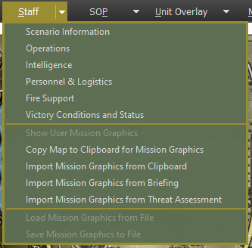

* **Scenario Information** – Selecting this action brings up the Scenario Information dialog. This covers the Scenario Description, Victory Conditions, and VP Distribution Details. See Section 15.1 below for the details of this dialog.
* **Operations** – Selecting this action brings up the Operations dialog. This covers the Mission Briefing, Map overlay, SITREP (Situation Report), Engineering, Air Support, Emitters, Diaries, and Runner information. See Section 15.2 below for the details of this dialog.
* **Intelligence** – Selecting this action brings up the Intelligence dialog. This covers the Threat Assessment, Enemy SITREP, Reported Kills and Claims, Weather Forecast, EW Report (Electronic Warfare), and Enemy Off-Map Assets. See Section 15.3 below for the details of this dialog.
* **Personnel & Logistics** – Selecting this action brings up the Personnel and Logistics dialog. This covers Staff Alerts, Detailed Unit Status, Reinforcements and Withdraws, and Ammunition. See Section 15.4 below for the details of this dialog.
* **Fire Support** – Selecting this action brings up the Fire Support dialog. This covers the Fire Support Assets, Fire Missions, and Fire Support Control Center. See Section 15.5 below for the details of this dialog.
* **Victory Conditions and Status** – Selecting this action will open the Victory Conditions and Status dialog, and you can review the current state of the scenario.
* **Show User Mission Graphics** – Selecting this action will toggle the latest Mission Graphics to be drawn on the map. The graphics can be from the Briefing, Clipboard, or User.
* **Copy Map to Clipboard for Mission Graphics** – Selecting this action will copy the map with unit counters and markers to the clipboard so it can be imported into a paint program for editing. We suggest using Paint.NET in Windows to edit the mission graphics with information. Other programs may not support the format for import.
* **Import Mission Graphics from Clipboard** – Selecting this action will load any mission graphics you have currently copied to the clipboard from your paint program, provided the image dimensions are identical to the map dimensions (as imported from the clipboard). The game will blend the image to show your color graphics on the map while turning grey scale-colored pixels (including white and black) transparent. The game is compatible with the ‘in-memory’ clipboard format from Paint.NET, not with those from MS Paint and Paint3D. **NOTE:** The color Black will not show in the mission graphics.
* **Import Mission Graphics from Briefing** – Selecting this action will load the pre-made mission graphic that supports the given side’s briefing for the scenario.
* **Import Mission Graphics from Threat Assessment** – Selecting this action will load the pre-made mission graphic that supports the threat assessment for the scenario.
* **Load Mission Graphics from File** – Selecting this action will load the pre-made mission graphic from the Custom folder in a scenario folder.

For the NATO side, the graphic must be named Overlay0.png, and for the Warsaw Pact side, it must be named Overlay1.png.

* **Save Mission Graphics to File** – Selecting this action will save the currently shown mission graphics to the Custom folder of the scenario folder with the name Overlay0.png for NATO and Overlay1.png for Warsaw Pact. It will only save a single image currently.

## SOP Items

SOPs (Standard Operating Procedures) are unit instructions on how to behave in certain situations on the battlefield. This menu item provides a means to adjust SOP characteristics for selected units or to set SOPs based on the type of unit and the selected SOP package for the selected units.

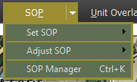

* **Set SOP** – Selecting this option will display the Set SOP options sub-menu. See Section 11.5.1 below for details on the various color options.
* **Adjust SOP** – Selecting this option will display the Adjust SOP options sub-menu. See Section 11.5.2 below for details on the various color options.
* **SOP Manager** – Selecting this action will open the SOP Manager Dialog for the selected unit. See Section 23 below for details on the setting of this dialog.

### Set SOP

The Set SOP menu item brings up an additional menu dialog with a list of unit types and arrows to open an additional menu with pre-set SOP options for those unit types. The pre-sets are based on the unit type and the roles it typically performs and the values that have been set by our team.

The Set SOP submenu is shown below.

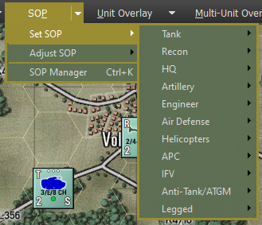

The Custom Unit Type selections are seen in the additional flyout submenu below.

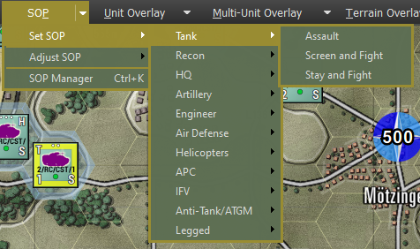

Once a Set SOP is selected, the following confirmation dialog is shown that explains the SOP settings used for the Set SOP selection. Under each counter is a checkbox that allows you to select which of a group of units the Set SOP applies to. At the bottom, there are options to apply the new Set SOP preset to the current default order, all movement orders, and all non-movement orders. The recycle button allows you to quickly invert the selected unit checkboxes in the dialog. When you are ready to apply hit the Done button. If you change your mind and do not want to do a Set SOP setup, click the cancel button.

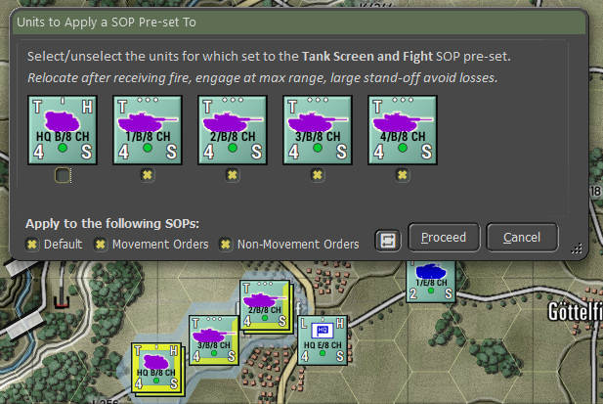

For more information on SOPs, see Section 23 below.

### Adjust SOP

This sub-menu has the following SOP items set out as individual items. These are the same items as found in the SOP Manager dialog. For any selected unit or units (Alt, Ctrl, or Shift selected), the setting will be applied to those units shown as checked in the setting dialog that pops up after choosing a setting.

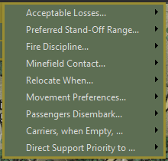

* **Acceptable Losses...** – This is the unit(s) willingness to take losses before seeking a change in orders. This works with the Tactical Initiative above to set how a unit reacts. The settings for this item are Do or Die, Substantial, Moderate, or Minimal.
* **Preferred Standoff Range...** – The number of 500m hexes you wish the unit(s) to be distant from any detected enemy units.
* **Fire Discipline...** – This sets the range or ability to shoot at enemy units in direct fire. The available settings are Refuse fire, Hold until fired on, Point blank (0 to 1 hex), Short Range (1/3 Max Range), Medium Range (2/3 Max Range), and Maximum Range. **NOTE:** This applies to all the unit’s weapons.
* **Minefield Contact...** – This is the unit(s) response to entering a minefield. The options here are Ignore and Run (do not delay and accept the potential for more subunit losses crossing the field), In Stride Breach (units slow down to follow a leader through the field, hoping to avoid mines by traveling in the same tracks), or Stop and Reduce (units halt and either wait for engineers to remove enough mines to open a path through or do the work themselves at a slower rate).
* **Relocate When...** – This determines under what condition a unit will seek to scoot to a new location for better protection or to avoid enemy fire.

The possible selections are After each fire mission, After all fire missions, While the enemy spotted, After receiving any fire, After receiving direct fire, After taking any losses, After taking direct fire losses, or Never. Some of these settings work better for certain types of units. The after-fire mission settings work better for artillery, for instance.

* **Movement Preferences...** – When a unit moves from waypoint to waypoint, there are a few options for how that travel can be done. The hasty move will prefer roads, and Deliberate or Assaulting move orders will mix roads with cross-country movement. You can set stricter movement preferences by checking the boxes for Concealment (more off-road and seeking better-covered terrain to move through, Roads (favor taking roads instead of cross country), and Avoid NBC (which will path units around NBC-contaminated locations on the map).
* **Passengers Disembark...** – Selecting this option will display the Adjust SOP options sub-menu. See Section 11.5.1 above for details on the various color options.
* **Carriers, when Empty...** – Selecting this option will display the Set SOP options sub-menu. See Section 11.5.1 above for details on the various color options.
* **Direct Support Priority to...** – Selecting this action will open the SOP Manager Dialog for the selected unit. See Section 23 below for details on the setting of this dialog.

Once an SOP Adjustment is selected, the following confirmation dialog is shown that states the SOP settings adjusted for the selected units. Under each counter is a checkbox that allows you to select which of a group of units the SOP Adjustments apply to. At the bottom, there are options to apply the new SOP Adjustment to the current default order, all movement orders, and all non-movement orders. The recycle button allows you to quickly invert the selected unit checkboxes in the dialog. When you are ready to apply hit the Done button. If you change your mind and do not want to do any SOP Adjustment, click the cancel button.

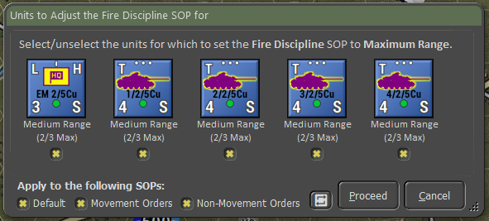

For more information on SOPs, see Section 23 below.

## Unit Overlay Menu Items

Overlays are helpful on-map graphics that show various information for the selected unit to help show lines of sight, the range for weapons and spotting, Electronic Emissions, if any, and a range ruler. Some of these can be used in combination on the map.

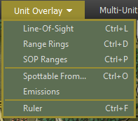

* **Line of Sight [*Ctrl+L*]** – Selecting this action brings up the Line of Sight (LOS) overlay and the basic Detection, Classification, and Identification rings for the selected unit. Hexes are in various shades of green based on how good the visibility is to that hex. The brighter the green, the better the visibility to the hex.

Also included are the visual capability values for each hex. Higher numbers mean a better chance to spot enemy units in those hexes. Hexes inside the hard outline are in weapons range. See Section 24 below for more details on LOS and the Spotting of units.

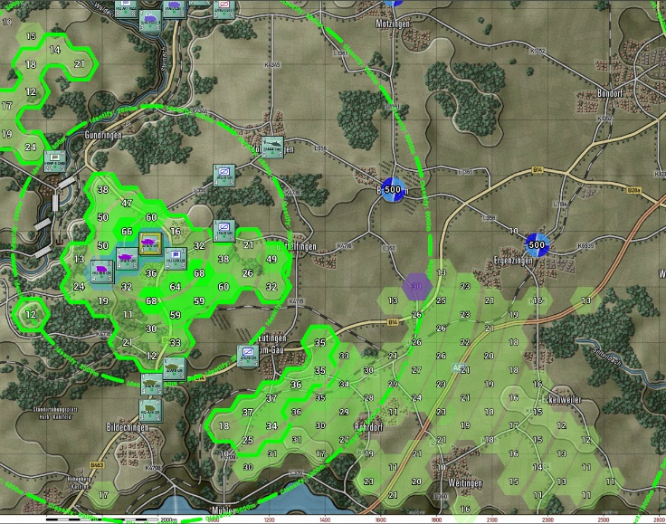

The range ring for Detection notes the maximum range under perfect conditions that an enemy unit of some type can be detected. Once inside the Classification range, the Detected target’s type can be determined (is it a tank or infantry unit). Once inside the Identification range, the exact type of enemy units can be determined (the tank is a T-80BV, for example).

**NOTE:** You can see the line of sight from any hex by doing a Shift + left mouse clicks on the hex you want to check.

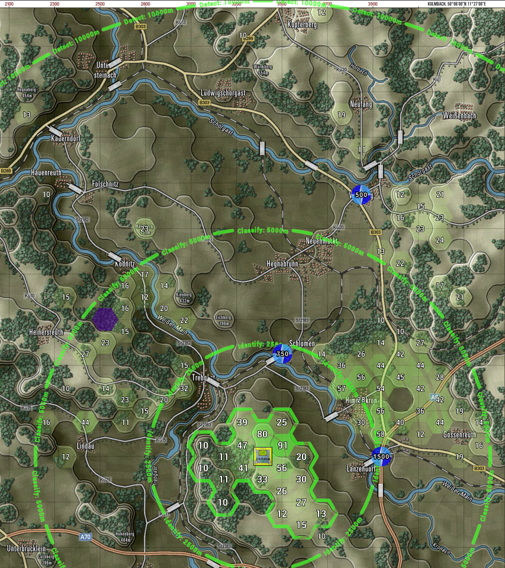

* **Range Rings [*Ctrl+D*]** – Selecting this action brings up the range rings overlay on the map for the selected unit. Rings include weapons ranges (in your combat preferences color), visible spottable range (Thermal and radar distances will be more prominent in most cases), and the max spotting range based on the environmental conditions.

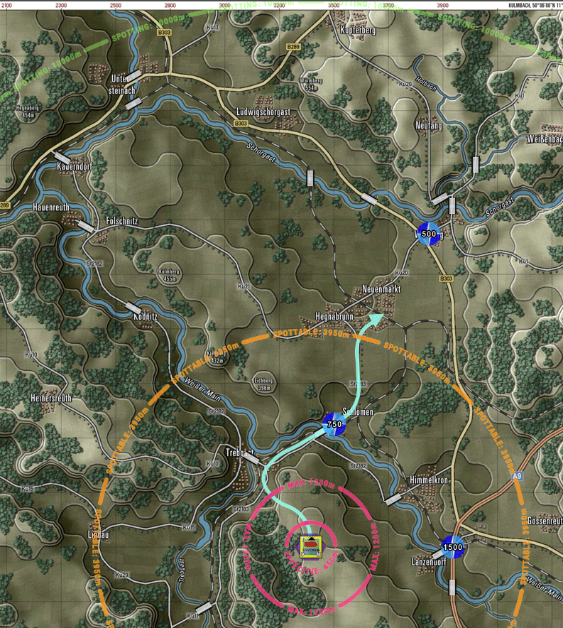

* **SOP Ranges [*Ctrl+P*]** – Selecting this action brings up the SOP-related range rings for the selected unit. This includes the unit’s standoff range and selected weapon engagement range. The filled hexes show the line of sight, with green being out to the maximum spotting range. Yellow hexes are the line of sight within the standoff range, and ones with red numbers are in the selected weapon’s range.

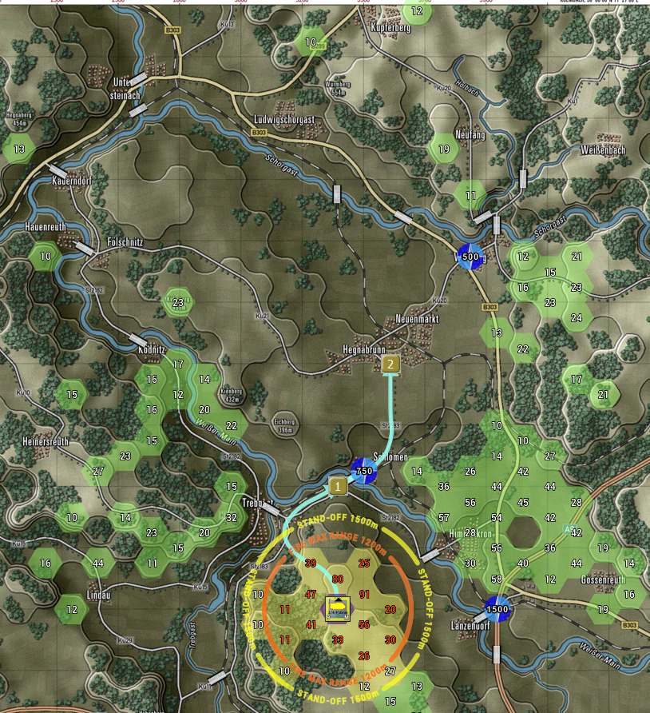

* **Spottable From [*Ctrl+O*]** – Selecting this action brings up the Spottable From overlay for the selected unit. This shows the various ranges and types of systems (Visual, Thermal, and Radar) that the unit is possibly visible to and the hexes where line of sight exists. The size, movement, firing, and other factors impact the ranges.

**NOTE:** You can check the selected unit’s Spottable From in any hex by doing a Shift + left mouse clicks on the hex you want to review. The information will change based on the type of terrain in that hex.

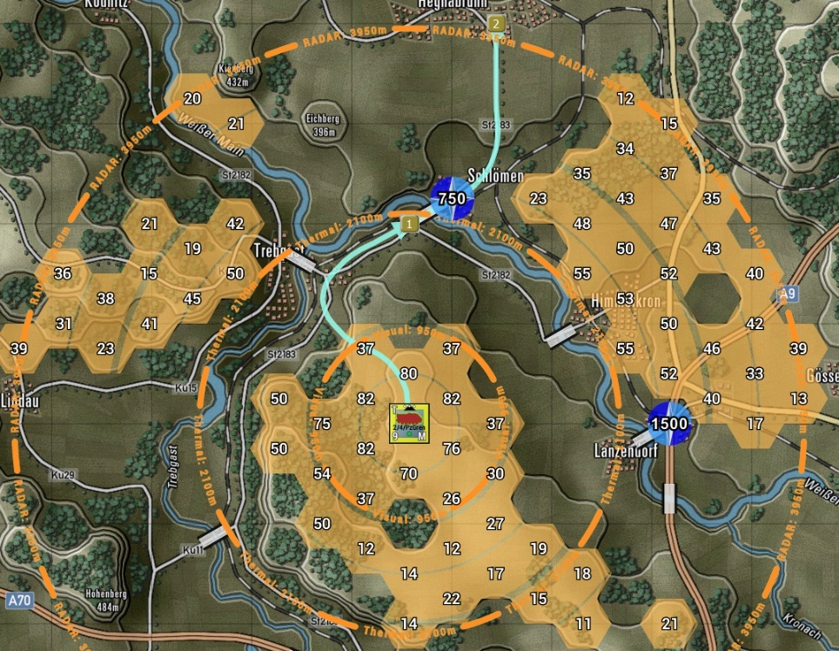

* **Emissions** – Selecting this action brings up the Emissions overlay. This shows the electronic line of sight of an emitting unit. These would be units with some form of radar (air search or ground search), and that system turned on (See Orders, Section 21 below).

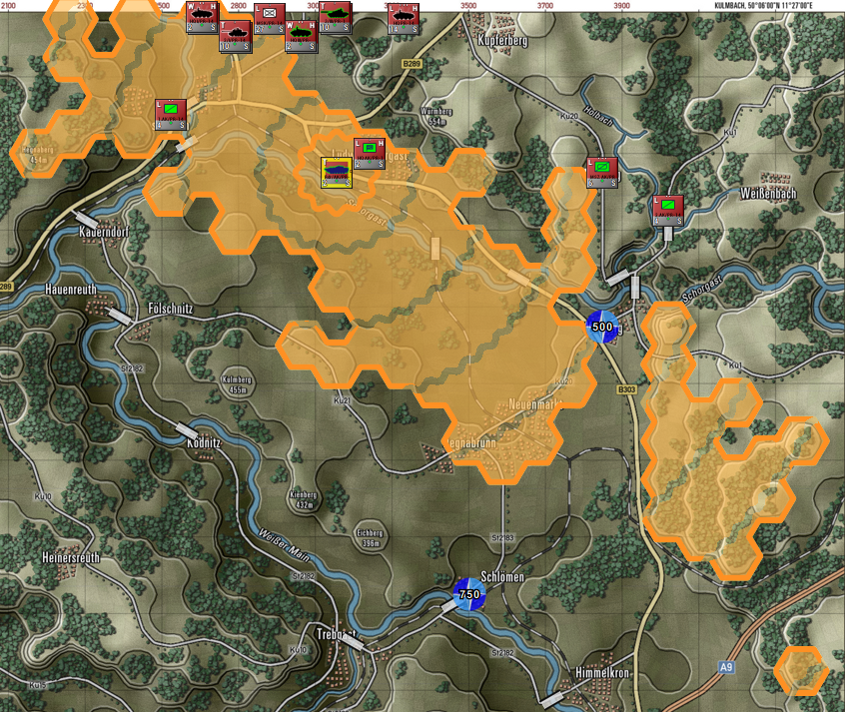

* **Ruler** – Selecting this action brings up the Ruler overlay. This shows range rings in 1000-meter circles with lighter rings for 500 meters up to 5000 meters.

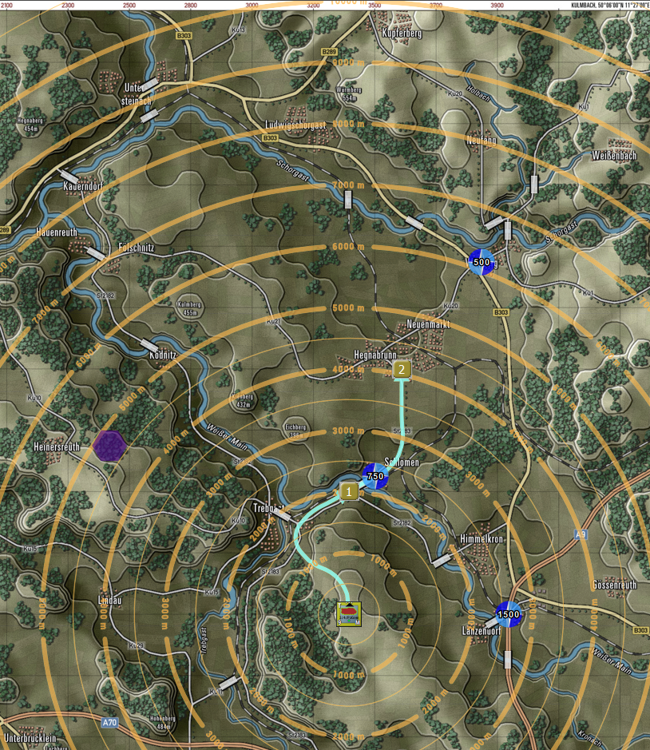

**NOTE:** You can check the from any hex by doing a Shift + left mouse clicks on the hex you want to review.

## Multi-Unit Overlay Menu Items

Multi-Unit Overlays are helpful on-map graphics that show various information for all units to help show lines of sight, ranges for weapons and spotting, Electronic Emissions if any, and Starting Deployment Areas. There are also functions to show Chain of Command, Air Defense coverages, Fire Support coverage, and Direct Support assets. Some of these can be used in combination on the map.

**NOTE:** Many of the following functions will also show the currently selected units overlay as it would appear in other hexes by Shift + Left Mouse Click in the hex of interest. This can be very useful when planning locations for things like air defense or looking at variations in line of sight at different map locations.

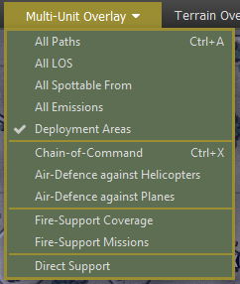

* **All Paths [*Ctrl+A*]** – Selecting this action brings up all the active paths for all your units. The currently selected unit will have a darker path line.

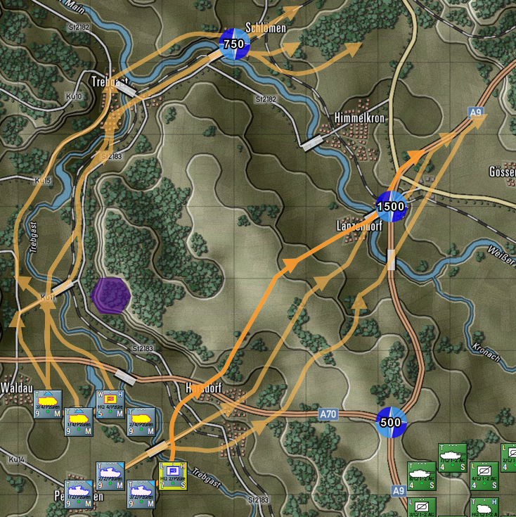

* **All LOS** – Selecting this action brings up the Line of Sight (LOS) overlay for all your on-map units. As you select units, you will see the LOS of that unit shown with the thick hex outline on the map.

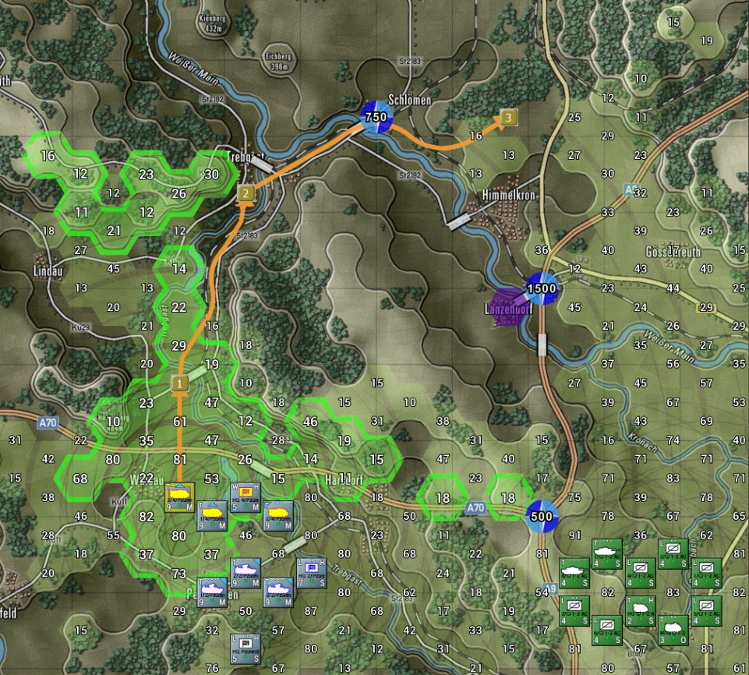

* **All Spottable From** – Selecting this action brings up the Spottable From overlay on the map for all your units on the map. The selected unit’s spottable hexes will be shown with a thick hex outline.

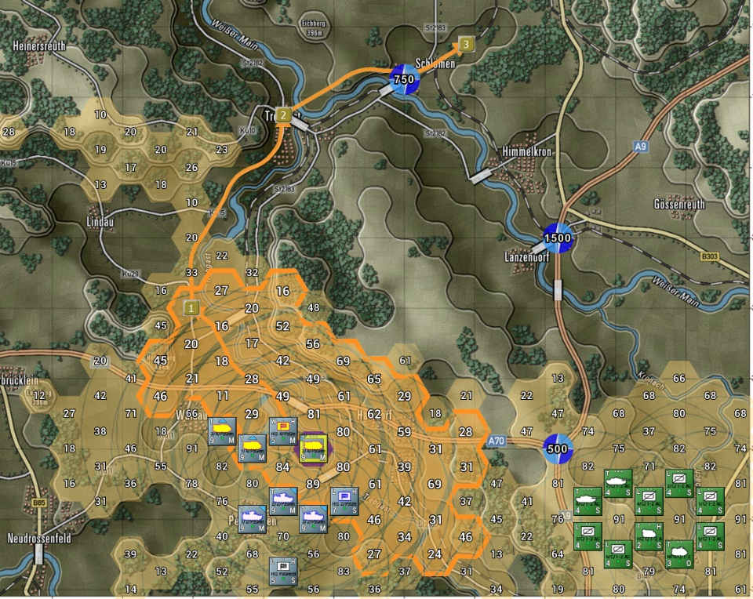

* **All Emissions** – Selecting this action brings up the All-Emissions map overlay. This shows the coverage for all emitting units on the map. The selected unit will have its hexes outlined, and the unit will have a wavey circle around it.

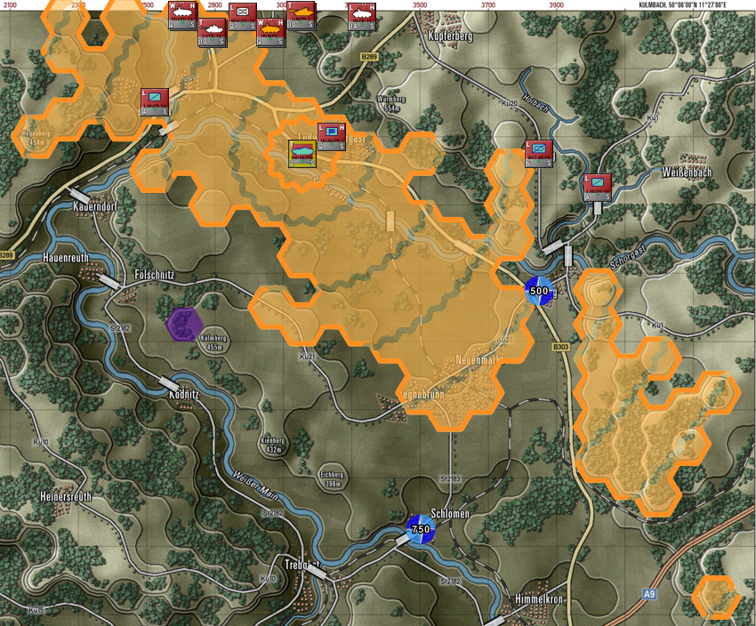

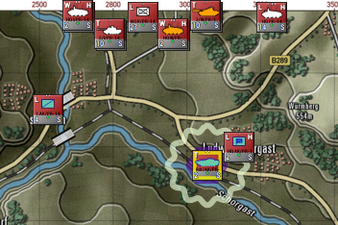In cases where a unit has an emitter(s), but they are turned off, the unit will have a gray wavey circle drawn around it as it shows to the left. See Section 21 below on how to issue orders to turn emitters on and off.

* **Deployment Areas** – This menu action toggles the setup zones for each side off and on. These are the colored hex areas that show up for your units at the start of the scenario. The selected unit can be dragged and dropped into any colored hex. The colors for each side and the level of transparency are set in the game options (see Section 3.4 above).

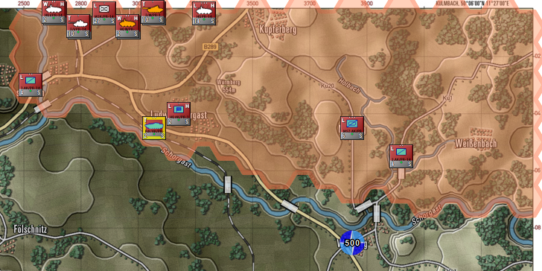

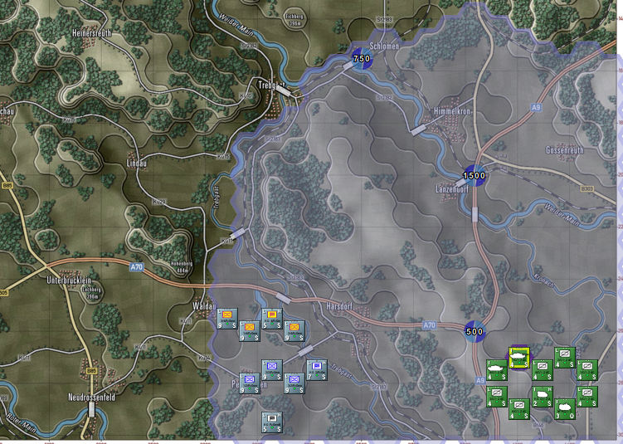

* **Chain of Command [*Ctrl+X*]** – Selecting this action brings up the Chain of Command overlay. This shows the chain of command for units. The chain of command is how orders are given and received by units and headquarters. As shown below, the highest headquarters, when selected, will show lines of command to the next lower-level headquarters. Solid lines are in range. Dashed lines indicate a subordinate HQ or unit that is out of command range. The HQ’s command range is drawn as a large circle. Units outside of the command range face additional delays in orders and reduced resupply. Some units, like Recon units, can operate at full capacity at any range.

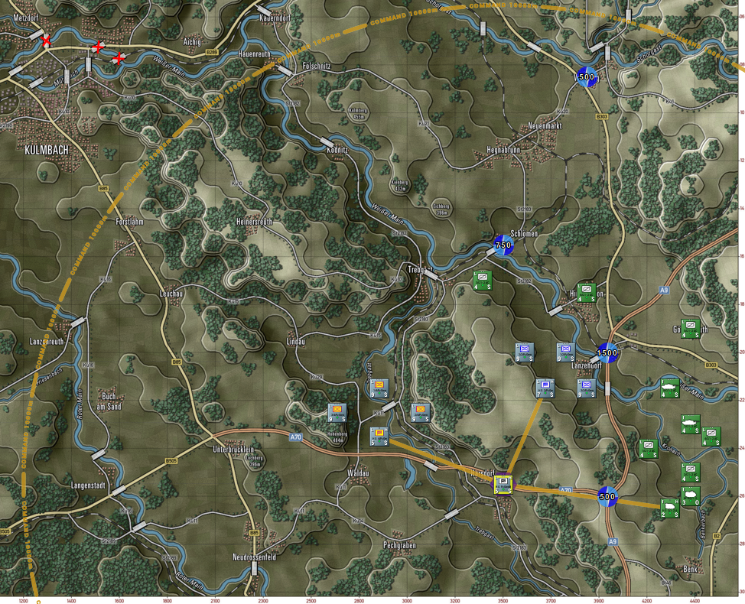

As seen above, dark-colored lines extend from the selected HQ to its next-level subordinate units. In this case, the subordinates are lower-level HQs.

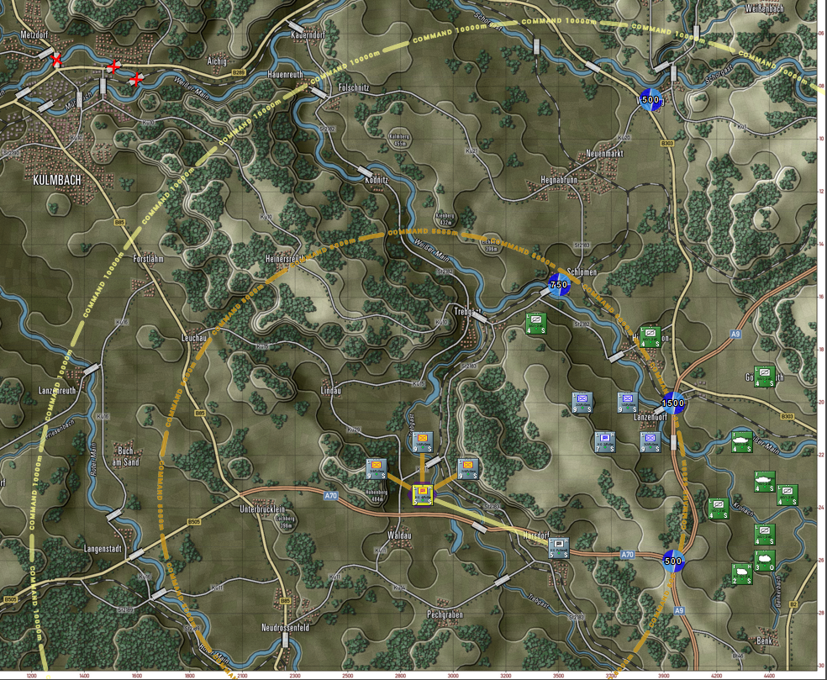

In the picture above, one of the subordinate HQs has been selected. Dark lines extend to the HQ's subordinate units, and a dark circle shows the extent of the HQ’s command radius. A light-colored line goes from the selected HQ up to the next higher HQ if it exists, and the command range of the next higher HQ is drawn on the map.

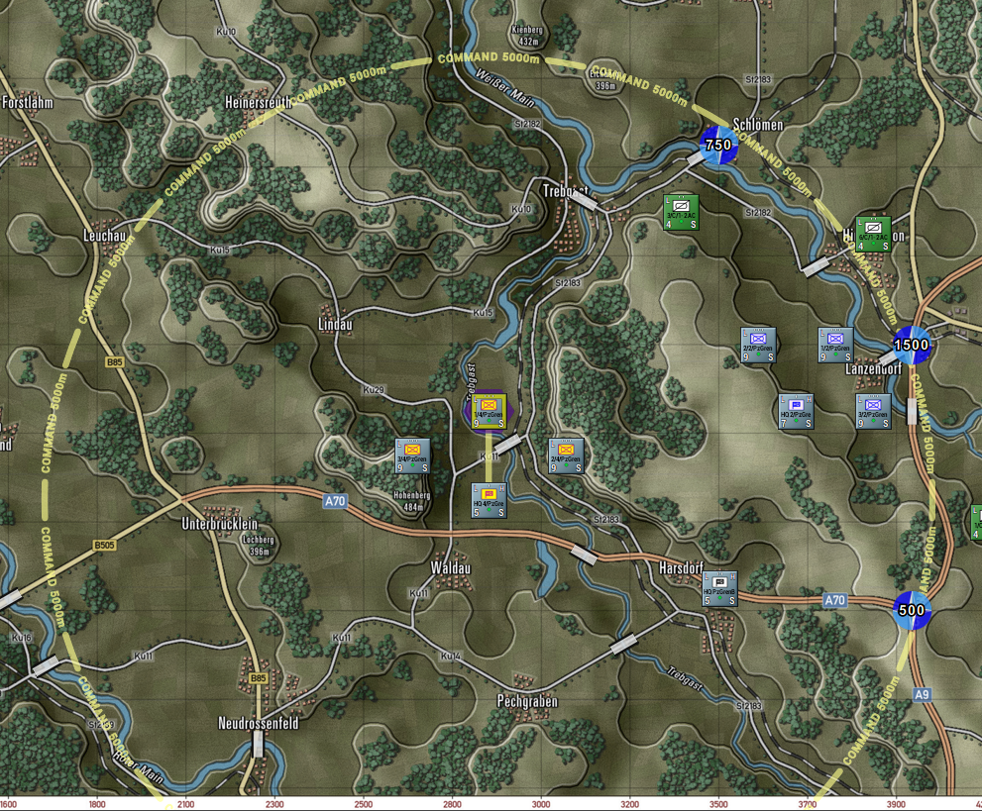

In the picture above, one of the subordinate units has been selected. Light lines extend to that subordinate unit’s HQ, and a light circle shows the extent of the HQ’s command radius for that subordinate. Selecting other subordinate units will show the relationship to their local HQ.

* **Air-Defense against Helicopters** – Selecting this action brings up the Air-Defense overlay for on-map Helicopters or Drones (assumed to be flying very low and defensively) for all air-defense capable units in your force. Depending on the type of unit you select, there are three types of overlay effects shown on the map. When you select a unit with an Air-Defense Surface to Air Missile system (SAM), the hexes are shown as filled, and the range of the selected unit is seen in the solid hex side outline, as seen in the image below.

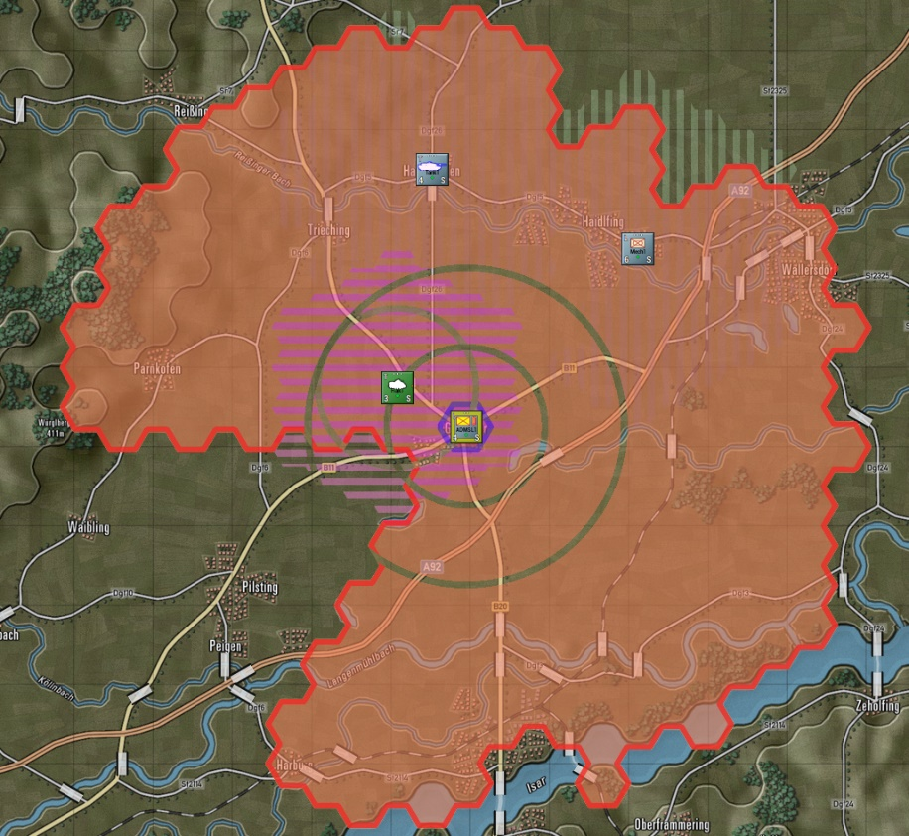

When you select a unit with an Air-Defense Gun system (Flak), the hexes are shown as horizontal hatched lines, and the range of the selected unit is seen in the solid hex side outline as seen in the image below on the left.

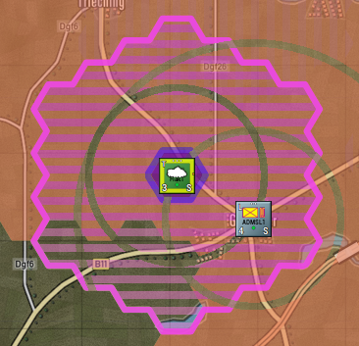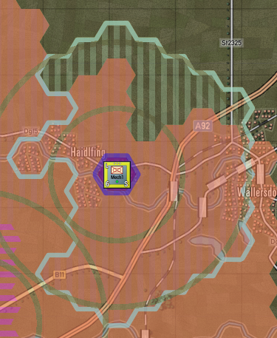

When you select a unit with a Limited Air-Defense system (like an anti-air machine gun or autocannon), the hexes are shown as vertical hatched lines, and the range of the selected unit is seen in the solid hex side outline as seen in the image above on the right. These are limited capability systems. These weapons will engage at a reduced range and only engage air threats approaching them (within a 30-degree arc).

* **Air-Defense against Planes** – Selecting this action brings up the Air-Defense overlay for off-map Aircraft (assumed to be flying low) for all air defense capable units in your force. Depending on the type of unit you select, there are two types of overlay effects shown on the map. When you select a unit with an Air-Defense Surface to Air Missile system (SAM), the hexes are shown as filled, and the range of the selected unit is seen in the solid hex side outline, as seen in the image below.

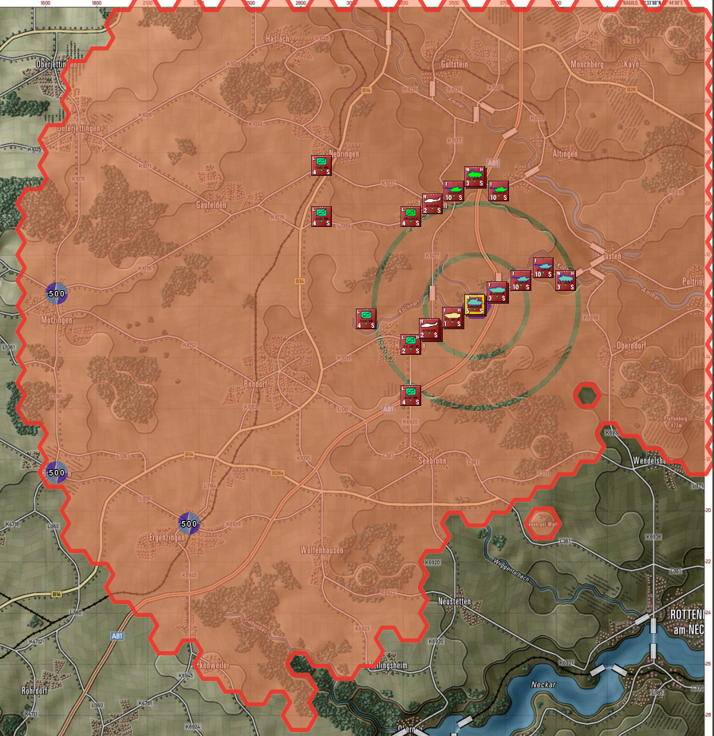

When you select a unit with an Air-Defense Gun system (Flak), the hexes are shown as horizontal hatched lines, and the range of the selected unit is seen in the solid hex side outline, as seen in the image below.

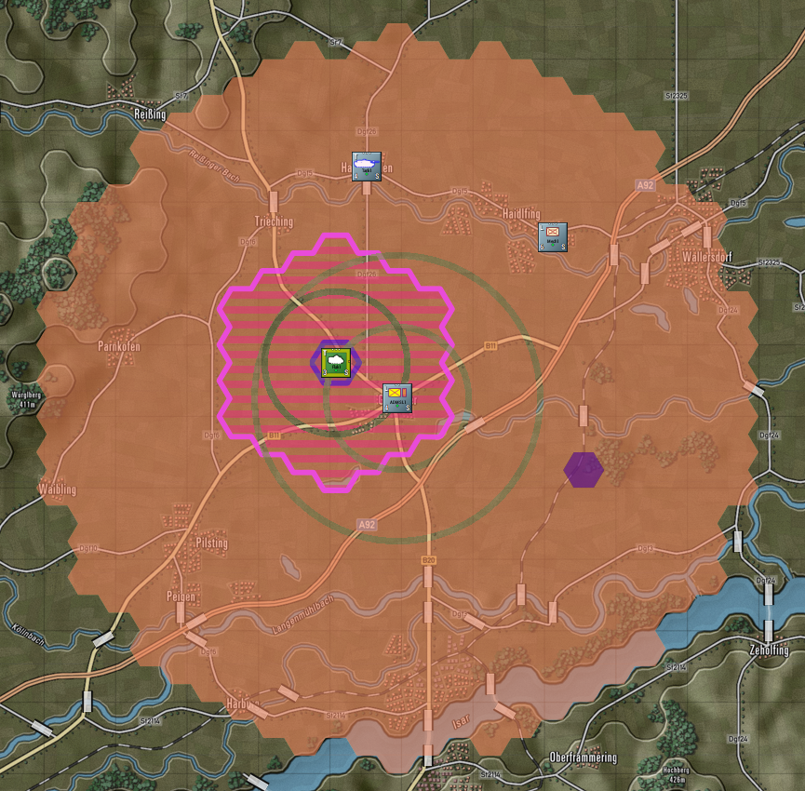

* **Fire-Support Coverage** – Selecting this action brings up the Fire-Support Coverage overlay. This shows the firing range for all on-map and off-map indirect fire artillery units (mortars, field guns, rockets). Selecting a unit will show darkened range rings and map coverage hexes.

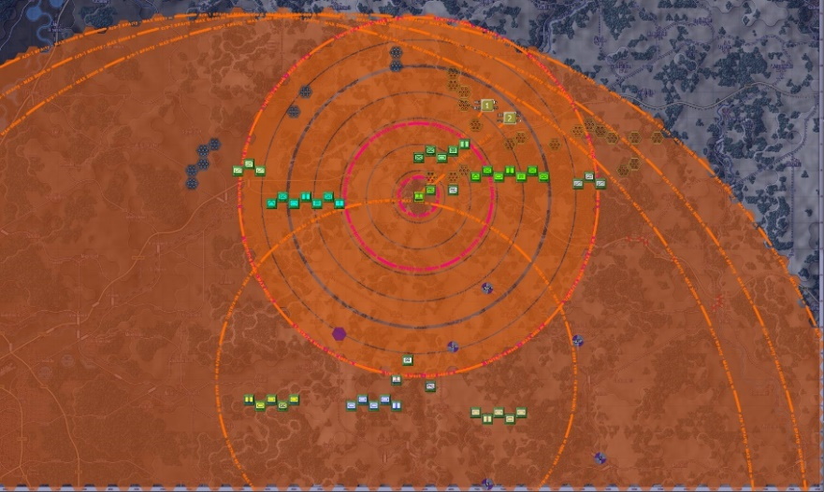

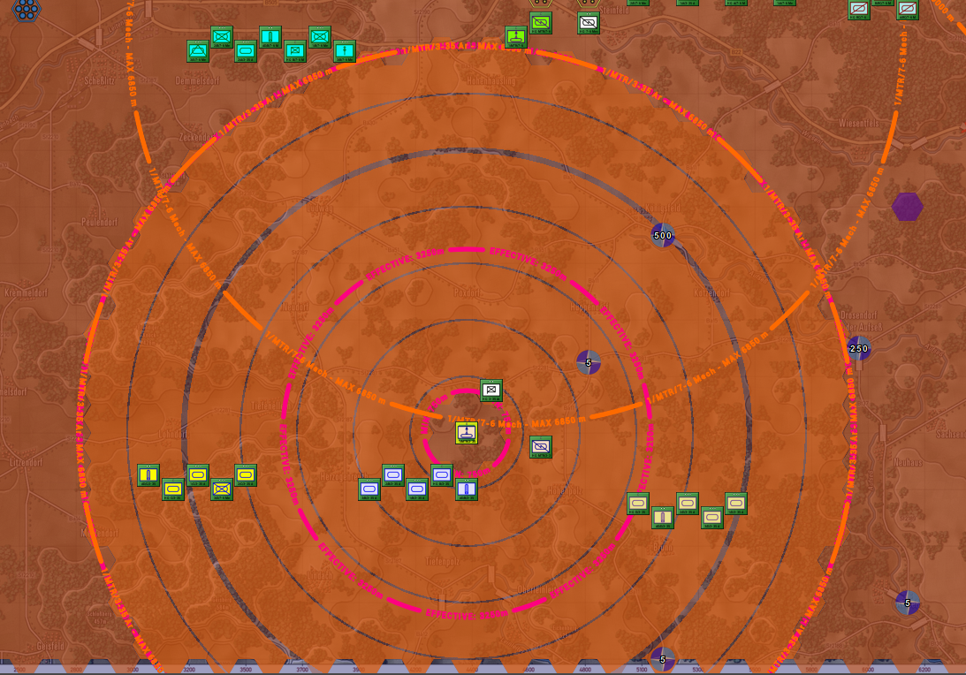

* **Fire-Support Missions** – Selecting this action brings up the Fire-Support Missions overlay. This shows All of the currently plotted fire missions. A line is drawn from each firing unit to the target hex(es). The target hex(es) will state the type of mission (HE = High Explosive, Smoke, ICM = Improved Conventional Munitions, or Chemical, for example), the number of rounds to be fired, and the time the mission starts. Lines will be drawn for off-map assets based on their off-map locations and target hexes.

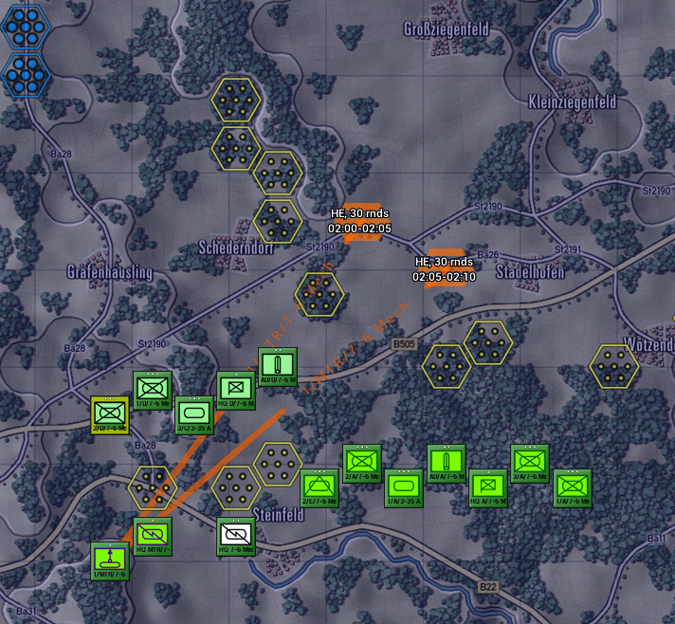

* **Direct Support** – Selecting this action brings up the Direct Support overlay. The direct support overlay indicates, given the selected unit, which assets are in direct support and which units are directly supported. DS assets either have a line to the selected unit supporting that unit), or six short lines in all directions when they are set to support all units. The ranges of DS assets are also shown on the map. If a DS asset is selected, the hexes in the line of sight of all supported units are indicated as hexes with a hard outline.

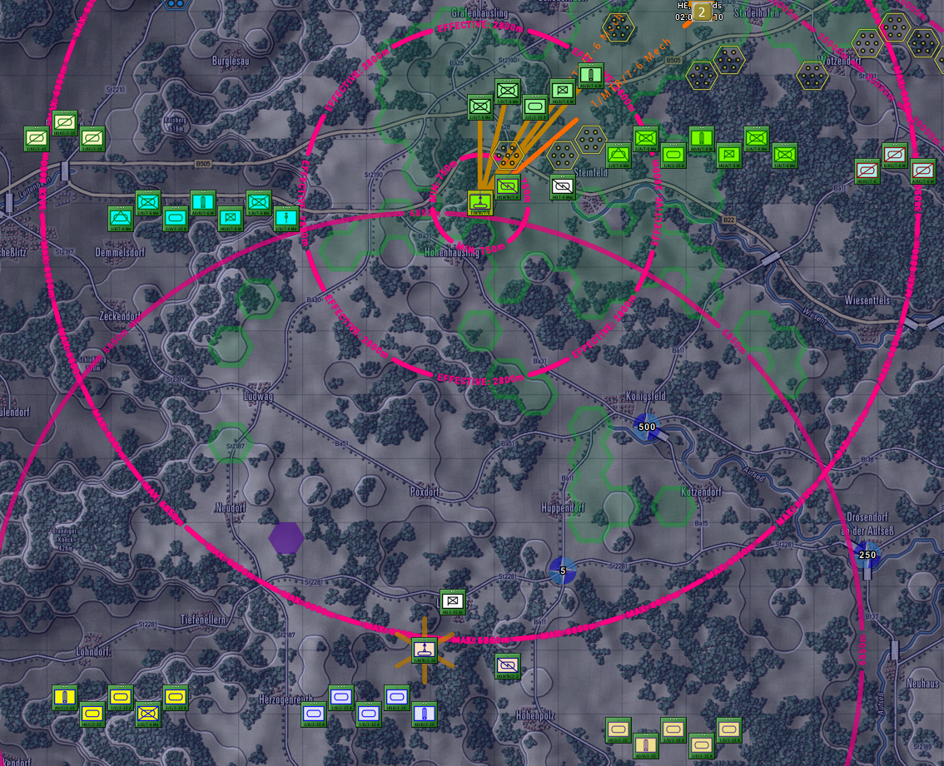

## Terrain Overlay Menu Items

The Terrain Overlay Menu has several useful overlays covering various factors of the map and the terrain. The most important from a planning aspect is the MCOO [Pronounced Ma Coo] or the Modified Combined Obstacle Overlay. The others have been used, and most are found in the Status Bar (See Section 12.2 below) for the hex the mouse is in.

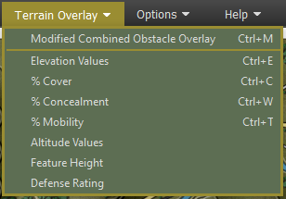

* **Modified Combined Obstacle Overlay (MCOO)** – Selecting this action will bring up the MCOO. The map will be overlayed with various colors, hatching, and edges that represent various levels of useful terrain information. A Legend also pops up to explain all the impact of the various information shown. Use this information to quickly note poor mobility areas, clear lanes of fire, impassible terrain, and good locations to hide recon units. See Section 16.12 below for details on what the various markings mean.

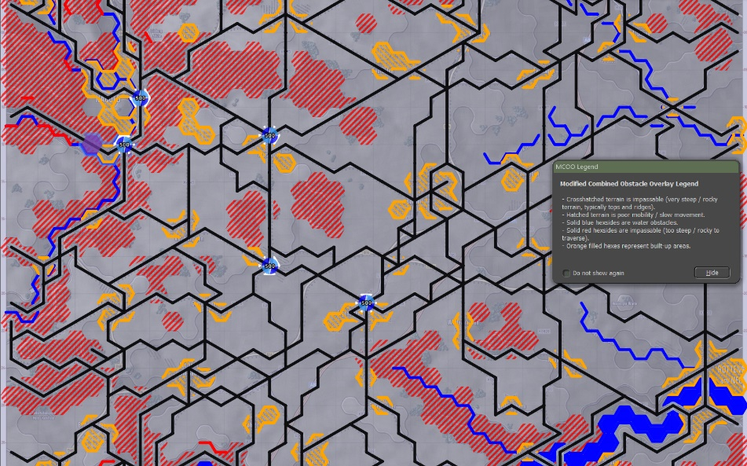

* **Elevation Values** – Selecting this option will show the elevation value for every hex on the map. Elevations run from 1 to 10 and denote changes of 25 to 50 meters of the ground level. Elevation changes impact the line of sight, and elevation changes also impact the speed of unit travel.

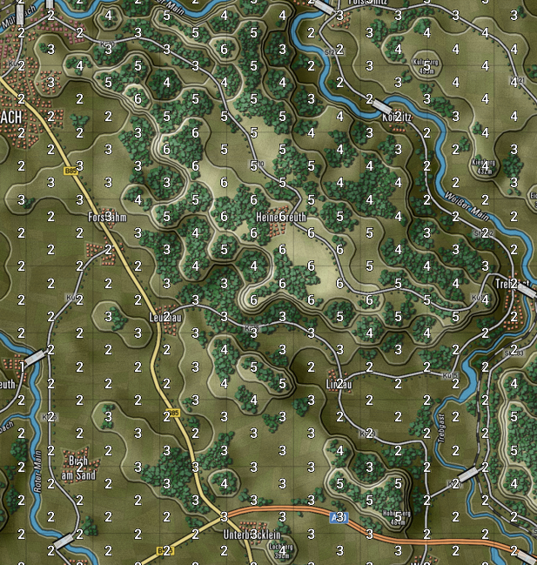

* **% Cover** – Selecting this option will show the Cover Percentage for every hex on the map. The cover runs from 1 to 99 and denotes the ability of the terrain to provide cover from direct/indirect fire, with 1 being no protection and 99 being a maximum.

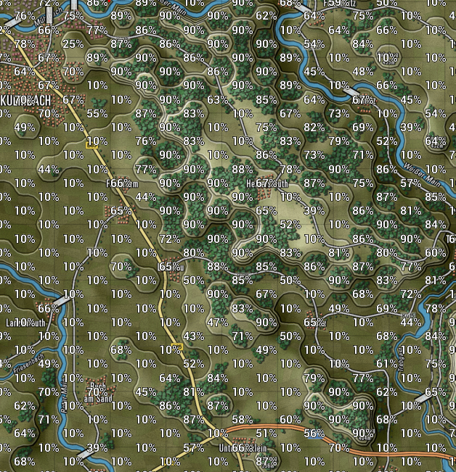

* **% Concealment** – Selecting this option shows the Concealment rating for each hex on the map. Concealment impacts the spotting and line of sight abilities of units. One being no impact to line of sight/spotting, and 99 being extreme degrading of the line of sight and spotting.

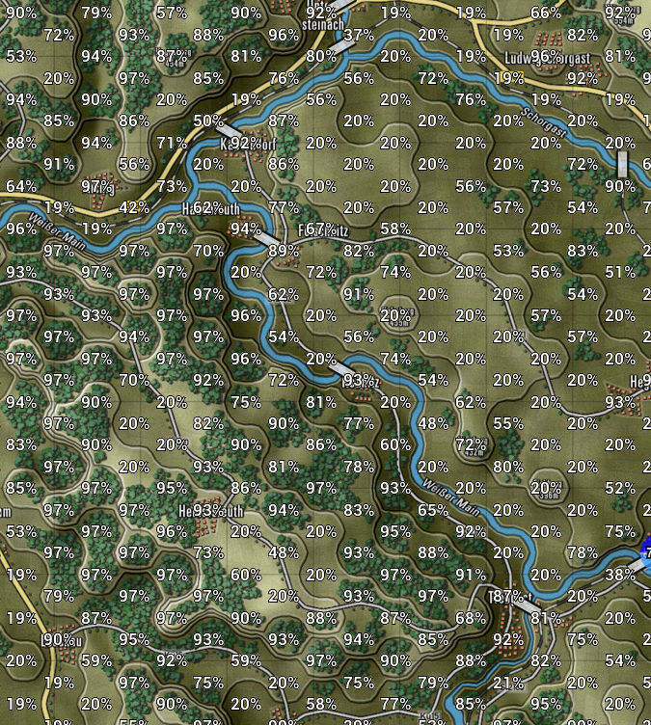

* **%Mobility** – Selecting this option shows the Mobility rating for each hex on the map. The Mobility rating shown reflects off-road movement for units. The higher the number, the faster units can travel off-road. Units using Hasty (road) movement will move faster where there are roads and ignore the mobility rating in favor of the type of road.

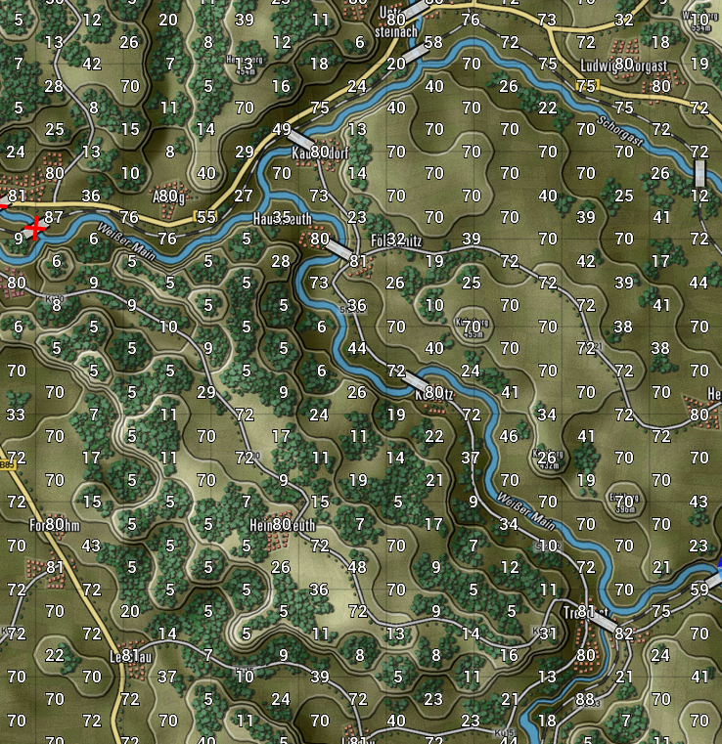

* **Altitude Values** – Selecting this option will display the Altitude value for every hex on the map. The Altitude value is the height above sea level in meters for the area represented on the map. The information is for display only and does not factor into gameplay.

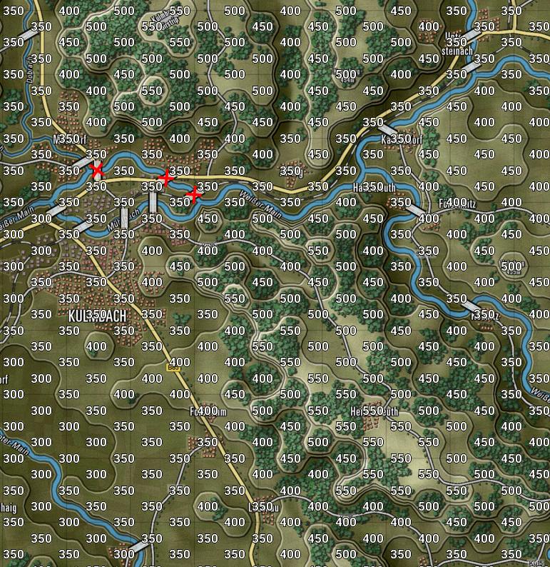

* **Feature Height** – Selecting this option will display the Feature Height for each hex on the map. Feature height is a primary measure of how tall the objects are in the terrain. This value impacts spotting and line of sight during the game.

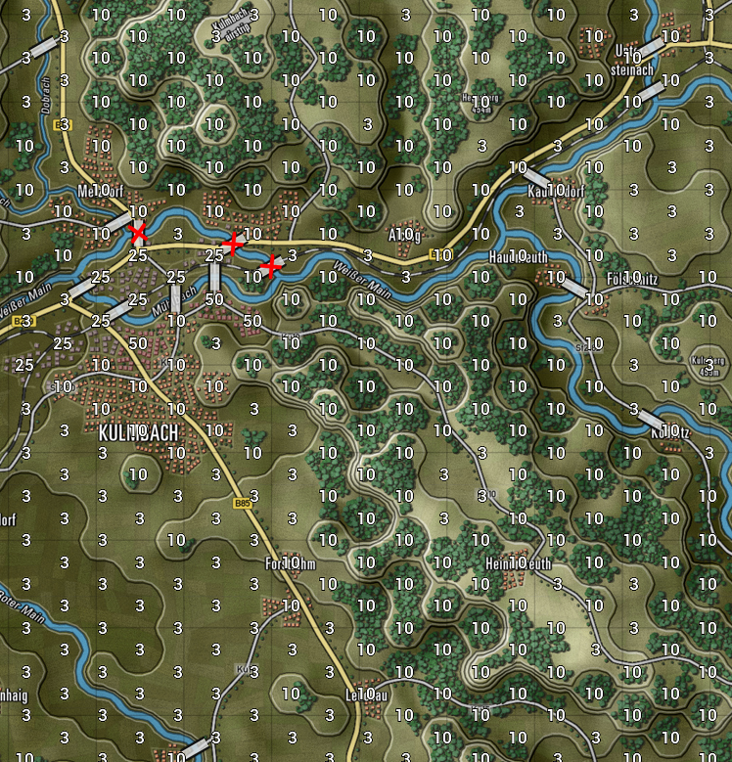

* **Defense Rating** – Selecting this option will display the Defense Rating for every hex on the map. This is a relative rating for how defendable a location is based on the terrain type. One would be very poor defensible terrain, and 99 would be outstanding terrain to defend in.

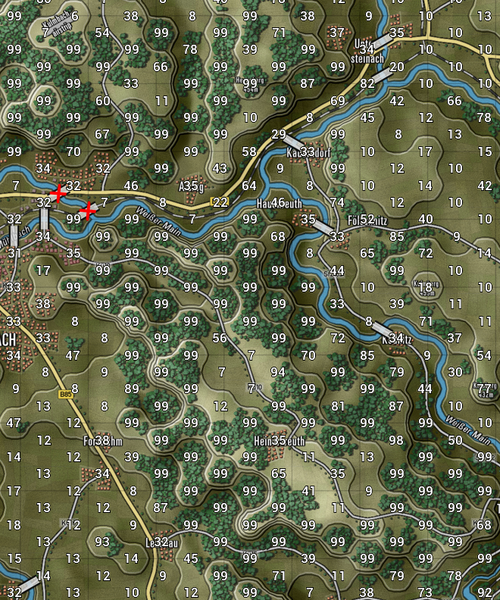

## Options Menu Items

The Options Menu is used to access the User Preference dialog, change up the counter art style and colors, and vary the map contrast to suit your taste to see the counters and markers.

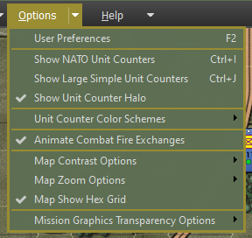

* **User Preferences** – Selecting this option will open the User Preferences dialog that has many of the game settings. See Section 3 above for details on what settings are there and what they do.
* 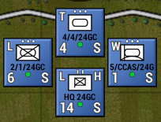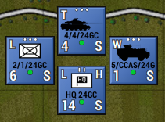**Show NATO Unit Counters** – Selecting this option will display NATO markers in place of the vehicle silhouettes on all counters. Default silhouette counters left, and NATO counters right. For a rundown of NATO symbols and their meaning, refer to the Battlefield Primer FM FCCW-02.
* 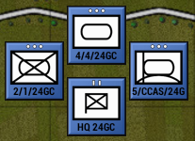**Show Large Simple Unit Counters** – Selecting this option will display Large NATO Symbols on all the counters to make the unit type more visible at extreme map zoom-out levels. Default silhouette counters left and Large Simple counters right.
* 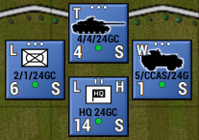**Show Unit Counter Halo** – Selecting this option will display a color halo around all silhouettes. Default silhouette counters left, and Halo enabled counters right.
* **Unit Counter Color Schemes** – Selecting this option will display the Unit Counter Color Scheme options. See Section 11.9.1 below for details on the various color options.
* **Animate Combat Fire Exchanges** – Selecting this option will turn on weapon-based firing animations for direct-fire weapons that replace the static “red” and “blue” lines in the default game setup. See Section 16.13 below for more details.
* **Map Contrast Options** – Selecting this option will display the Map Contrast Options. See Section 11.9.2 below for details on the various map contrast options in the game.
* **Map Zoom Options** – Selecting this option will display the Map Zoom Options. See Section 11.9.3 below for details on the various map zoom levels in the game.
* **Map Show Hex Grid** – Selecting this option will draw a light-colored hex grid over the current map to better show the map hexes. This can be toggled on and off via the menu item.

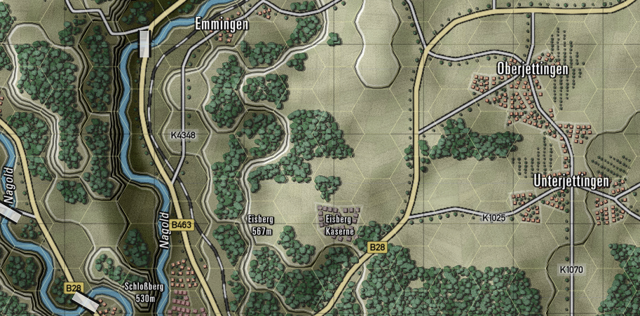

* **Mission Graphics Transparency Options** - Selecting this option will display the Mission Graphics Transparency Options. See Section 11.9.4 below for details on the various transparency options in the game.

### Unit Counter Color Schemes

Along with being able to change the basic look of the counter art between Silhouettes and NATO standard markings, these additional counter options allow you to change the colors for better identification or contrast depending on your style or need. These settings can be changed at any time the menu is active in the game.

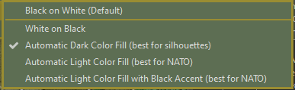

* **Black on White (Default)** – Simple black art or black NATO symbol on a white field.

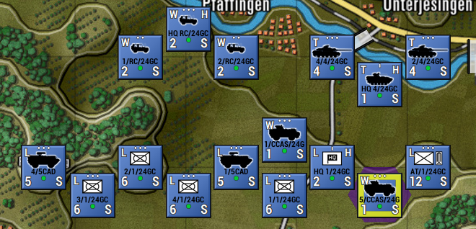

* **White on Black** – Simple white art or white NATO symbol on a black field.

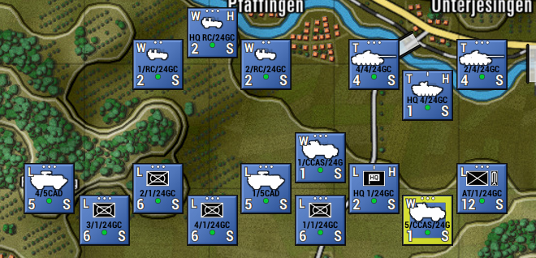

* **Automatic Dark Color Fill (best for silhouettes)** – Based on formations, each unit will get a contrasting dark color fill for the silhouettes and halo or the NATO backgrounds. This makes it easier to see what units belong to what formations and HQs.

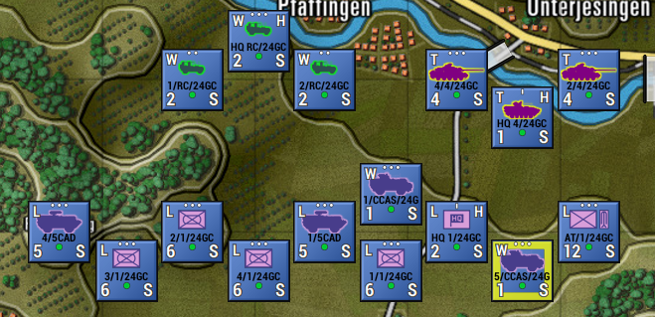

* **Automatic Light Color Fill (best for NATO)** – Based on formations, each unit will get a contrasting light color fill for the silhouettes or the NATO backgrounds and contrasting color lines for the NATO symbols. This makes it easier to see what units belong to what formations and HQs.

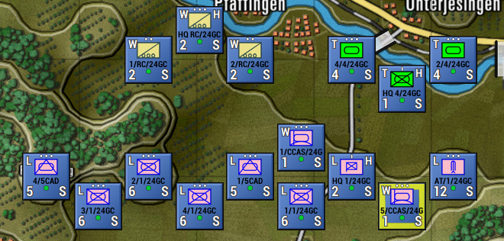

* **Automatic Light Color Fill with Black Accents (best for NATO)** – Each unit, based on its formation, will get a contrasting light color fill for the silhouettes or the NATO backgrounds with black line art for the NATO symbols. This makes it easier to see what units belong to what formations and HQs.

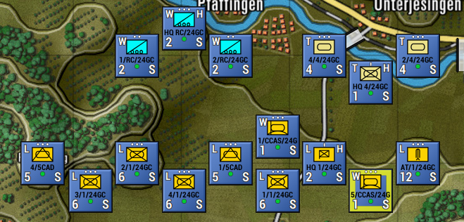

### Map Contrast Options

These options allow the user to change the level of contrast/saturation (color vibrancy) of the map to make the counters and map markers more visible in some cases. The option goes from full color down to a basic grey scale look. This setting can be changed at any time when the menu is active.

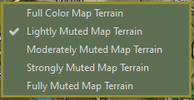

* **Full-Color Map Terrain** – This selection shows the map in its default color as made.

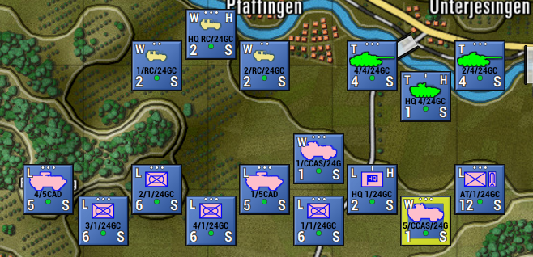

* **Lightly Muted Map Terrain** – This selection shows the map with a slight change to contrast and saturation.

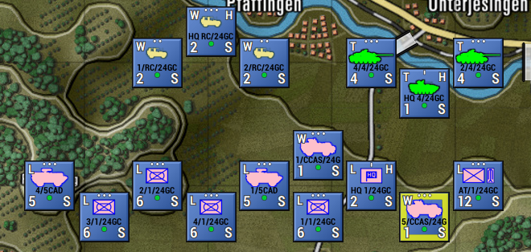

* **Moderately Muted Map Terrain** – This selection shows the map with a moderate change to contrast and saturation.

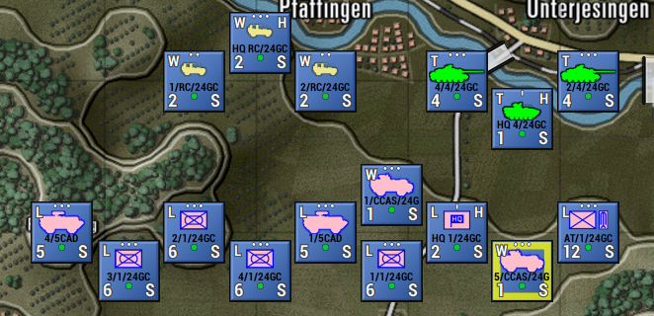

* **Strongly Muted Map Terrain** – This selection shows the map with a strong change to contrast and saturation.

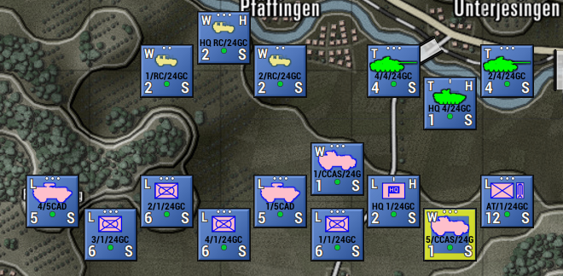

* **Fully Muted Map Terrain** – This selection shows the map with an entirely muted contrast and saturation. Turning the map into a scale.

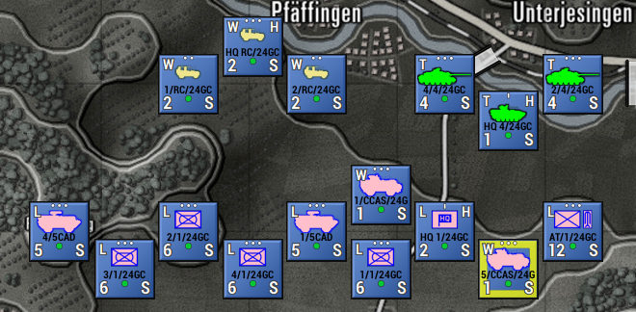

### Map Zoom Options

The Zoom Options menu item provides the user with the ability to zoom the map from 30% up to 200%. This wide range allows layers on very high-resolution screens to zoom in and still see and read counters and the map. The Fit option automatically scales the entire map to fit on the screen. There are hotkeys for the basic ranges between 50% and 130%.

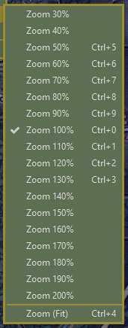

### Mission Graphics Transparency Options

The in-game Mission Graphics Transparency is 50% and can be set to a less transparent level on the map by selecting 25% or 10% Transparency via this option. The lower the value, the brighter the mission graphics will appear over the map.

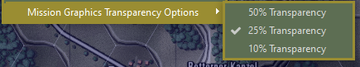

## Help Menu Items

The Help Menu contains several items to allow you to access various game documentation folders to access the PDFs for the What’s New, Field Manuals and Operational Area Guides, the in-game Hotkeys listing, About the game info, and the all-important Credits (check it out at least once to see all those responsible for this great game).

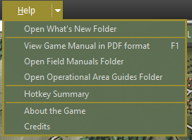

# Status Bar

At the bottom of the game screen is the Status Bar. This bar has two areas with different functions and information.



In the blank area between the two status zones, information about the selected unit and overlay(s) in use is displayed.

## Speed Buttons

The left side of the Status Bar has several Speed Buttons that perform various game functions.



* **Map + and Map - -** These speed buttons are used to zoom the map in or out, and the percentage of zoom is shown between these speed buttons.
* **LOS –** This speed button turns on the Line of Sight (LOS) overlay for the selected unit, or a shift selected hex.
* **Paths –** This speed button toggles on or off all the movement paths for your units if set.
* **Ranges –** This speed button draws in the range rings for Spottable, Weapon Ranges, and Spotting range for the selected unit. If the unit is an HQ, then the command range will be shown as well.
* **SOP –** This speed button draws the selected unit’s SOP-related range rings showing Stand-Off range and Weapon Firing range settings.
* **Special –** This speed button will toggle off or back on the last overlay not covered by any of the other speed buttons on the status bar.
* **Mission –** This speed button toggles on and off any custom or loaded Mission Graphic for the scenario.

## Hex Information

The right side of the Status Bar has five symbols and numeric information for the hex the mouse cursor is in.



* **Hex Icon** – this is the ID number of the selected hex.
* **Mountain Icon** – This is the elevation of the selected hex, with 00 being water/ground level and going up from there.
* **Shield Icon** – This is the percentage of cover the hex provides units in it. Higher is more cover.
* **No Eye Icon** – This is the concealment capability of the hex selected. Higher numbers make it harder to be spotted.
* **Truck Icon** – This is the mobility rating for the selected hex. The higher the number, the quicker units can move through the hex.

# Core Game Panels

On the right side of the screen, next to the map, are the Core Game Panels. This is the default position of these panels. They can be moved around on the screen or moved to another screen. See the sections below for details on each of these Core Panels.

## Game Control Panel

The Game Control Panel contains information critical to the overall play of the scenario.

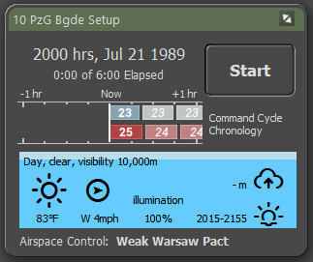

1. The top bar states the commanding force name. During turn resolution, the title changes to “Turn Resolution.”
2. This area shows the time of day, date, and elapsed time of the scenario and the total time limit of the scenario.
3. This is the Start/Pause button that starts turn execution after an orders phase or pauses the resolution if the game is running.
4. This graph shows the command cycles for both sides. The player side is an exact measure of the command delay time, and the enemy is an estimated value.
5. This area is the weather panel. At the top, the current weather and visibility conditions are shown. Below that is a weather icon and the temperature. To the right of that, there is an icon for wind direction and wind speed. Next is the percentage of illumination (which is vital at night based on the phase of the moon). In the upper right, the cloud ceiling in meters is shown (if one exists). Finally, in the lower right, the next phase in the time-of-day cycle (dusk in this case).
6. At the bottom of the panel, the state of Air Superiority Control is noted. This will be noted as who is in control and how strong that effort is.

## Commander Panel

The Commander Panel contains information about your command and shortcuts to the Staff information dialogs.

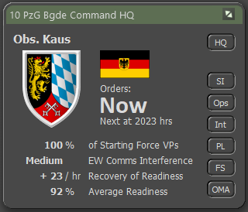

1. The top bar shows the name of the commanding force.
2. This is the commander's name and rank. This is you as the player.
3. This is the force’s badge or flag.
4. This is the national flag of the commanding force.
5. The HQ button calls up the Dashboard for the highest HQ unit on the map and highlights the HQ on the map.
6. This area tells you the time of your next Order input cycle in minutes of game time.
7. These buttons can be used to bring up any of the Staff dialogs and the Off Map Assets (OMA) dialog. See Section 15 below for more details.
8. This area has information related to the overall condition of your force. This includes current Force percentage, Electronic Warfare Interference level, Recovery of Readiness capability per hour, and the overall Average Readiness of your force.

These are the primary determinants of the command cycle length.

## Spotlight Panel

The Spotlight Panel can be set to one of three modes to display 1) The Order of Battle (OOB Tree), 2) Detailed Unit Information on the selected unit, or 3) in cases where there is enough screen space, both can be shown at the same time. You can toggle between modes 1 and 2 or show/hide the panel by pressing the F10 key or switch to mode 3, showing both by pressing Shift + F10.

### OOB Tree View

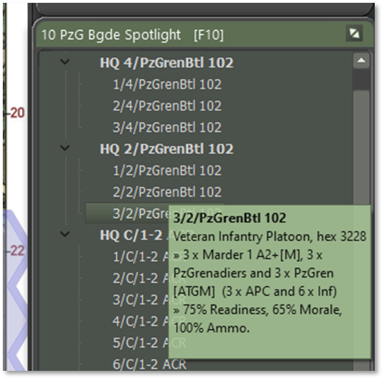

1. The top bar shows the name of the commanding force being spotlighted.
2. This panel displays your force’s Order of Battle (OOB). You can open and close the OOB by clicking on the chevron icons to the left of the list. Clicking on a unit name will highlight that unit on the map. Right-clicking on a unit name will open the Unit Popup Menu (see Section 21.1 below).
3. This area allows you to select a unit and then resubordinate to another HQ or to change its order within a formation by clicking on the unit and dragging and dropping to a new position in the list. For more details on both actions, see Sections 20.1 and 20.2 below.
4. Running the mouse over the list of names in any tree view, e.g., the Spotlight, and instantly see the composition of the unit in the tool tip window that pops up.

### Detailed Unit Information View

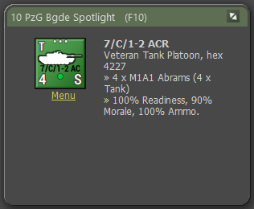

1. The top bar shows the name of the commanding force being spotlighted.
2. The currently selected unit counter is shown in the window.
3. The text area states the selected unit's complete ID, Training Level, Type of unit, Size of the unit, Hex Location of the unit, Unit’s Composition (by platform name and type), and then the percentages of the unit’s Readiness, Morale, and Ammo (average for weapons).
4. Clicking on the highlight Menu text item will bring up the Unit Popup Menu, which allows for orders and other unit-related functions and information (see Section 21.1 below).

### Combined Spotlight View

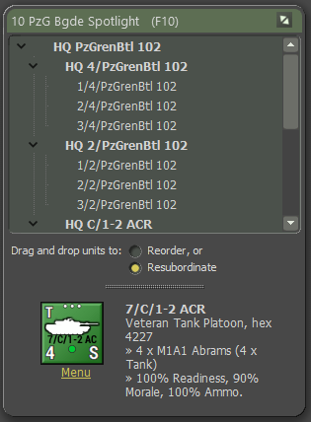

This view, as noted above, combines both windows into a single dialog view with all the information noted above. You can adjust the size of both windows within the dialog by dragging the splitter bar (1) up or down.

## Mini-Map Panel

The Mini-Map panel or Jump Map as it is called in many games, shows the entire map (greyscale), units (blue or red squares with a dark outline and in the case of the selected unit it is yellow), and objectives (white outlined blue or red squares).

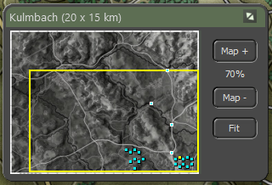

1. The top bar shows the name of the Map and its dimensions in parentheses.
2. This is the full Mini-Map in greyscale. Clicking anywhere on this map will recenter the visible map on the game screen.
3. The yellow outline shows what part of the map is currently visible on the screen based on the level of zoom currently selected and the location on the main map.
4. You can change the level of the map zoom up or down with these buttons.
5. The Fit button will zoom the game map out so all of it fits on the screen.

# Info View Panels

There are five additional information panels that you will use during the game for various functions. There are the Unit Popup Menu, Unit Dashboard, Sub-Unit Inspector, Command Log, and Off-Map Assets. The following sections will detail them all.

## The Unit Popup Menu

The Unit Popup Menu is the primary means of interfacing with the selected unit or units. Right-clicking on a unit will bring up the menu. You can also select multiple units and then right-click one of the units to bring up the menu. Any orders given to one selected unit will also apply to any other selected units.

### General Menu Layout

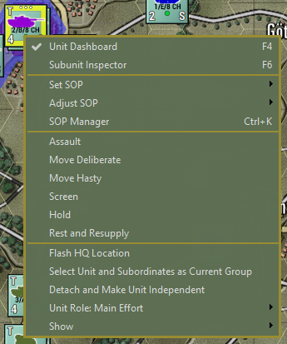

1. The first section provides a means to open the Unit Dashboard (See Section 14.2 below) or open the Subunit Inspector (See Section 14.3 below) for the unit right clicked on.
2. The second section of the menu has SOP-related commands. Set and Adjust SOP are covered in Section 11.5 above. The SOP Manager is covered in Section 23 below.
3. The third section of the menu shows all of the available orders for the selected unit. The selections will change based on the unit’s capabilities. See Section 21 below for details of the orders.
4. The fourth section of the menu contains functions related to unit Commands, Roles, and Overlays.

* **Flash HQ Location** – Flash the hex location of the unit’s immediate HQ unit.
* **Select Unit and Subordinates as Current Group** – This is a shortcut to select a formation of units based on a single selected unit.
* **Detach and Make Unit Independent** – Removes the selected unit from the formation and HQ it is under and places it as its force. For most subunits, it is better and safer to use the Order of Battle Tree to do subordinations see Section 20 below.
* **Unit Role**: - Displays the unit’s current role in the battle. Can be changed via the arrow and sub-menu that pops up. See Section 18 below.
* **Show** – Clicking the arrow with bring up a sub-menu with the Unit Overlay options. See Section 11.6 above for details on the various overlays.

## Unit Dashboard

The Unit Dashboard is the central interface for dealing with many important factors of the selected unit. Double-clicking a unit on the map will bring up the Dashboard. Having a unit selected and hitting F6 will also bring up the Dashboard. From the Unit Popup Menu, you can open the Dashboard via the menu item selection there.

### General Layout

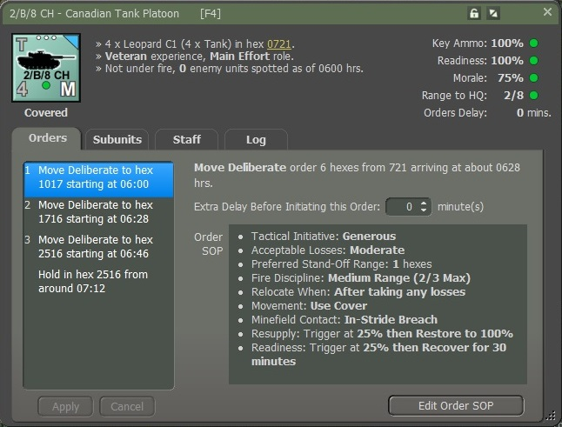

1. The top bar shows the name of the selected unit.
2. You can click the Lock to freeze the panel on the selected unit. The Expand/Collapse icon will collapse the tabbed section of the dialog to save space.
3. This area shows the counter of the currently selected unit. Below the counter is an indication of the current tactical posture of the unit.
4. This area of text relays the current SitRep (Situation Report) of the unit. This is the composition of the unit, the hex the unit is in (hyperlinked can click to go there on the map), the unit’s commander rank and name, the experience level of the unit, and the unit’s role. Finally, an indication of the unit is under fire and the number of spotted enemy units. In cases of critical alerts, like low ammo, a line will show up in this area noting the problem.
5. The information in this area covers the unit’s Critical Ammo level (primary weapons), Readiness, Morale, Range to HQ (local HQ for the unit), and any Orders Delay. The percentages from 100% high to 0% low and have status icons to the right. These icons are a green circle for good condition, a yellow upward triangle for marginal condition, a red downward triangle for critical condition, and finally, a black square for a combat ineffective condition.
6. The tabbed area covers the unit’s Orders, Subunits, Staff, and Unit Log information, as detailed in the following sections.

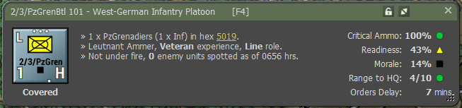

### Orders Tab

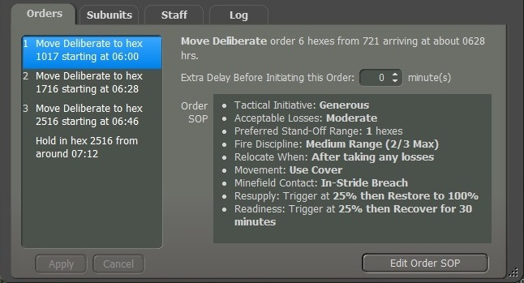

1. This window lists the unit’s orders noting the type of order, the hex location of the order, and the estimated start time of the order execution. As seen below, you can click to select any of the orders and then right-click to bring up a popup menu to change the selected order. The selection is context-sensitive based on the initial order.

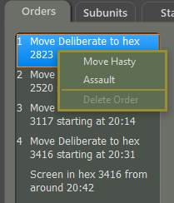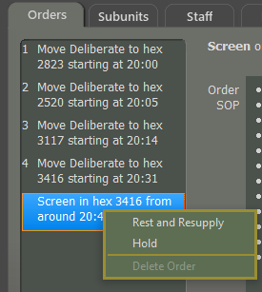

1. If you change an order(s), you can then hit Apply to make the changes or cancel to ignore changes.
2. This is a text summary of the currently selected order with time and distance information.
3. This option, when shown, allows you to add additional delay time BEFORE an order starts. This is useful if you are trying to synchronize units to get to locations at the same time.
4. This window provided a summary of the unit’s current SOP (Standard Operating Procedures) for the highlighted order.
5. Click this button to edit the current unit’s SOP. See Section 23 below for details on how to set the SOP items.

### Subunits Tab

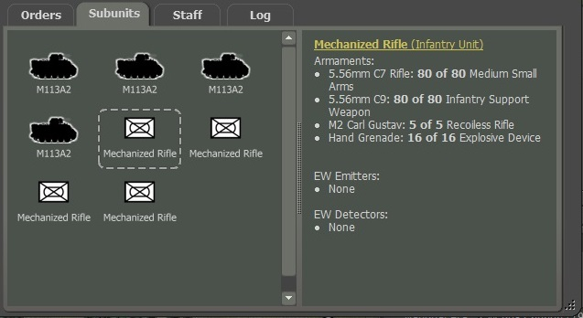

1. In this window, you will see all the subunits within the selected unit on the map. If there are more units than can be seen in the dialog, a scroll bar will be shown to allow you to see all the items. You can click on any of the subunits in the first window to display information about that subunit in the second window. If units have fallen out or have been destroyed or died, icons will appear over the subunit art, and the information in the second window will note that state.
2. This window shows a breakdown of the subunit's Weapons and current Ammunition levels, Emitters (radars) if they have them, or EW detectors (ESM or Radar detectors). The hyperlink at the top will open the Subunit Inspector (SUI) to see more details about the subunit.
3. You can move the splitter bar left or right to resize the windows.
4. You can resize the dialog by dragging the corner point. The dialog has a minimum size set by the game.

### Staff Tab

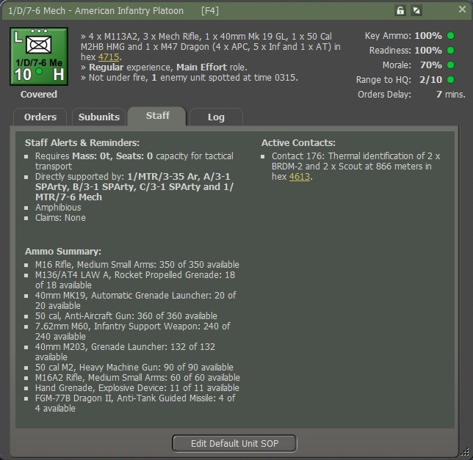

The Staff tab of the Dashboard provides many valuable bits of information about the selected unit.

1. Under Staff Alerts and Reminders, you will get information on weapons that are out of ammo, what artillery units can support this unit (if available), unique unit capabilities and any claims of enemy units destroyed.
2. Under Ammo Summary, shows the total ammo inventory for the unit in the Staff page of the Unit Dashboard to save clicking around to look it up manually.
3. Under Active Contacts, a list of detected enemy units is shown. Contact number, type of detection (visual, thermal, radar, etc.), number and type of units (if known), range of the contact, and a hyperlinked Hex location.

### Log Tab

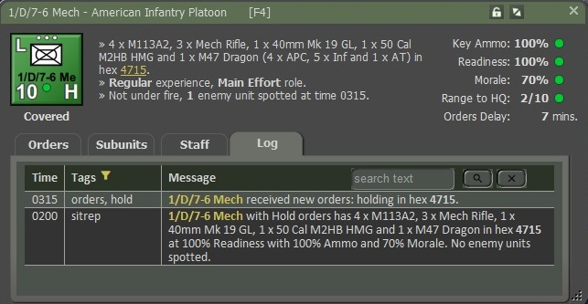

The Log tab lists messages that are recorded to the various unit logs, related to the actions of the selected unit. Both the game Time and Tag (type of message) are listed with the Message. On the face of it, Radio Logs/Unit Logs don’t look like much has changed. On closer inspection, you will see that all messages are not Tagged (instead of just some of them as before, unit names are highlights, and locations are given subtle highlights (just bold, no color).

Unit names you can now click on to take you to that unit if it’s not in the frame. You can also click on a location to go to that location on the map.

In the top right corner, there is a search field that filters the display down to just messages involving the desired text (searching for a particular unit or vehicle type). Search is case-sensitive.

The message Tag can be of the following types:

* **sitrep** – This is a breakdown of the current active subunits in the unit, hex location, unit readiness, unit morale, and average ammo level, and the number of spotted enemy units.
* **orders** – If the unit gets a new order or a change in orders, the new order is listed here with start and end times and hexes if available.
* **loss** – If the unit loses any subunits, they are listed here and the hex they were lost in.
* **spot** – This message notes that your unit has spotted an enemy unit, a temporary enemy bridge, a VP location, and other spottable items.
* **claim** – If your unit kills or believes it has killed enemy subunits, they will be listed in this entry with the number, type, and hex of the kills.
* **(empty)** – These entries are mainly updates on a unit moving to a new hex and the detail of the cover, concealment, and mobility of the hex moved into.

Another obvious change is the little filter icon next to Tags. Also, you can right click on it, or anywhere on the log, will cause a pop-up filtering menu as shown below.

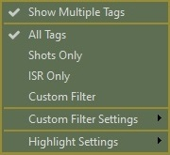

For convenience, the Tags column can be set to show only the dominant primary tag for a log entry, or to show all the tags that are in the entry.

We can now easily filter the logs by Tag type. If you want to see just the message that involves just bullets firing, Select “Shots Only”.

To see different set of things you want to be visible, then select Custom Filter Settings, a popup menu will have very large list of Tags. Uncheck the Tag types that you don’t want to see, and then once done set your filter to “Custom Filter”.

To set up different colors to make your tags stand out using different colors. Select the “Highlight Settings” and a popup menu with a very large list of Tags. For example, let’s say I want to see messages with the Tag “Mines”, select “Mines” from the list and you then can set the color for that Tag.

**NOTE:** Be Caution for you to not overdo it, it may be too hard to read the text.

## Sub-Unit Inspector (SUI)

The Sub-Unit Inspector is the primary tool for deep diving into all the information on a given sub-unit in the game. The following sections will detail all the various tabs and the information displayed. You can open this dialog with the F6 key for any selected unit.

### General Layout

1. You can click the lock to freeze this dialog or click the “X” to close.
2. Sub-unit name and then the type of sub-unit in parenthesis.
3. Unit Code of the sub-unit from the data file.
4. Sub-unit silhouette or image if available via mod.
5. National Flag or Emblem.
6. This listing notes the number of the selected sub-units that are Active, Fallen Out, or Destroyed in the current scenario.
7. The date unit is active in the game.
8. This is a five-tabbed panel that covers the Platform, Weapons, Sensors, Systems, and Transport that the selected sub-unit has. These tabs are detailed in the following sections.
9. If there is more than one type of sub-unit available based on the Scope chosen, you can use the controls here to page through them.
10. You can use the drop-down selections here to look at other national data files (Source) in the scenario and change the Scope from Selected Unit, Units in the Scenario, or all units in the data file.
11. You can use this icon to drag the SUI larger or smaller.

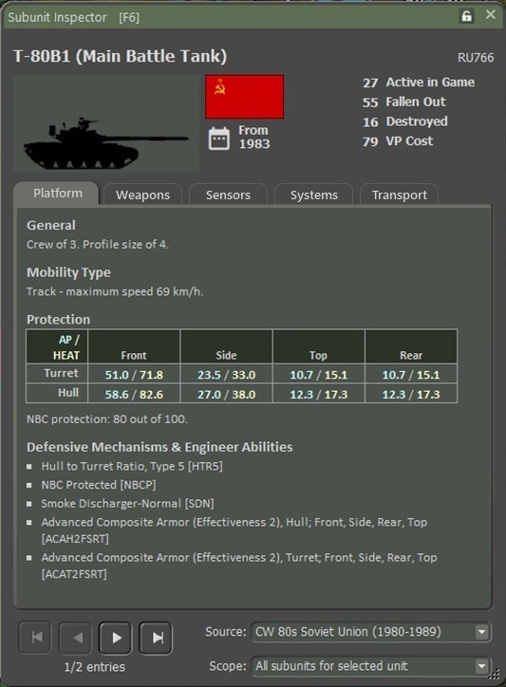

### Platform Tab

The Platform tab provides information related to the general capabilities of a given sub-unit. Here you will find the values for Victory Point cost, Crew size, Use date, and Size rating.

Then the Mobility Type and Maximum Speed.

Protection Ratings (Armor) for the Front, Flank (side), and Top/Rear of the sub-unit or a static Protection Factor for aircraft and helicopters are shown in this section.

Next, under Particulars is a listing of platform-specific characteristics/traits that it has that can impact gameplay, if available.

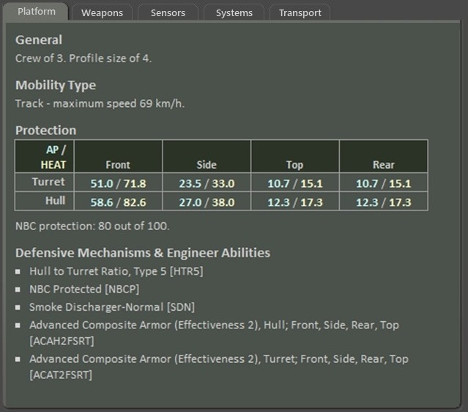

### Weapons Tab

Every weapon system on a platform/sub-unit is listed on this tab with its various performance parameters and any unique characteristics that the systems possess.

Shown are the Weapon Name and Type. Then the number of rounds or bursts of ammo carried typically (those values can be different in scenarios based on supply and munitions loadouts). The damage rating for the weapon or munition is shown with its type. Lastly, the maximum range in meters is listed. If the weapon system has any unique characteristics used in the game, those are listed after the munition specifications.

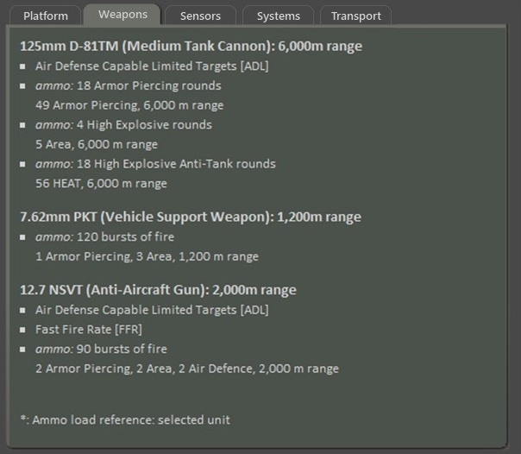

Basic Ammo comes in various types as noted below:

* **Armor Piercing (AP)** – These are solid, long-rod projectiles used to defeat armor.
* **High Explosive Anti-Tank (HEAT)** – This round uses an explosive charge to create a plasma jet that cuts through armor.
* **High Explosive (HE) –** These rounds use a blast fragmentation warhead and affect an area.
* **Area -** This type of damage reflects weapons that impact an area and are used against soft targets that cover an amount of ground.

### Sensors Tab

The Sensors tab shows all the equipment on a platform that is used to detect, spot, or range enemy units on the map. If a system has detection capability, it will list the ranges (under optimal conditions) that it can Detect an enemy unit, Classify the type of enemy unit, and identify the sub-units of an enemy unit. Other Sensor systems have an impact on combat calculations.

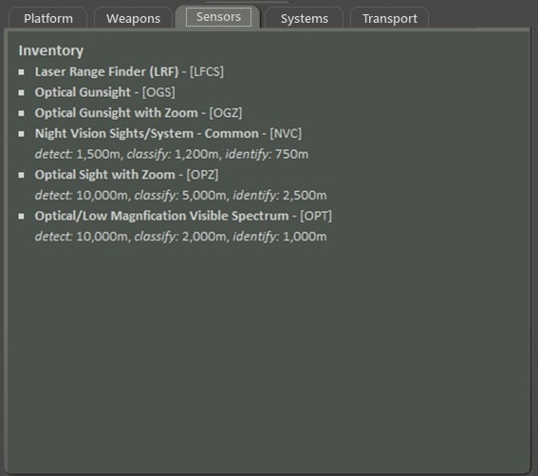

### Systems Tab

Any other systems that provide a unique capability not already covered in the other tabs will be noted here.

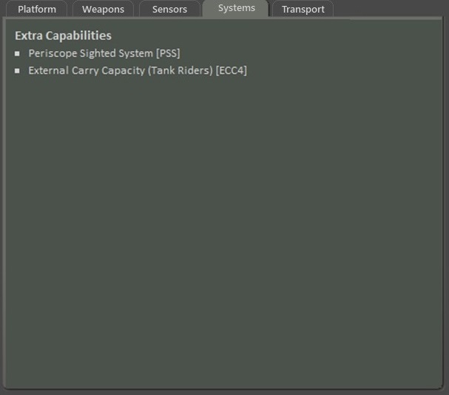

### Transport Tab

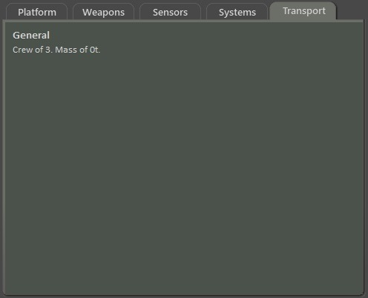

The Transport tab shows all the transport capability on a platform that is used to provide a unique capability not already covered in the other tabs will be noted here.

### Further Information on Capabilities

To get more details on these various Capabilities, you can check out the information in FM02: Battlefield Primer and in deeper detail in FM09: Data Structures and Editing.

## Command/Unit Log

The Command/Unit Log is a dialog that shows all the latest Log messages for all units in your force. It will list the last 50 entries. You can dig deeper by looking at the Unit Log in the Dashboard for each unit. This dialog can be opened and closed on the screen with the F7 key. The dialog does allow for expanding and collapsing via the arrow’s icon in the upper right of the dialog.

A complete listing of log entries can be found in the Operations Report on the Log tab.

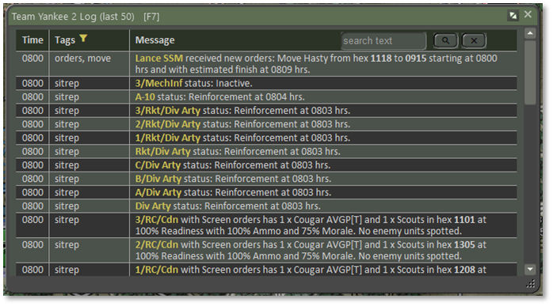

As the game unfolds, a series of messages are recorded to the unit logs with a time stamp, a “tag” or type of log entry, and then the text of the entry.

### Log Capabilities

* All messages are now Tagged (instead of just some of them as before)
* Tags are now filterable (see below)
* Unit names are highlighted to make them easier to find and hotlink to the Dashboard
* Locations are given a subtle highlight (just bold, no color) and are hot linked to flash on the map
* The log is searchable – see the top right corner
* Highlight colors may be specified by tag type so that specific tags can be emphasized or de-emphasized (see below)

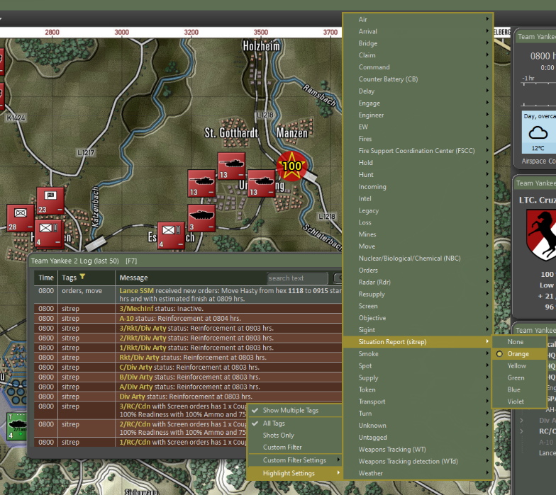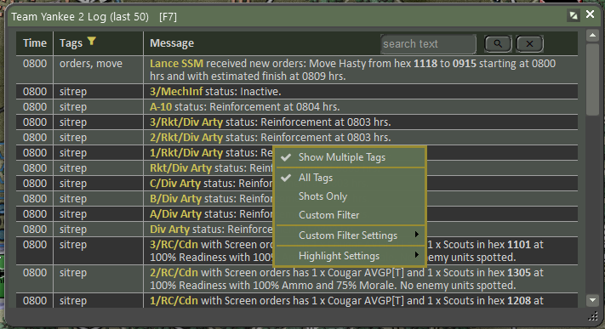There is a new filter icon (a yellow funnel icon) next to the “Tags” column header. Right-click on it, or anywhere else on the log, to pop up the filtering menu.

For convenience, the Tags column can be set to show only the dominant primary tag for a log entry, or to show all tags.

**Filtering**. The log can be filtered by Tag types. To see just the messages that involve bullets flying, use the “Shots Only” combat filter. For further customization, use the “Custom Filter Settings” popout to uncheck the Tag types you don't want to see, and then set the filter to “Custom Filter.” You will not see messages you don't care about.

**Highlight Settings**. The highlight settings are a way to make the tags you want to stand out using different colors. Use with care! It's all too easy to set everything to have a highlight color and become dazzled by the beautiful but unreadable Christmas tree-like effect that results.

This new system is used everywhere we show the unit logs – this log, the unit dashboard, the counter-battery screen, and the TOC Ops Unit Logs report.

If this dialog has the Windows focus, then it can be closed by tapping the Escape key.

## Off-Map Assets

The Off-Map Assets dialog provides you with a listing of any of your forces that exist off-map for the scenario. This is currently an aircraft or artillery asset in a scenario that you can order to support your on-map forces. As you can see in the dialog below, this shows the headquarters and an artillery battery located 2km off the West edge of the game map.

1. Name of the overall force being supported by the off-map assets.
2. Name the smaller off-map asset formations available to use.
3. The counter of each supporting off-map unit, name, type, size, training level, and off-map location of the unit
4. Menu hyperlink that will open the Unit Popup Menu so you can issue orders to these off-map assets.
5. This text block tells for each unit what its Current Orders are, Readiness, Morale, Ammo levels, and current Delay for orders to process.
6. This second text block shows the unit’s composition by platform and type and then a breakdown of the ammo carried by the unit.

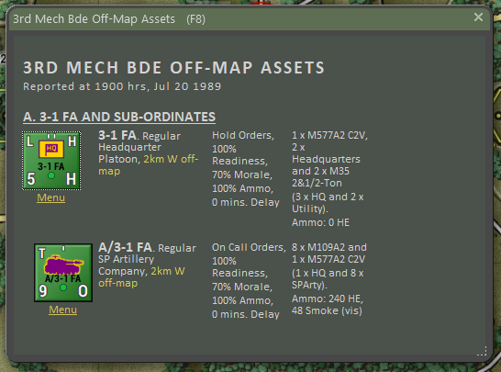

# Staff Dialogs

One of the areas in the game that has had a massive increase in information for the player is Staff Reports.

These reports cover all aspects of your virtual Command Staff and should be used to help formulate your battle plan and to keep tabs on various aspects of your force, and the battle as the scenario unfolds.

These reports can be accessed from the Staff Main Menu item at the top of the screen (see Section 11 above) or from the speed buttons on the floating Commander Panel (see Section 13.2 above).

At the bottom of most of the dialogs are buttons for Print and Close.

Print will open a Printer Dialog box and allow you to print out what is on the tab to your printer or other printout options if available. The Close button will close the entire Staff Report.

## Scenario Information

The Scenario Information (SI) dialog provided information on the Scenario Description and the Victory Status and Conditions information.

### Scenario Description

The Scenario Description tab provides a detailed narrative of the scenario to be played. This provides some background on the events of the battle and an idea of the forces involved in the fighting.

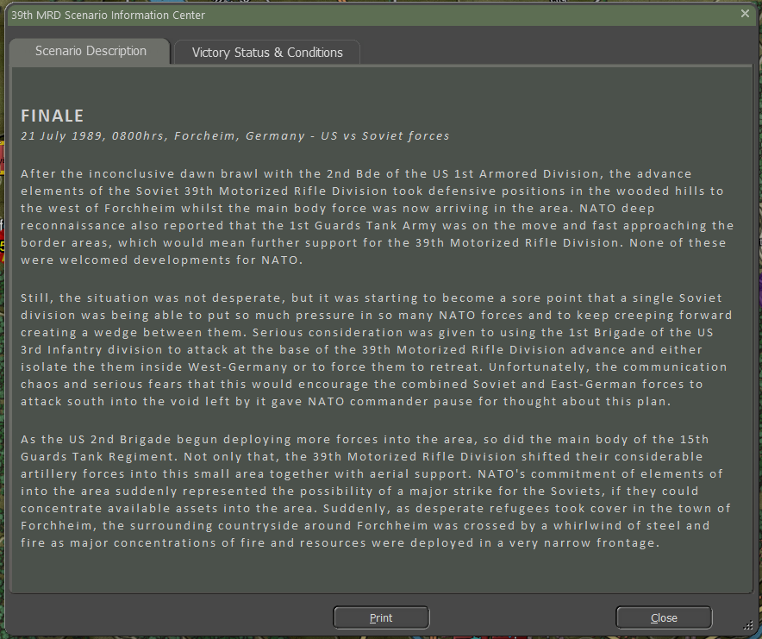

### Victory Status & Conditions

The Victory Status and Conditions tab contains sections of information that detail or estimate if the game is in progress and how the current scenario is going.

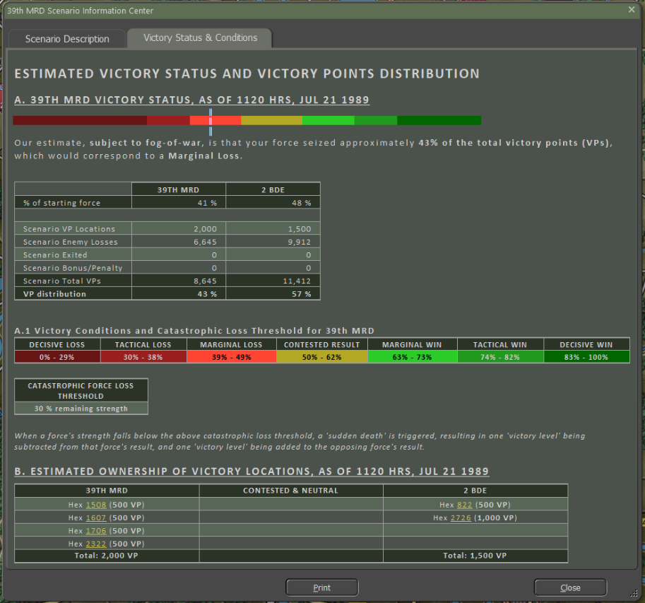

1. A graphical representation of the currently estimated victory level and a brief explanation below it.
2. A table breakdown of victory point (VP) allocations by type for each side of the battle. VP percentages are shown in the last line.
3. This bar shows the Victory Conditions level based on the percentage of VPs in the scenario.
4. This table shows the Catastrophic Force Loss Threshold for your force strength.
5. This table lists the ownership and value of all on-map VP locations.
6. This area has the Print and Close buttons for the report dialog.

## Operations

The Operations Reports (Ops) provide a wealth of information about your forces and capabilities, show your mission orders, and provide a view of the map and your force placement.

### Mission Briefing

The Mission Briefing tab provides all the information for the current scenario.

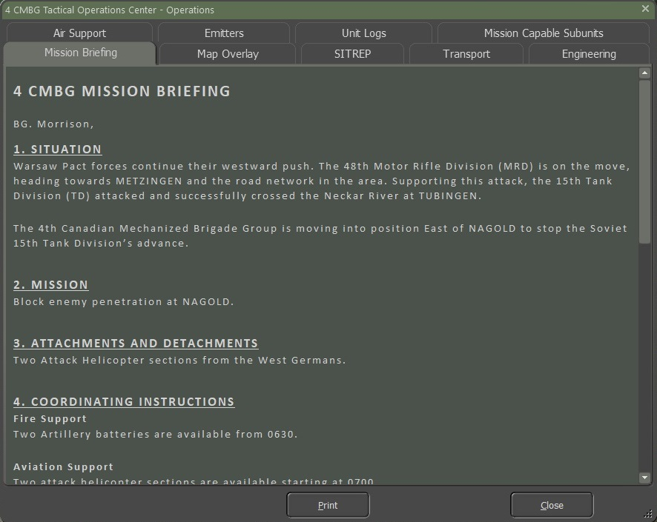

1. The Situation for the mission is stated in this section. The Mission objective(s) are noted in this section.
2. This section notes any additional forces added to your core forces to support the mission.
3. This section lists any Aviation, Fire Support (on and off-map artillery), and engineering assets for the mission.

As seen below, the map and the location of known Victory locations are shown.

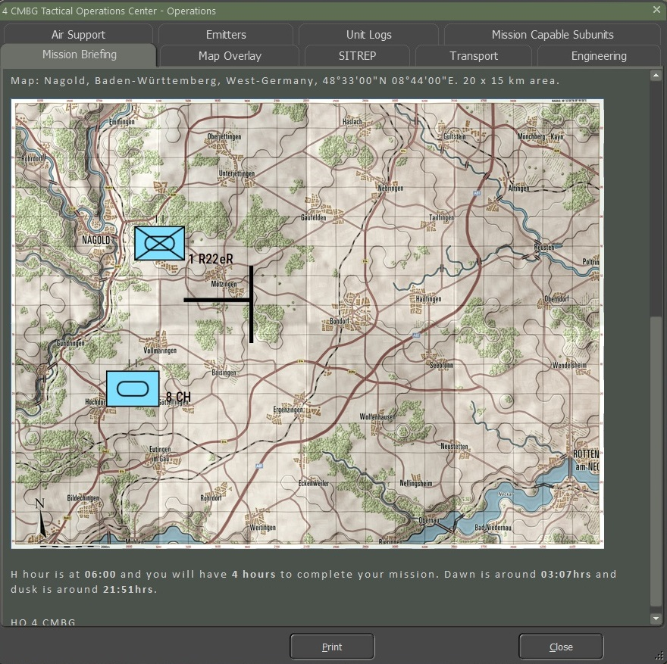

### Map Overlay

The Map Overlay tab shows the location of your forces and any spotted enemy forces. This map updates in real time as the battle unfolds.

Below the map is a listing of all your on and off-map headquarters (HQs), their number of subunits, and the location of the HQs.

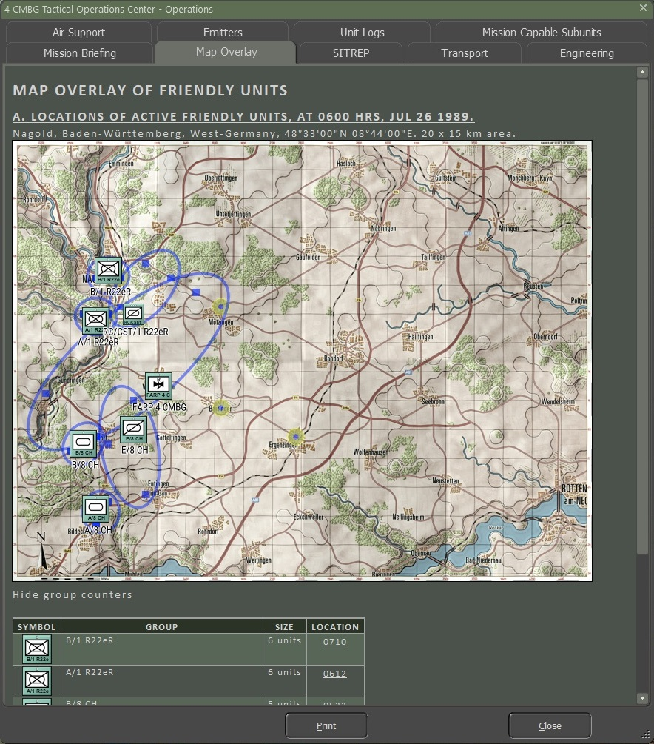

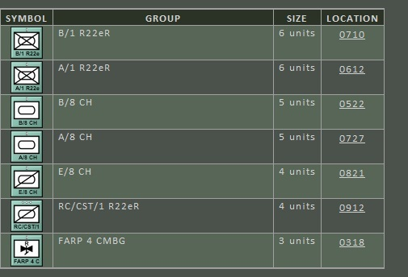

### SITREP

The SITREP (SITuation REPort) tab has a graphical representation of your command cycle times (past, present, and estimated for the future) in Section A.

Section B lists the number and types of subunits in your force, followed by a detailed breakdown of your forces by unit. This breakdown includes the counter, unit name, local leader name, type, and training level of the unit and the hex it is in. Also noted are the unit’s readiness, morale, and ammo levels. Lastly, a breakdown is shown by platform and unit type.

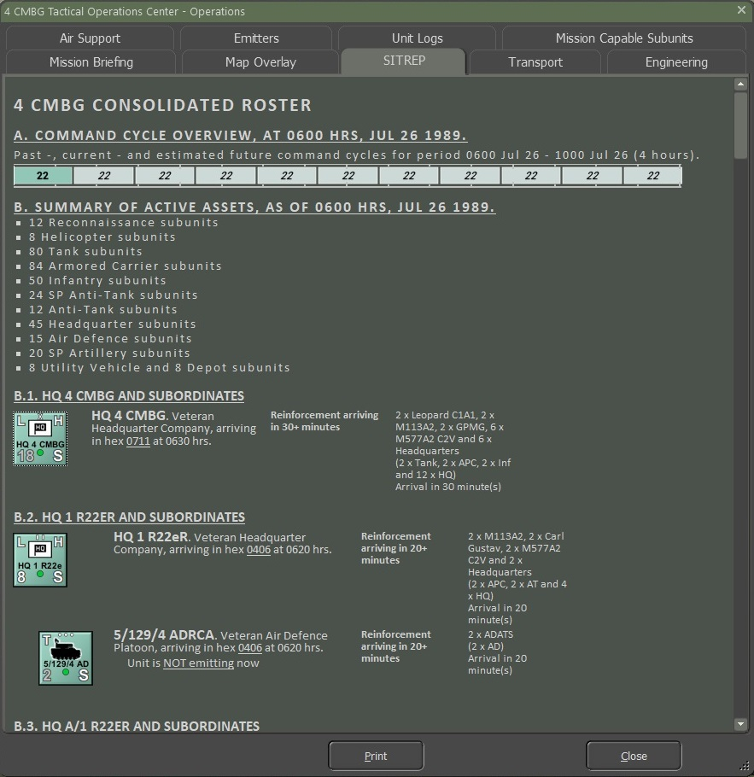

### Transport

The Transport tab provides information about any transport assets you have in your force. It covers air, ground, and naval tactical transport which can give the players both an overview and hyperlinks to jump to specific units.

Section A, Air Transport Operations

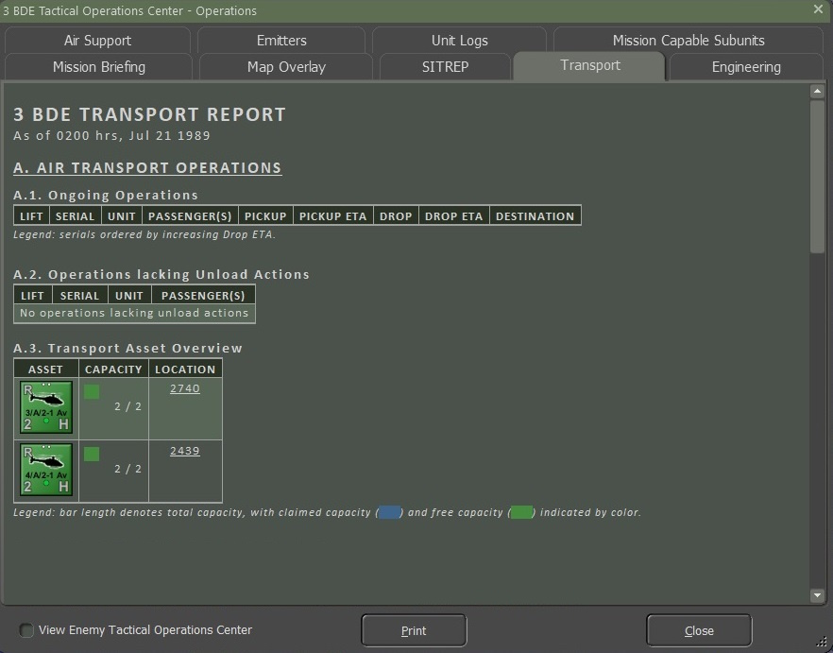

Section B, Ground Transport Operations

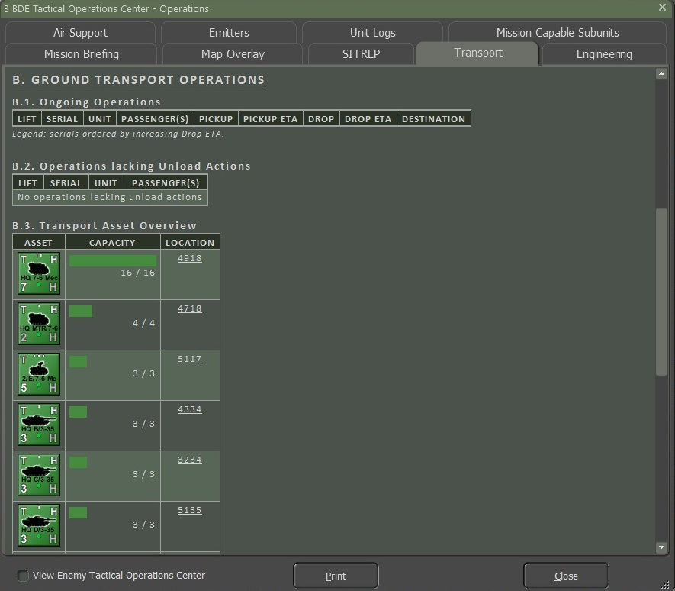

Section C, Naval Transport Operations (**NOTE:** Not in the game currently)

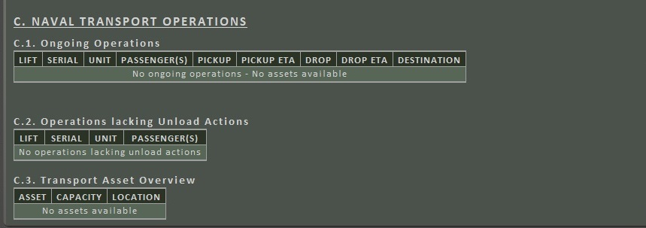

### Engineering

The Engineering tab provides information about any Engineering assets you have in your force.

Section A notes the HQ name and hex location.

Section B lists out the dedicated Bridging, Mine Clearing/Laying, and General engineering vehicles or troops at your disposal.

Section C shows any planned or ongoing engineering activities on the map.

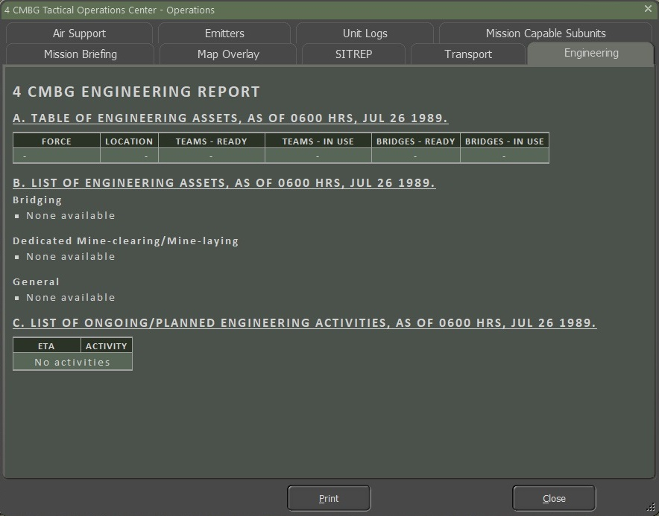

### Air Support

The Air Support tab provides information about any available aircraft that you may be able to call in to support the battle.

Section A describes the current situation, including Air Superiority level (who controls the airspace over the battlefield), time of day, and current weather.

Section B lists all Air Assets you have at your disposal (if available in the scenario). The counter, type of aircraft, arrival time if the unit shows up after the start of the scenario, withdrawal time if a unit is called away later in the scenario, if the aircraft is night operations capable, and if the unit can fly in bad weather are shown in the panel. If there is a capability issue, the table cell will be filled in with a red color.

Section C provides an hour-by-hour breakdown of the Airspace Control and weather (type of weather, visibility, cloud ceiling, and illumination level). If there is a weather-related item that poses a problem for aircraft use, the cell will be filled in red.

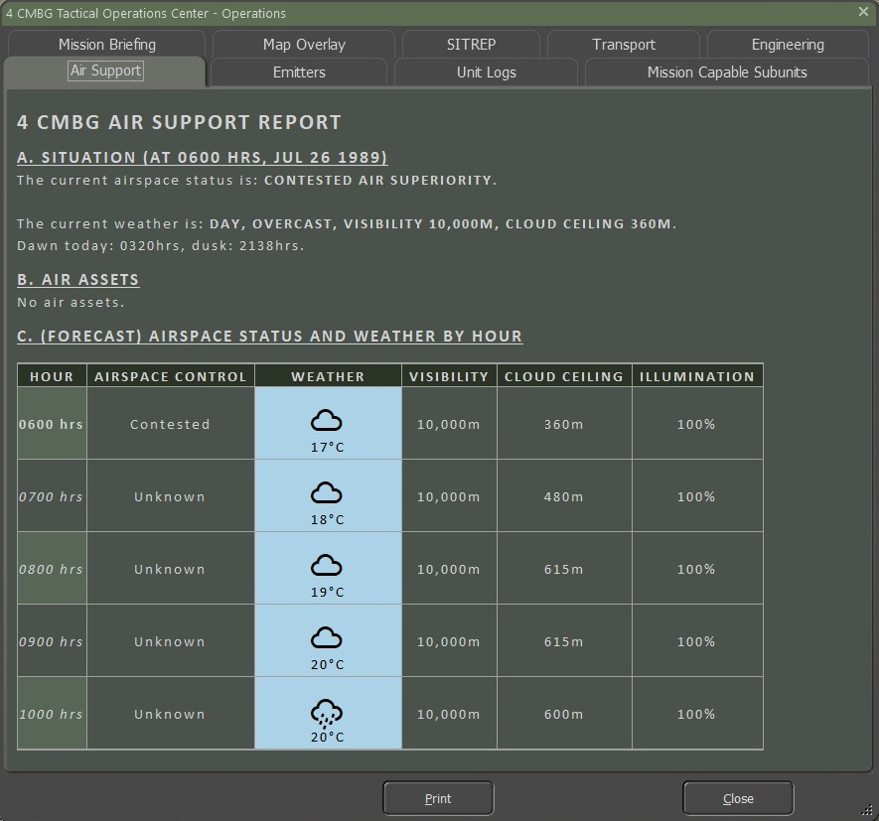

### Emitters

The Emitters tab provides a detailed breakdown of any units with electromagnetic emitter equipment like radars. Of note, the status of the emitter is shown in a hyperlink that you can toggle on and off from this report. The type of emitter is described on the far right of the detailed information.

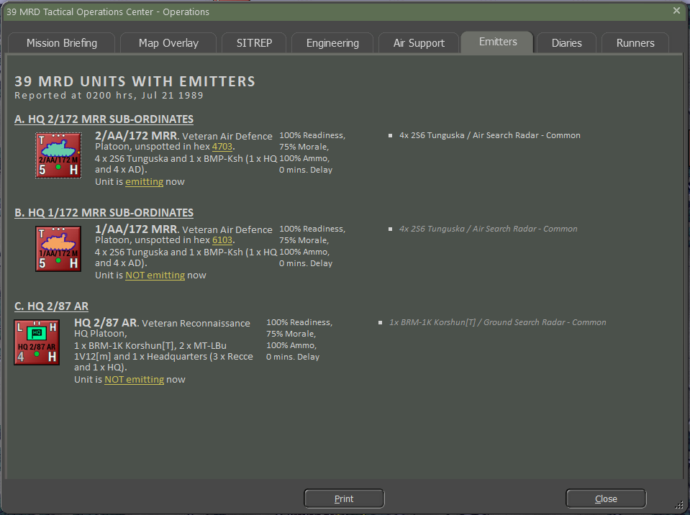

### Unit Logs

The Unit Log tab of the Staff Reports lists all the information entries from the Command Log for all units of your force. By selecting a unit in the order of battle (OOB) list in the left window, all related log entries will be shown in the right window of the dialog. This window can be scrolled to see all the scenario events.

Under the OOB window is an option to Show Combined Diaries. Selecting this will show all unit entries in chronological order in the right-side window. The total number of entries is also noted in both modes.

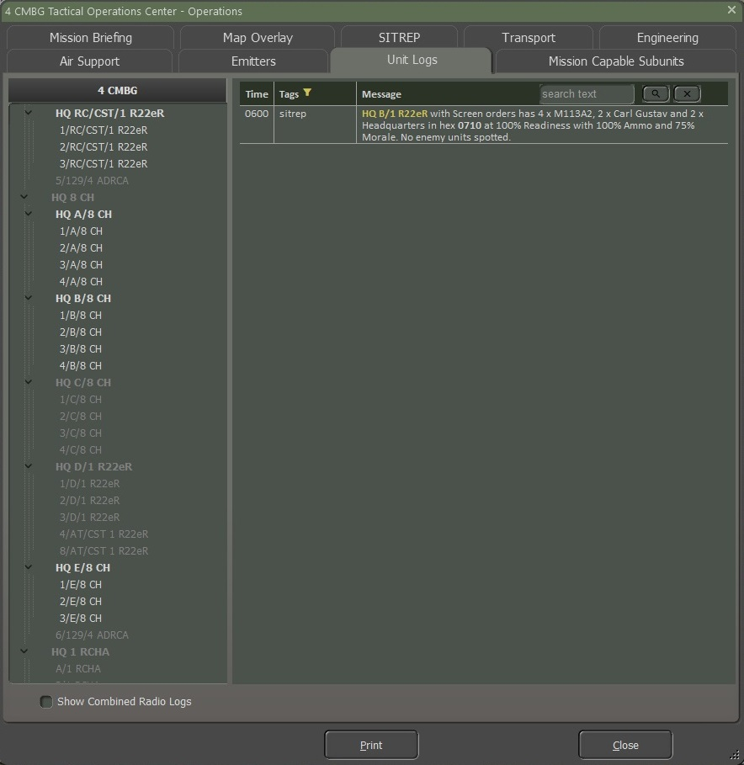

### Mission Capability Subunits

The Mission Capability Subunits tab provides information on the number of subunits by type and by platform type to give you a clear picture of how your force is doing at the current time in the scenario.

Section A is a graphical representation of the number of units of each type under your command. The dark bar portion represents those units still active out of the total number in the light bar. The totals and types are in the column on the right.

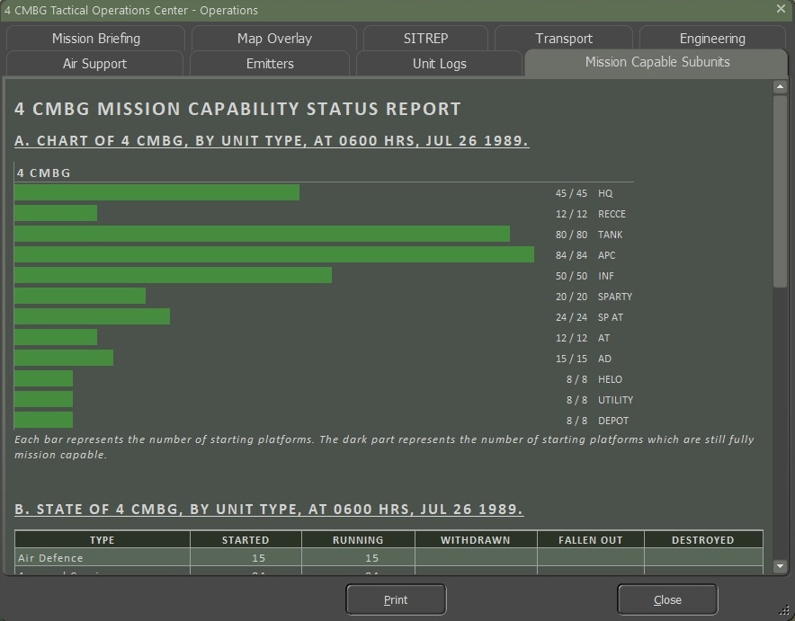

Section B is a tabled representation of your forces by type. The table notes each Type, the number of units that Started the scenario, those still Running, any units Withdrawn, any units that have Fallen Out (damaged/wounded and no longer combat effective), and those Destroyed (brewed up or killed).

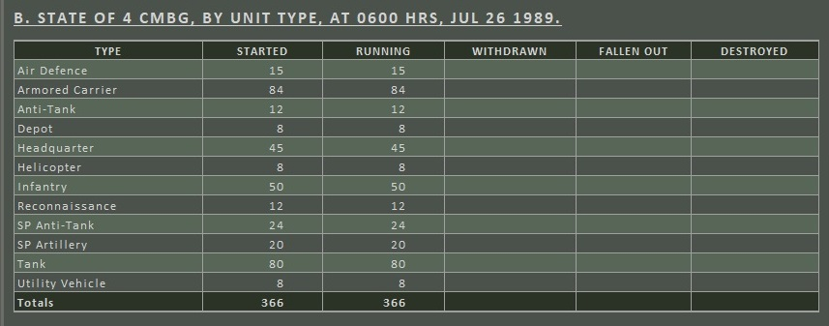

Section C is a similar table to Section B, but by each platform by name and description.

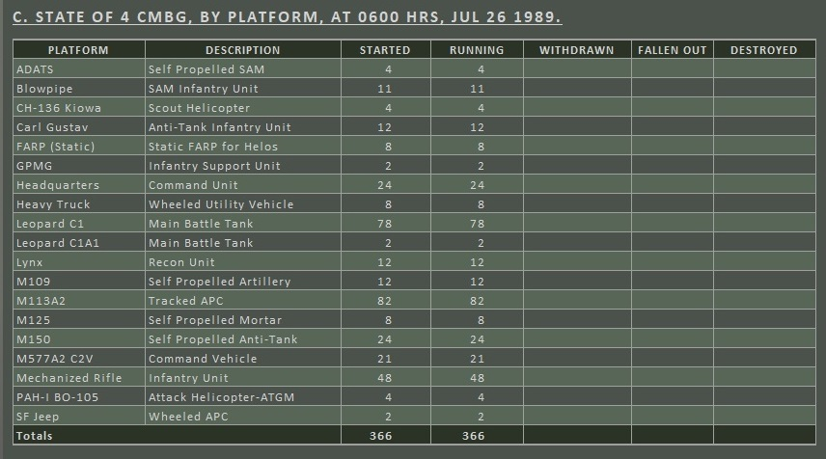

## Intelligence

The Intelligence Reports (Int) provide information about your enemy’s forces and capabilities, kills, and claims against the enemy, and other factors that impact your ability to fight effectively.

### Threat Assessment

The Threat Assessment provides you with your Intel section assessment of the enemy forces you will be facing during the battle. Along with the Threat Brief, you are given the map with graphics with the best estimation of what the enemy’s plan may be. This should help with your planning for what you will do with your forces to complete your mission.

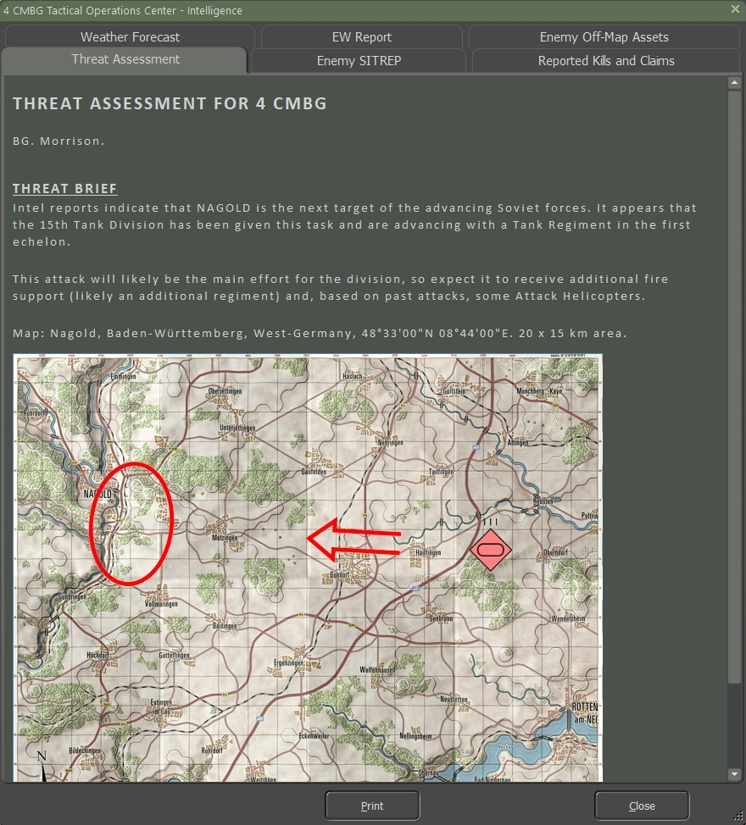

### Enemy SITREP

The Enemy SITREP tab provides information on the estimated state of the enemy forces.

Section A provides an estimate of the enemy’s Command Cycle for the past, present, and future cycles.

Section B shows the game map and the estimated locations of known enemy forces. The circles show a rough idea of the dispersion of those specific enemy units. This map is updated in real time as more information is gained during the fight.

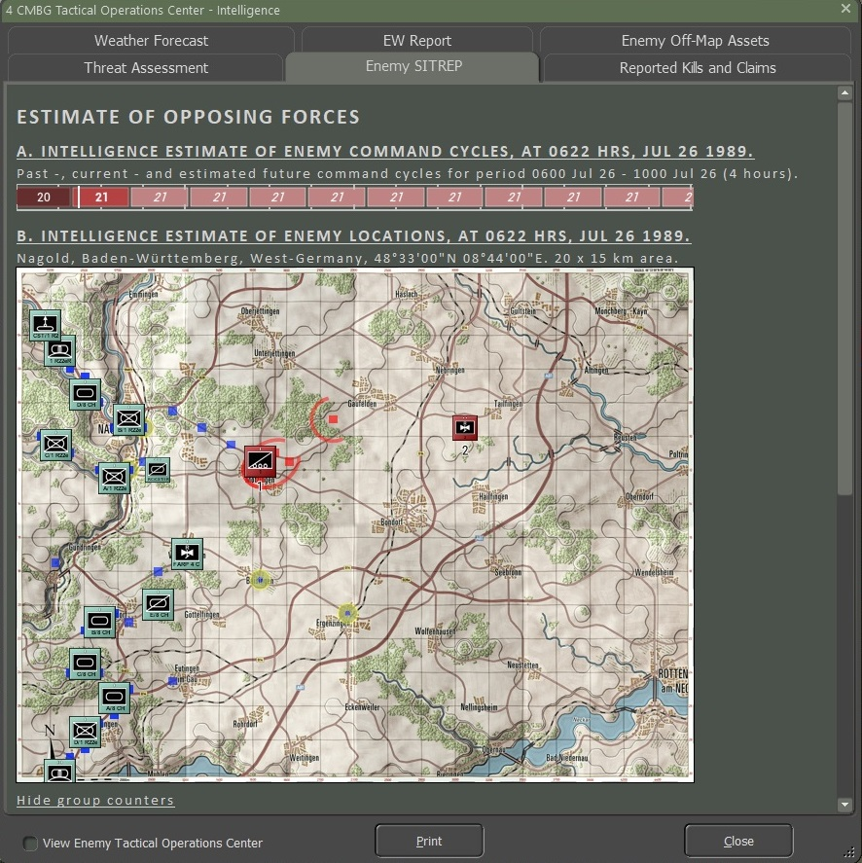

Below Section B is the listing and breakdown of the spotted enemy units. The size of the unit and a hyperlinked hex location are also shown, and the numbers in the left-hand column match those shown on the map. If an off-map unit has been detected, it is also noted on the list but shown as an Off-Map with a distance and direction.

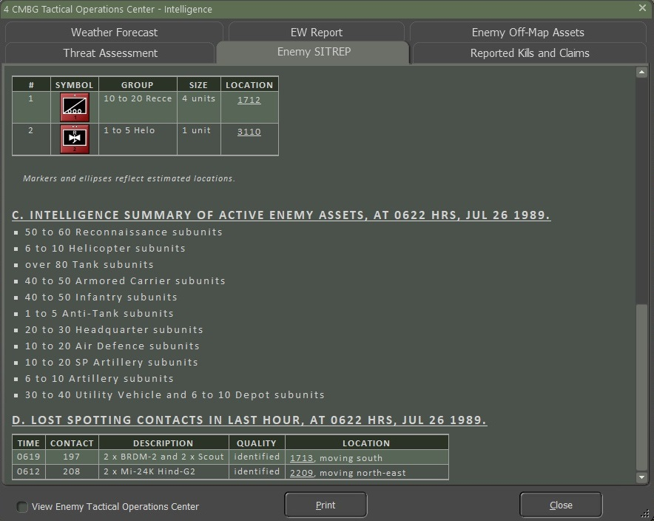

Section C provides a range of numbers and types of enemy units that you may face in the scenario. This gives you a starting point for being able to track enemy losses and an idea of the number and type of threats you will be facing.

Section D provides a list of lost contacts over the last hour of the battle. This list shows the time of the contact, a contact number for tracking, a description of the contact based on the quality of the detection, the Quality of the contact (Classified, Identified, Detected, or Radar), and the location of the lost contact. Contacts are lost when the unit moves out of the line of sight, or your units move or are lost and lose the line of sight to the target.

### Reported Kills and Claims

The reported Kill and Claims tab provides a table tracking what your units have killed during the scenario.

The Unit column lists all your units.

The A/F/D column notes which of YOUR units are still Active, Fallen Out or Destroyed.

The remaining Unit Type columns represent the enemy’s forces and the number of kills (or fallouts) your forces are claiming.

At the very bottom of the table is a line with the grand totals for the A/F/D and enemy types columns.

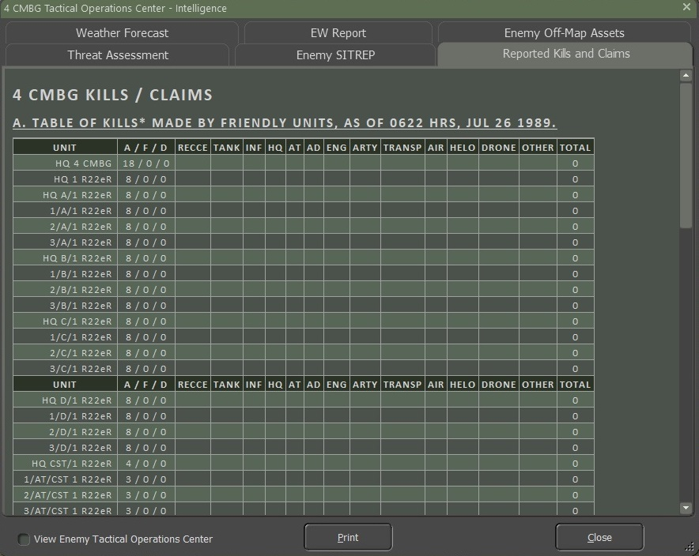

### Weather Forecast

The Weather Forecast tab provides you with information and any impacts on systems of the weather for the scenario. Weather can have a significant impact on combat operations, and you, as the commander, should plan accordingly.

Section A provides details on the weather forecast for 24 hours. The time in hours of the weather conditions, along with Temperature, Cloud Cover, Precipitation if any, Wind speed and direction, Visual distance, Illumination range, and Cloud Ceiling, are listed in the table.

Section B notes the Time of Day for Dawn and Dusk, and the phase of the moon for night illumination.

Section C provides information on the impact on specific systems (Artillery, Air Defense, and NBC Operations) based on the weather at different times of the scenario.

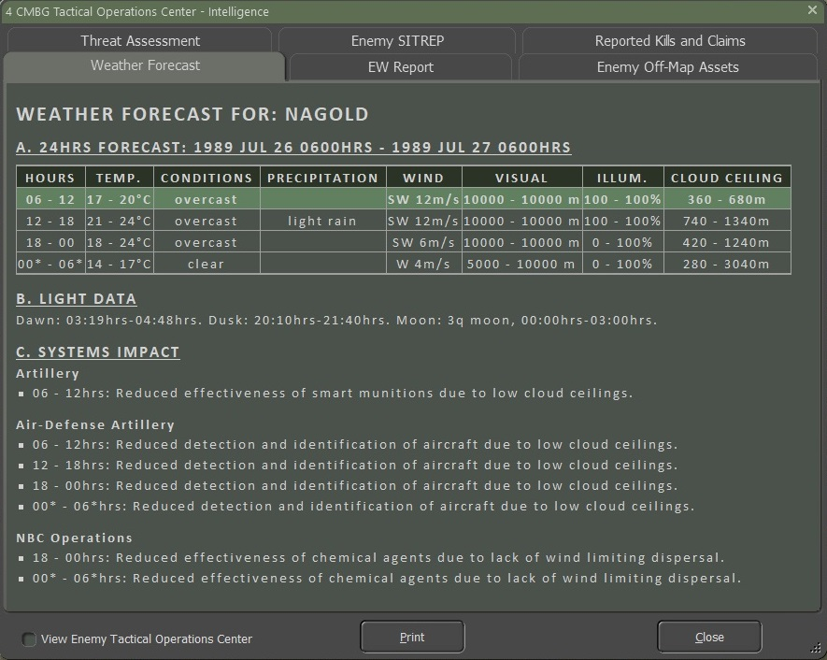

### EW Report

The EW (Electronic Warfare) tab provides information on the level of your EW efforts and what the enemy is doing to you currently.

EW disrupts your communications with your troops, adding additional delay to issuing orders. The higher the hindrance, the longer the delays.

Section A details both your EW level versus the enemy and the effects of the enemy EW on your forces. The main impact is a delay in your command cycle.

Section B graphs out the level of EW for both sides (yours in blue) hour-by-hour for the scenario.

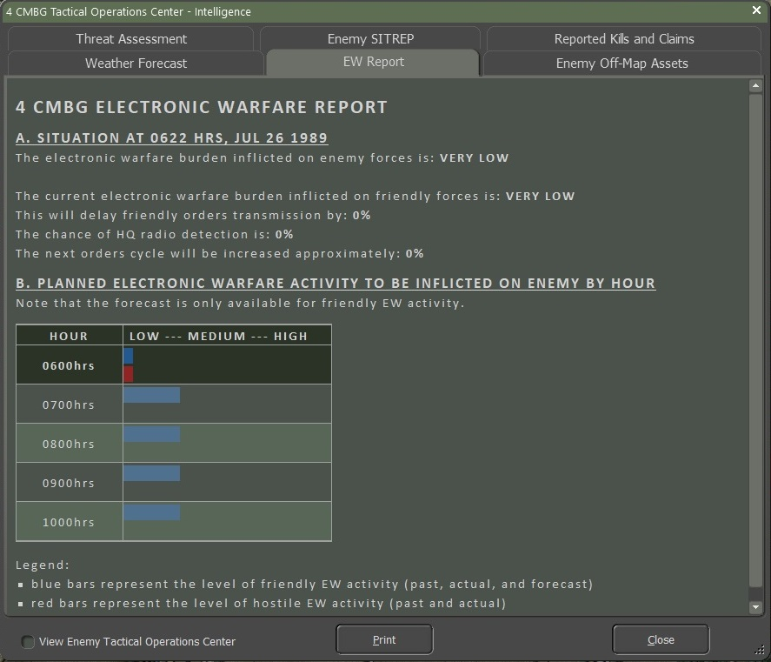

### Enemy Off-Map Assets

The Enemy Off-Map Assets tab will list any units the enemy has off-map that are detected by radio intercepts, counter-battery radar, or other recon sources provided by friendly forces outside of your command. These units are being used against your forces.

Currently, those off-map assets are long-range artillery units. More types may be added in future updates.

If you have long-range artillery or airpower, you can target these enemy units.

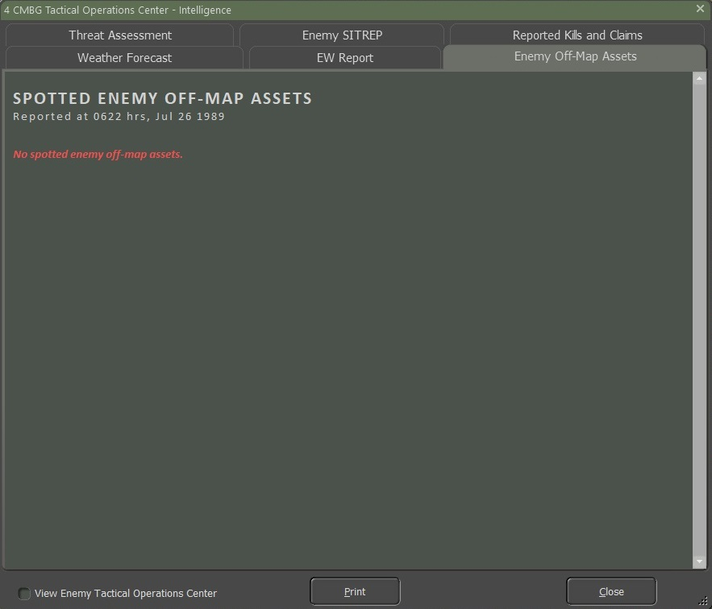

## Personnel and Logistics

The Personnel and Logistic Reports (PL) provide information about the condition of your forces, when new units will arrive on the map and when other units on the map will leave, and the overview of ammunition use and quantity for your forces.

### Staff Alerts

The Staff Alerts tab warns you about any units suffering problems that degrade their ability to fight and maneuver on the battlefield.

This includes the following problems:

* **Out of Command Range –** Impacts resupply and adds delays to orders being done.
* **Low Morale, Readiness, or Ammo** – These can impact the effectiveness of fighting the enemy.
* **Insufficient Transport** – Leg units no longer have carriers to move them quickly across the battlefield.

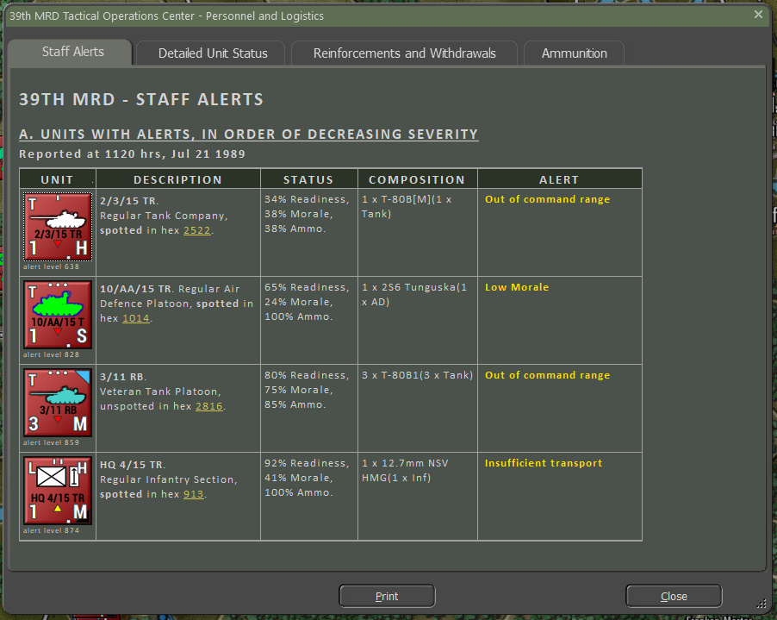

### Detailed Unit Status

The Detailed Unit Status tab provides an order of battle (OOB) listing in the left windows where you can select a unit and then, in the right window, see the counter with the unit’s name, training, type, and total victory point value. Readiness, Morale, and Ammo percentages show next, along with hyperlinks to the unit’s headquarters and hex location. Then detailed information about the subunits is shown.

Below that, you will get the breakdown of subunits by name and type, plus the current number of Active Runners, Fallen Out, and Lost units. Next, there is a silhouette of the unit and its VP cost. Next is the type of mobility and top speed of the unit. Then a listing of basic protection values (for more detail, see the armor values in the Subunit Inspector (SUI-F6 key). The number of Crew and the Date of use is also listed. To the right of the information is a listing of the subunit’s armaments and special capabilities. At the very bottom, there is a listing of units claimed as destroyed.

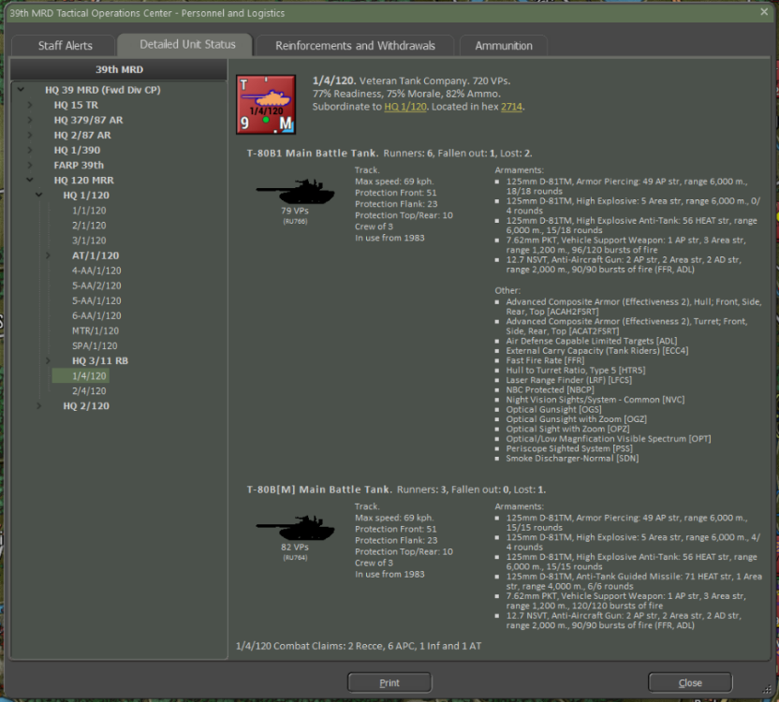

### Reinforcements and Withdrawals

The Reinforcement and Withdrawals tab provides an order of battle (OOB) listing in the left window that shows the arrival or withdrawal time of units throughout the scenario. Selecting a unit in the right window will provide a subunit breakdown and details, as seen in Section 15.4.2 above.

Of importance in the right window is the time of arrival or withdrawal and the hex the unit will enter the map. Clicking the hyperlink for the location will flash the hex location on the map.

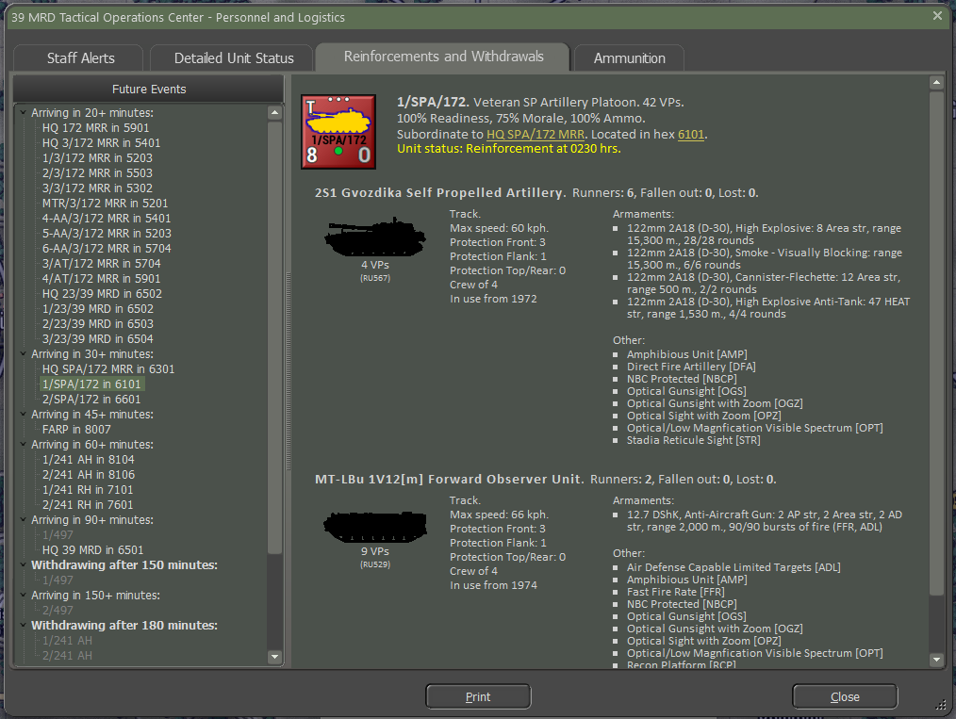

### Ammunition

The Ammunition tab provides a means for you to track and review a unit’s ammo use and remaining rounds by weapon and by munition for weapons that use multiple types. This report is updated as the scenario unfolds.

Section A runs down the Overall Ammunition Status of your force.

The table shows the weapon system and description, the basic starting loadout of the ammunition, the current number of rounds/bursts on hand, the percentage on hand, and the number of rounds or bursts expended.

Information in yellow is from units and subunits that have fired and expended ammunition. The values in white are units that have not engaged the enemy. Currently, there may be duplicated entries from different subunit types with the same weapon system (the 125mm D-81TM below being a case).

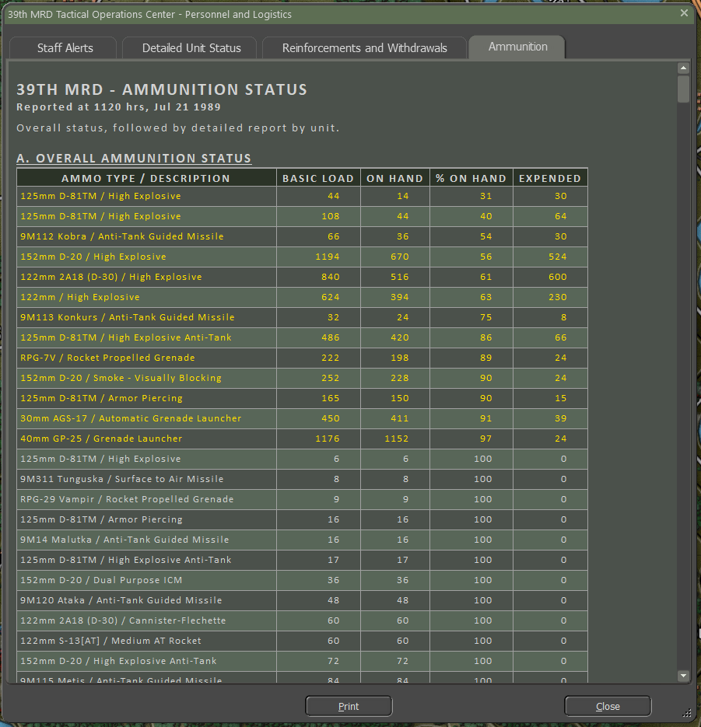

Section B Shows each unit and the ammunition for each significant weapon system (no small arms weapons listed). Each entry contains the unit’s name, unit composition, counter, and then the table showing each weapon system’s ammunition in the same format detailed in Section A above.

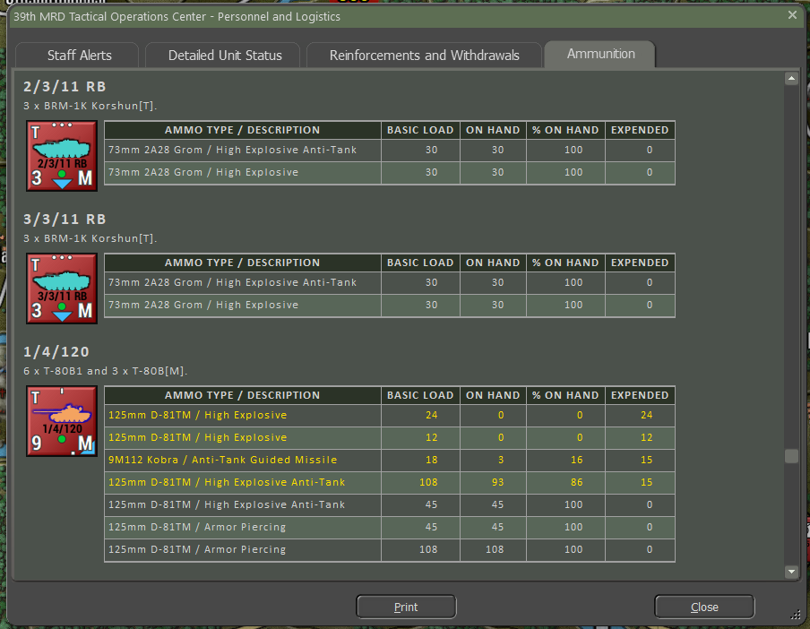

## Fire Support

The Fire Support (FS) Staff Report provides information about your artillery and air units available in the scenario, a listing of fire missions and strikes planned and in progress, and the fire missions in the Fire Support Control Center (FSCC) queue.

### Fire Support Assets

The various sections will note Mortars, Tube Artillery, Rockets, and Strike Aircraft assets available to use during the scenario. Each entry shows the counter. Under the counter is a Menu hyperlink to the Orders Menu Popup Dialog so you can issue orders to these units.

The first text block provides the unit’s name, training level, type, and size (artillery formations are normally called batteries), location (on map hyperlinked hex or off-map with distance and map edge), under FSCC control toggle via the hyperlink, arrival or withdrawal time if needed, and finally the unit’s local HQ.

The next block states the current Order and then the current Readiness, Training, and Ammo level percentages.

The next block of information shows the unit’s composition in detail and unit type and a listing of munitions available.

The last block notes the details of any Fire Mission currently in progress.

At the bottom is information on what units this fire support unit can provide fires for and the possible delay time for the call to be processed in the command chain.

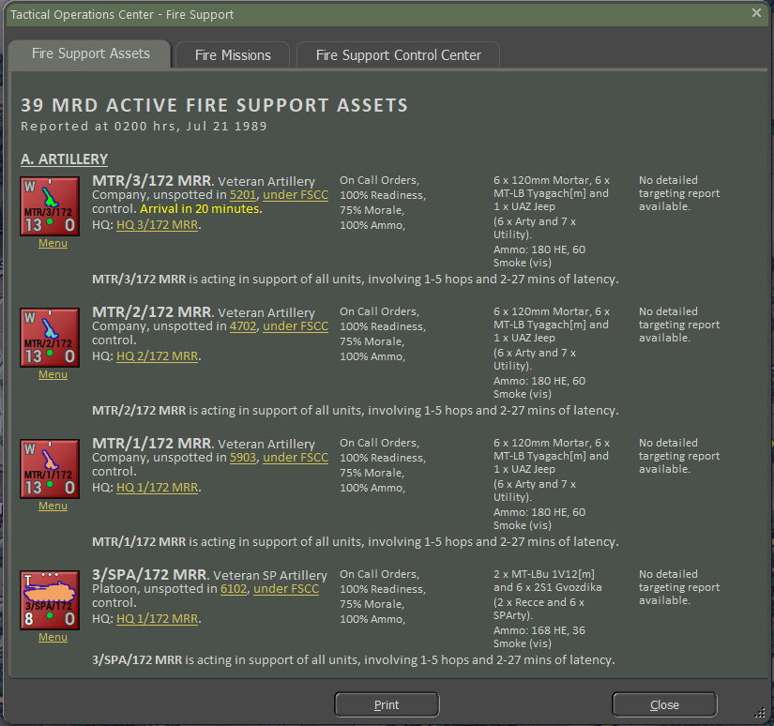

### Fire Missions

The Fire Missions tab shows a listing of all fire missions for your forces. The information shown in each entry is the Start and Finish time of the fire mission in-game time, the Status of the mission Active or Planned, the Contact number of the enemy if known/spotted, the Target, and its location if known/spotted, Type of Fire Mission ammunition being used, Rounds shows the total number of rounds to be fired at the target, Duration states the amount of time of the fire mission, Asset shows the counter-image of the firing unit, and Asset Status shows the average ammo percentage and unit readiness level.

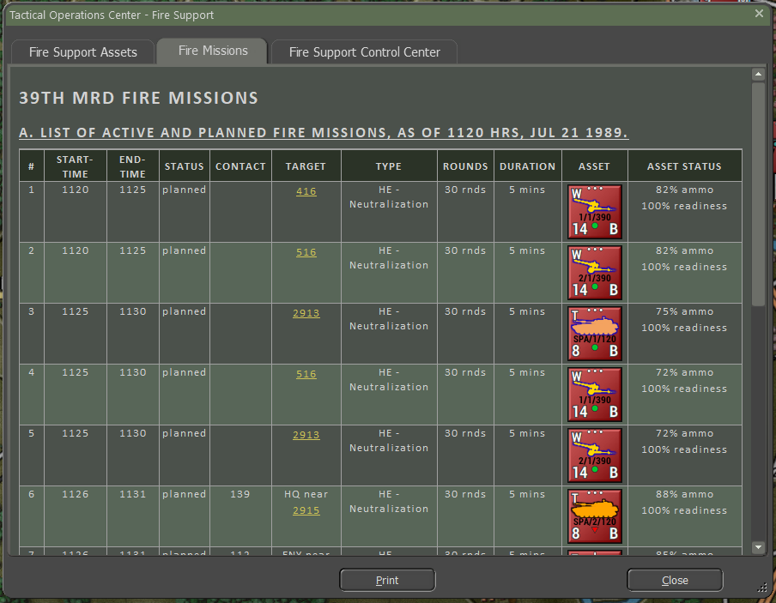

### Fire Support Control Center (FSCC)

The Fire Support Control Center tab provides a listing of all requested fires on targets that have been spotted or off-map targets detected for counter-battery fire. The information shown in each entry # is the ID number of the fire support request, Sent is the time of the request (if logged), Time is when the request is needed, Priority is a ranking of importance (higher is more important), Contact is the ID number of the target, Target is the type of target and noted if it is moving, Location is the hex or off-map info of the target, and Spotter notes which unit is making the request of the spotted target.

You can also use this listing to find targets for manually entered fires from your artillery by noting the hex locations and target types.

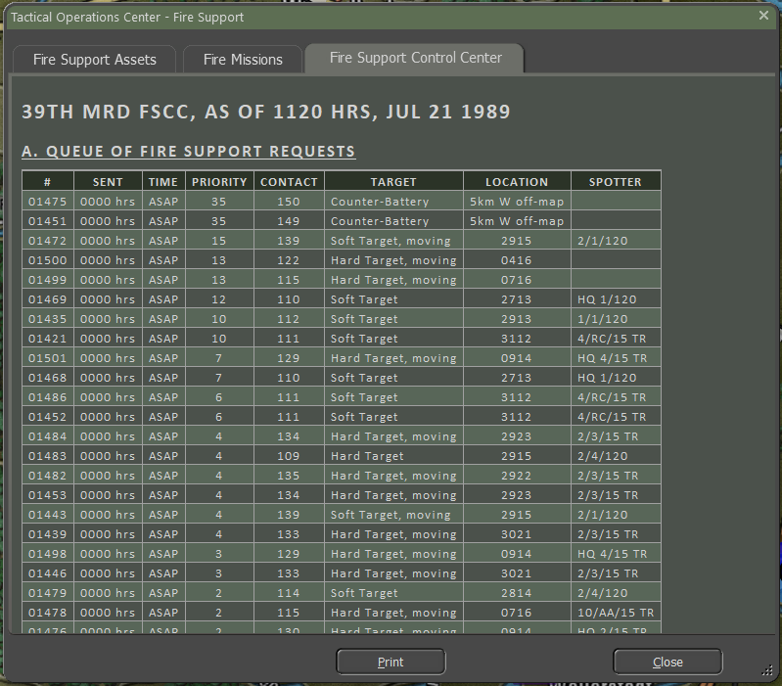

# The Game Map

All the action in the game takes place on beautifully rendered maps of real-world terrain. Each hex represents 500 meters of distance, hex face too hex face. The map shows terrain elevations, terrain types, roads, rails, and map markers. Knowing the effects of these elements is critical for success on the battlefield.

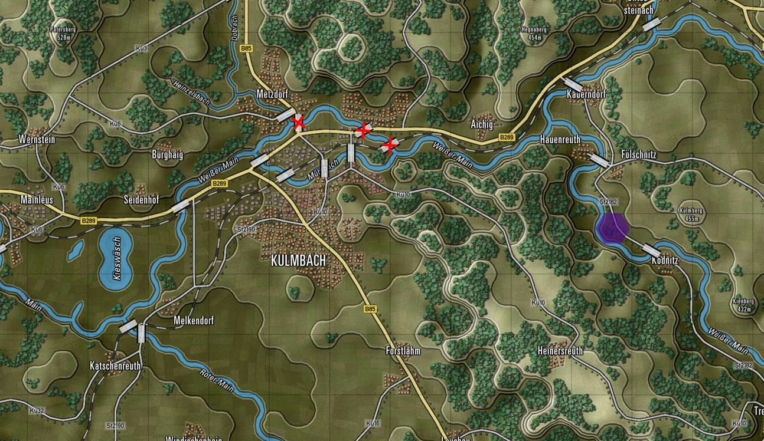

## Moving the Map

There are a few ways to move around the map during the game and they are as follows:

* Map scrolling by placing the mouse cursor near a map or program edge. This is defined in Game Options.
* You can left-click and drag any non-unit part of the map to a new position on the screen in real time. Clicking a unit will highlight the unit.
* You can click the Mini Map and center the game map to the chosen location based on the zoom level.

## Zooming the Map

There are a few ways to zoom the map during the game and they are as follows:

* Rolling a mouse wheel will zoom the map in and out by the set increments if your mouse is equipped as such. There is a setting in the game option to reverse the direction of the zoom function.
* You can click the Mini Map (+) and (–) buttons. The Fit button will zoom the map out so the whole map is visible on the screen.
* You can go to the Options menu select the Map Zoom Option item and select a Zoom from the menu.

## Flyout Panel/Unit Hint

The Flyout Menu activates if you hover the mouse cursor over a stack of units or a hex on the map. The Flyout menu appears after a second or so showing you the terrain under the counters or markers, any significant markers like VP markers, bridges, mines, or obstacles, and each of the counters present in the stack. At the bottom of the Flyout menu, you also get the hex location (column/row), hex elevation, cover, concealment, and mobility values.

Beyond helping see stacked units, you can right-click on units in the Flyout dialog to issue orders and even shift-click units to group select them.

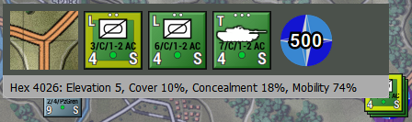

## Elevations

On the game map, you will notice that the ground is colored differently based on its elevation. The more elevated the terrain is, the lighter the basic green color will be. Elevated sections of the terrain are outlined in a visible shaded edge.

You can also check the hex elevation by hovering on the tile and seeing the information on the Flyout or in the Status Bar at the bottom right of the screen or going to the Terrain Overlay menu and selecting Elevation Values.

Placing units on higher terrain will provide them with a better line of sight.

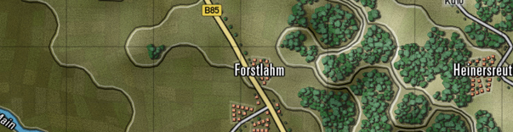

## Terrain

The map is made up of various terrain elements applied over the elevations.

Each type of terrain has mobility, concealment, and cover values that impact spotting, combat, and movement in various ways. The values are set in the Map Values Editor for each map used in the game.

* 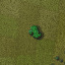**Clear** – A few small elements are visible on the elevation art. These tiles are not really “clear”, as they have a small number of rolling hills, some trees, fields, and buildings. These elements have a small amount of cover and concealment capability.
* 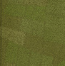**Fields** – Cultivated farm fields. Relatively flat solid terrain (in the summer and if it is not raining). One of the more numerous terrain types in central Europe. Fields do provide some concealment with the crops during the growing seasons.
* 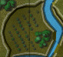**Forest/Orchards** – Lots of trees of various types cut with the occasional path, trail, or road. Not so thick that driving over them is prohibited. Orchards show smaller trees in nicely spaced rows. Trees can also be found along many country roads.
* 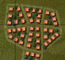**Rural** – Houses and small buildings found in villages and towns. These built-up areas provide good cover and concealment and decent mobility with many roads. They also provide good ambush sites for infantry against armored vehicles. They are depicted as orange squares, some trees, and minor roads.
* 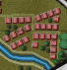**Urban** – Larger government buildings, shops, and apartment complexes. These built-up areas provide good cover and concealment and decent mobility with many roads. Also, provide good ambush sites for infantry against armored vehicles. They are depicted as brown squares, a few trees, and some roads.
* 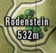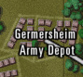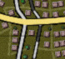**Industrial** – Factories and warehouses. These built-up areas provide good cover and concealment and decent mobility with many roads. They also provide good ambush sites for infantry against armored vehicles. They are depicted as gray squares, occasional trees, and roads.
* **Named Landmarks** – On several maps, there are some named landmarks like airfields, depots, or hills with heights. These are cosmetic but informational.

## Roads

The map has a few types of major road networks represented for use in the game.

Each type of road provides improved mobility through the various types of terrain found on the map.

* 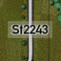**Road** – These are basic two-lane country roads paved and in decent condition. These roads provide a suitable means of movement for forces through the various terrain on the map. Roads are shown as gray lines with a black border.
* 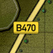**Highway** – These are multilane roads paved and in good condition for heavy traffic. These roads provide a reasonable means of movement for forces through the various terrain on the map. Highways are shown as wide yellow lines with a black border.
* 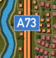**Autobahn** – These are modern very wide multilane roads built to allow fast movement of traffic and military vehicles. These roads provide an excellent means of movement for forces through the various terrain on the map. Autobahns are shown as double orange lines with black borders.

## Railroads

* 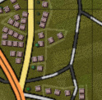**Railroad** – While we do not have trains or move things by rail in the game, we do show railways as alternating black and light gray lines on the map. Rail bridges are also shown on the maps and can, in a pinch, be used to cross units over water.

## Water Obstacles

The map has a few types of water obstacles that can hamper the movement of military units across the map. There are different means to cross these obstacles.

* 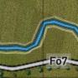**Stream** – These waterways are small, narrow, and shallow. With a bit of prep time units can cross these without the aid of bridges or engineering bridges.
* 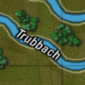**Minor River** – These waterways are wide enough and deep enough to require a bridge (road or engineering) or amphibious vehicles to cross (with some prep time). Most of these will be names on the map.
* 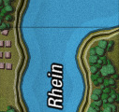**Major River** – These waterways are vast and deep and must be crossed by bridge (in this case shown by two bridge markers) or swam at slow speeds by amphibious capable vehicles. Most of these major rivers will have names on the map.
* 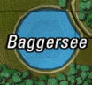**Lakes** – Lakes and ponds are various sizes of enclosed water obstacles. The only means of crossing these obstacles is an engineering bridge or two or amphibious units that can slowly swim across to the other side. In most cases, going around them is the better plan.

## Bridges

As noted in the section above, the primary way to cross rivers and streams is to use a bridge. These markers are shown on the map as wide light gray/white semi-transparent rectangles with black edges, and they are placed on the map across water obstacles and meet up with the ends of roads.

* Road and Rail bridges both use the same marker.
* A Blown bridge is denoted with a red cross over it. Bridges can be in a blown state as part of the scenario design or can be blown with engineering units during a scenario.
* Specific engineering units can place temporary bridges across water obstacles. These bridges are colored blue for NATO-owned and red for Warsaw Pact-owned bridges.

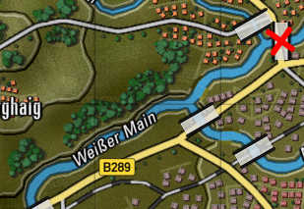

Road Bridge

Blown Bridge

Rail Bridge

## Map Markers – Full Hex

Full hex map markers apply their effects on the entire hex and any units within. The color shows ownership. Red for Player one and Blue for Player two. Unowned markers are in yellow.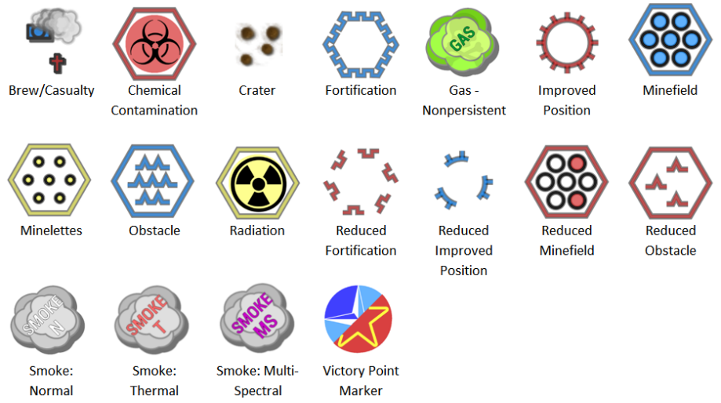

* **Brew/Casualty Kill Markers** – A small blue (Player 1) or red (Player 2) smoking tanks or crosses showing where a subunit vehicle/squad was destroyed or fell out.
* **Chemical Contamination** – The hex at this location is contaminated with persistent chemicals. Units can suffer losses if they move through these areas and become contaminated.
* **Crater** – A small image showing the impact point of a barrage or air strike. Craters cause a slight movement penalty in the hex.
* **Fortification** – A purposely built defensive structure made to protect forces from enemy fire. Units can screen or hold in them to gain a significant protection advantage. Not currently in the game.
* **Gas Cloud (Nonpersistent)** – The hex contains a non-persistent chemical cloud. Units entering run the risk of losing subunits. These clouds will dissipate over time and pose no lingering threat.
* **Improved Position (IP)** – An engineered defensive position that provides additional protection to units in them.
* **Minefield** – A mixed anti-tank/anti-personnel minefield that attacks all who enter the location particularly those who do not know it is there. Engineering units can clear lanes in these fields for safe movement.
* **Obstacle** – An engineered barrier that obstructs the movement of forces leading to movement delays. Engineering units can clear lanes in these fields for safe movement.
* **Radiation Contamination** – The hex is littered with highly radioactive debris and fallout after a nuclear strike. Entering these can cause losses to subunits based on the NBC protection level of the units passing through. Units moving through become contaminated and must be “cleaned” when out of the hazardous terrain.
* **Reduced Fortification** – Marker shows a Fortification that has been damaged by engineers or combat and is no longer able to protect the unit in it. Not currently in the game.
* **Reduced Improved Position (IP)** – The marker shows an Improved Position (IP) that has been damaged by engineers or combat and is no longer able to protect the unit in it.
* **Reduced Minefield** - The marker shows a Minefield that has been cleared by engineers with lanes making it safe to pass through.
* **Reduced Obstacle** – The marker shows an obstacle that has been cleared by engineers with lanes making it safe to pass through.
* **Smoke: Normal** – An obscuring cloud that reduces the visibility into and through it extensively unless a unit is using a thermal sight.
* **Smoke: Thermal** – A thermally obscuring cloud that reduces the visibility into and through it considerably unless a unit is using a radar system for spotting.
* **Smoke: Multi-Spectral** – An obscuring cloud that blocks visual, thermal, and radars from seeing into it and past it.
* **VP Location** – A banner with a point value that is awarded to the owner (blue-Player 1 and red-Player 2) who holds the objective at the end of the game. Unclaimed VP locations are shown with a split NATO/Warsaw Pact symbol. The point values for these locations can be split with different values for each side.

## Map Markers – Hex Edge

Hex Edge Map Markers are placed along the edge of a hex, and the marker's effect only applies when crossing that hex edge. These markers are shown as full on the top of the picture below or reduced at the bottom of the image for each type. The color shows ownership. Red for Player one and Blue for Player two. Unowned markers are in yellow.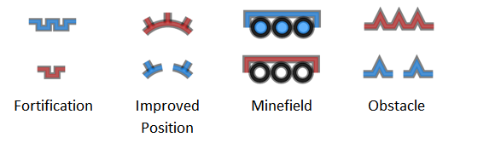

* **Fortification** – A purposely built defensive structure made to protect forces from enemy fire. Units can screen or hold in them to gain a significant protection advantage. A Reduced Fortification has been damaged by engineers or combat and is no longer able to protect units in it. Not currently in the game.
* **Improved Position (IP)** – An engineered defensive position that provides additional protection to units in them. A reduced IP marker shows an Improved Position (IP) that has been damaged by engineers or combat and is no longer able to protect units in it.
* **Minefield** – A mixed anti-tank/anti-personnel minefield that attacks all who enter the location particularly those who do not know it is there. Engineering units can clear lanes in these fields for safe movement. A Reduced Minefield shows that it has been cleared by engineers with lanes making it safe to pass through.
* **Obstacle** – An engineered barrier that obstructs movement leading to movement delays. Engineering units can clear lanes in these fields for safe movement. A Reduced Obstacle shows an obstacle that has been cleared by engineers with lanes making it safe to pass through.

## MCOO Map Legend

The following hatches and lines are found on the Modified Combined Obstacle Overlay (MCOO) and have the following impact on gameplay for ground-based units. These effects do not hamper the movement of air units.

* **Impassible Terrain** – A terrain with a red cross-hatching is considered impassable by ground units. Units cannot travel into or through this type of terrain. There is no impassible terrain currently in the game.
* 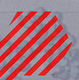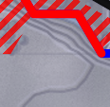**Impassible Hex Edge** – Hex edges shown with a red solid line are impassible to ground forces. This indicates a slope that is at an incline/decline that is too steep for ground units to traverse. This is seen in hexes with multiple elevations at an edge.
* **Slow-Go Terrain** – The terrain with the red hatch is noted as slow-go terrain. This means your ground units will be slowed down as they navigate more restricted lanes of travel. This terrain is mainly seen in forested hexes in the game.
* 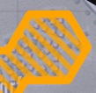**Built-Up Terrain** – Terrain with an orange hatch is built-up areas like villages, towns, and cities. The unit will be a bit slower through these areas. These hexes are also a potential danger for units moving through as cover and concealment for enemies is high in these areas.
* 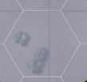**Open Terrain** – The grey terrain zones are considered open ground. These hexes have a few hills, trees, or buildings, and can be crossed without slowing down. They also show clear lanes of fire and line of sight. These areas are good to avoid if moving into an enemy area and having clear lanes of fire from cover is excellent when defending.
* 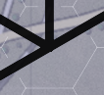**Road Network** – The black or dark gray lines show the road network on the map. This terrain will have better movement rates than open ground and also allow for faster travel through any Slow-Go or Built-up terrain.
* 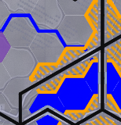**Water Obstacles** – The solid blue lines or blue-filled hexes represent water obstacles that require bridging or units with amphibious capability to cross over them. Other units can cross with road bridges.

## Animated Fire Lines

Flashpoint Campaigns offers two types of fire line animations. The default basic fire lines or direct-fire-based weapon animations. You can turn on the weapon-based effects from the Options menu.

### Classic Fire Lines

These are the fat red/blue (default colors, transparency, and width, which can be changed in the User Preferences dialog) lines from shooter to target.

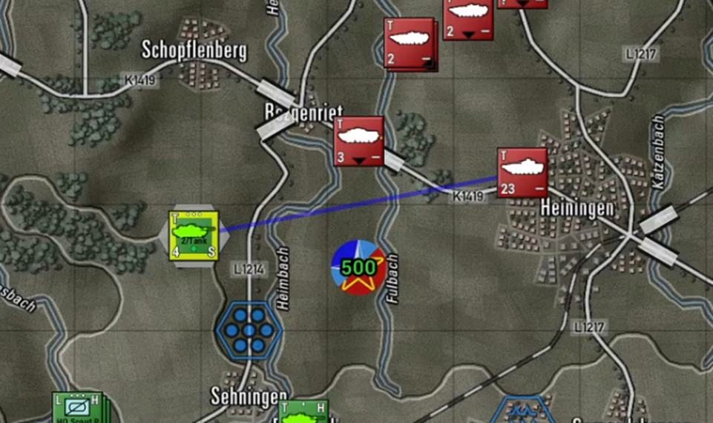

### Main Gun Fire Animation

These are narrow “semi-transparent” straight lines from shooter to target. Fast-moving colored projectile with a thin vapor trail moving from shooter to target. A wide muzzle blast smoke animation at the shooter location.

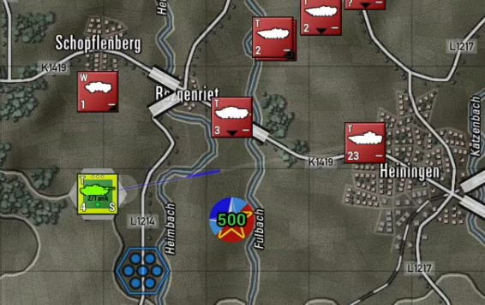

### Autocannon/Machine Gun Animation

These are narrow “semi-transparent” straight-line vapor trails from shooter to target with three short colored projectiles moving from shooter to target. Three narrow muzzle blasts smoke animations at the shooter location.

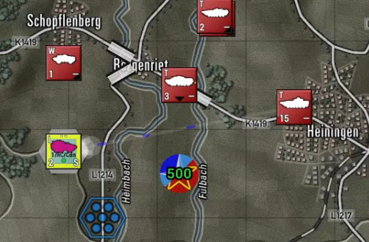

### Anti-Tank Guided Missile Animation

These are wiggly trajectory vapor trails from shooter to target (representing ATGM course corrections) a fat, colored projectile with a bright orange tail (engine), and a vanishing smoke trail. There is a launch blast smoke animation at the shooter location.

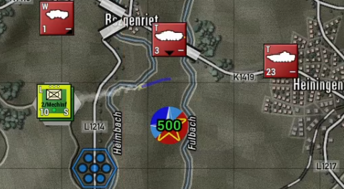

### Surface-to-Air Missile (SAM) Animation

These are hooked trajectory vapor trails from shooter to target (representing off-angle launch followed by tracking) and a fat accelerating color projectile with a persistent smoke trail. There is a launch blast smoke animation at the shooter location.

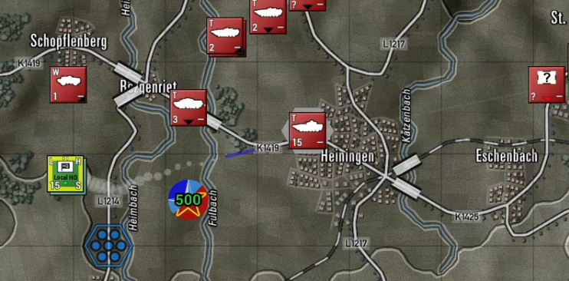

### Fire Line Colors and Scaling

Projectile colors follow User Preferences for Line of Fire colors for both sides. You may want to switch to more tracer-like colors like yellow, orange, or red to brighten up the default colors (brighter is the new default for new installs).

Animation sizes follow map scaling and will scale up and down with changes in zoom levels.

Animation speed follows other animation speeds but is capped at a maximum speed of 10. Reduce animation speed below 10 to slow down fire exchange animations.

# Unit Counters

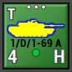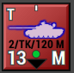Units are the individual playing pieces in the game. Units are composed of one or more subunits, such as vehicles, aircraft, artillery pieces, or squads of men.

For example, a tank brigade HQ unit composed of 3 subunits might contain a T-80 command tank, a BMP-2 armored personnel carrier, and a BTR-60 command vehicle. The details of the counter are noted below. Units can also be a mix of unit types that are used together for operation needs. One of the most common mixed units are Mechanized units with both Infantry Fighting Vehicles (IFVs) or Armored Personnel Carriers (APCs), Infantry squads, and weapon teams. Aircraft units like helicopters or Close Air Support (CAS) assets are always of the same type in a unit but could have different roles like attack and recon.

The unit counters in the game contain several important values to show information to the player on the state of the unit. These items are detailed in the following section.

## Counter Information Layout

The image below shows all the various bits of information contained on most of the counters in the game.

Understanding these items and their meaning is an essential part of the game.

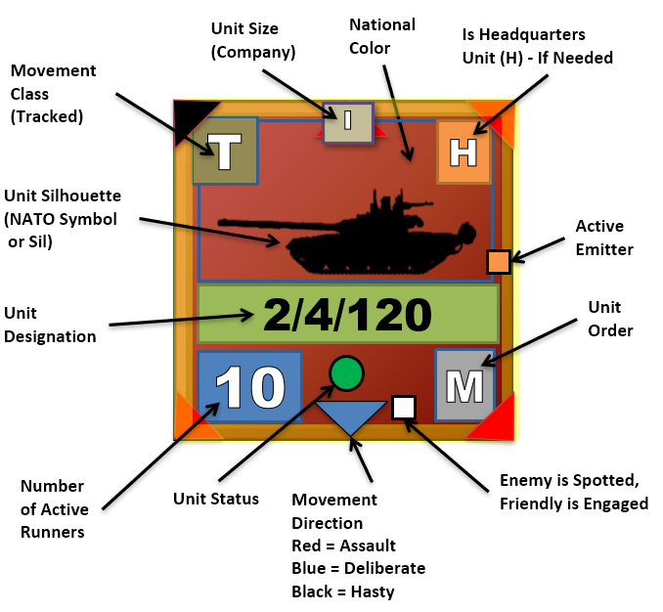

* **Unit Silhouette (Sil)** - The primary constitution of the unit is shown by the central graphic. In this case, a tank is shown, so you may assume that the unit is predominantly composed of those types. Vehicles of all types, artillery, and aircraft are shown with vehicle graphics. Non-vehicular units use NATO symbolic graphics. Suppose the unit is composed of carrier vehicles and dismountable passengers. In that case, the vehicle Sil will be shown while the unit is moving, and the dominant passenger NATO Symbol will be shown. In contrast, the unit is stationary to indicate that the passengers have dismounted.
* **Unit Designation** - Immediately below the unit graphic will be an identifying unit designation. These tags allow the player to more quickly identify where the unit belongs in the general organization of his forces. This information is shown only to the owning player and long tags are truncated to fit.
* **Unit Status** - To quickly show the combat effectiveness of a unit there is a symbol just below the unit’s designation.
* **Green Circle** - Indicates the unit is combat effective and is in good order with ammo and readiness levels.
* **Yellow Triangle** - with the point up denotes a unit that is of marginal fighting capability. It has possibly taken some losses or is low on ammo, readiness, or morale and its combat abilities are reduced.
* **Red Inverted Triangle** - Indicates a unit with critical combat effectiveness conditions. It is deficient in ammo, readiness, or morale, and has taken significant losses or a combination of this effect. These units should be pulled out of combat for resupply as they are not very combat-effective in this state.
* **Black Square** – Indicates a unit has reached combat ineffectiveness and is no longer capable of practical combat action. These units are usually out of critical ammo, are very low on readiness, have shattered morale, or sustained heavy losses in several subunits.
* **Unit Size** - The three dots at the top center tell us the size of the unit, in this case, a platoon. The size indicators are “X” = brigade, “III” = regiment, “II” = battalion, “I” = company (approx. 10 subunits), “...” = platoon (approx. 3-5 subunits), “..” section (1 or 2 subunits), and “.’ = an individual subunit. This information is shown only to the owning player. **NOTE**: For headquarters units, the unit size shown is the size of the command, not of the HQ unit itself.
* **National Color** – Every unit of a nation has a color-coded background for the unit counters. The Soviets are red, the Americans are green, and the French are blue. Each nation’s background is unique and allows the players to tell the various forces apart.
* **Is Headquarter Unit** - The “H” in the upper right corner means that this unit is a headquarters unit. Some are formally organized to be headquarters, and some are just acting as such. In either case, an H will appear in this location. This information is shown only to the owning player. These units provide the chain of command and communications link to their subordinates.
* **Active Emitter** – If a unit is equipped with a Radar system, either Air Search or Ground Search and it is activated, an orange box will be displayed on the counter to show an active emitter.
* **Unit Order** - The white letter (“M”) in the lower right of the counter indicates the unit’s current Order. Valid orders are the following: “A” = Assault, “M” = Move - Deliberate, “2” = Move - Hasty, “S” = Screen, “H” = Hold, “B” = Barrage, “G” for Gas Attack, “C” = Counter-Battery, “E” = Engineering Action, “R” = Resupply, “O” = On the call, “F” for Fallback (Scooting), “W” for Withdrawing, and “Z” for helicopters that are in Hunt mode. This information is shown only to the owning player. These orders will be explained in more detail in Section 21 below.
* **Spotted Indicator** - If the unit has been sighted by the enemy, then a tiny white dot will be drawn at the bottom of the counter to the left of the unit order. This is based on being lazed, shot at, or a reasonable estimation of “we see them so I bet they can see us” for your units and spotting the enemy. **NOTE:** This indicator will only show if the option to Show Enemy Units is turned on.
* **Movement Direction and Type** - If a unit is currently in motion, then a small triangle will be shown pointing in the direction that will be moved in next. If the triangle is black, the unit is utilizing road movement via a hasty move order and is going for speed over combat readiness. A blue triangle indicates a Deliberate Move order, and the unit is moving slower and will use both road and off-road movements to the objective while being ready for combat. A red triangle indicates a unit moving in an Assault order and is combat-ready. Assault movement is a bit faster than a deliberate trading cover for speed to close on an objective.

* **Number of Active Runners** - The large number in the bottom left corner is the number of subunits mission-capable (“10” in this example). A subunit is mission-capable (also known as a “runner”) if it is physically and psychologically able to carry out its orders. The other possible states are destroyed and fallen out. A tank that has thrown a track, a truck with a conked-out engine, or an infantry squad so shattered that it cannot rise from the bottom of its trench are examples of subunits that have fallen out. Fallen-out subunits count equally with destroyed subunits for victory purposes but can be recovered between scenarios in a campaign game.
* **Movement Class** – The letter in the upper left of the counter indicates the unit’s current movement type. These types are as follows: “L” = Leg, “W” = Wheeled, “T” = Tracked, “R” = Rotor, “P” = Propeller, “J” = Jet, “R” = Rocket, “S” = Static (non-movable).

**NOTE**: See Section 22.1.3 below for details on the Lost Transport Indicator.

# Specific Unit Roles

***Flashpoint Campaigns: Cold War***has a vast array of unit types covering the major platforms (vehicles, aircraft, helicopters, field guns, etc.) and squads of the Cold War. The primary unit types are described below.

How these units are used in battle, and more information about their systems and sensors can be found in Battlefield Primer FM FCCW-02.

**NOTE:** Roles can be changed in the game and impact how the AI tries to use the units. Recce units will try to be out front locating the enemy. Following that are the Main Effort (mainly armor) and Line (mainly mechanized/infantry units. Just behind those or mixed with are Overwatch units (Defense and dedicated Anti-tank units). Finally, units in a Support role (mainly Headquarters and Artillery units) should stay at the rear of the force.

## Recce Role

Recce (Recon or Reconnaissance) units are ideal scouts and should be used to find enemy units and to build a picture of how and where the enemy is attacking. Reconnaissance units can safely operate outside the command range with no penalties (they are trained to do this) and often have better equipment and sensors to spot enemy troops. Most of them are also harder to spot, but the downside of these units is (in most cases) that they are only lightly armed and armored.

Recon units are, in most cases, not meant to stop enemy line forces, but to locate them for you to plan how to deal with them with your line and other forces like artillery. It is also critical as a commander to find and eliminate enemy recon units and deny them the ability to find and attack you.

## Main Effort and Line Roles

Units with tank, infantry, or mechanized infantry subunits are defined as “Main Effort” or “Line” units. Main Effort units are those tasked with taking ground and objectives and are usually tank-based units. Line units are the second line of attacking units and are generally the mechanized parts of the force. These unit types make up most of the player’s combat force. Line units can be divided into three types: Infantry, Mechanized (armored fighting vehicles and infantry), and Tanks. The specific capabilities of these units may vary, but in general, these are their uses in battle:

* **Infantry** – These units are weak in the open and often in need of support, but when well-hidden and armed with specialized weapons like ATGMs, they pose a severe threat to any unit out there.
* **Mechanized** – These units are quick, but often only lightly armored and should not be expected to hold their ground in the open against enemy tanks. Depending on the armaments of the unit, however, they can seriously damage enemy infantry and armor.
* **Tanks** – Tanks are the best units to kill the enemy’s tanks and other armored fighting vehicles at range. Tanks have the toughest armor protection of any platform in the game and large cannons able to destroy enemy tanks at ranges over 2000 meters.

Tanks are high-value assets, so don’t throw them away recklessly in battle.

## Overwatch Role

Units in the Overwatch role are used to provide some form of defense for the units in the Main Effort or Line groups. These units usually follow behind the Main Effort and Line forces as units move and they sit ahead of any support units in the rear. The capabilities of these units vary, but in general, these are their uses in battle:

* **Anti-Tank (AT)** – These units are weak in the open, but when well-hidden pose a serious threat to any unit out there. These weapons are mainly used to kill tanks but can also take out infantry fighting vehicles. Weapons used can be ATGMs, tank guns, recoilless rifles, and other anti-armor systems.
* **Air Defense (AD)** – These units specialize in finding and destroying aerial threats over the battlefield. These units need a good line of sight in and around the rest of your forces and should be used to keep them protected from enemy helicopters and aircraft. These systems can be gun or missile-based and usually have air search radar or other optical sensors to find and track air threats.
* **Artillery** – In some cases, self-propelled artillery units with short ranges like mortars can be in an overwatch role if they provide fires for main effort/line units that they are part of the formation with.

## Support Role

Units in the Support Role provide a variety of functions for the rest of the force. These functions are as follows:

* **Headquarters** - Headquarters units are the command network of your forces. These units are the ones that draw up plans and issue orders to their subordinate forces or relay orders to other forces. Keeping these units alive and in command range of their subordinates will have a significant impact on your force’s ability to fight and win battles. Most upper-level headquarters are full of troops, trucks, and command vehicles and not meant to fight toe-to-toe with enemy units.

Lower-level headquarters for companies and platoons usually have the same type of units as those they command, like tanks, and can lend firepower during a battle. Headquarters have some of the following abilities:

* Each order sent out to a unit and each situation report back from a unit is a “radio event”. Excessive use of the radio can reveal a unit’s location and it will be shown on the map in a ‘detected’ spotted state if it is not detected already. If the unit is an HQ and the enemy staff are enabled to give FSCC missions, then a high-priority fire request against the HQ will be entered into the enemy FSCC mission queue. The bottom line, move your HQs on occasion if order traffic is high or risk getting them shelled.
* If an HQ unit is destroyed, then another unit will be promoted to fill its spot in the chain of command. This is called HQ subordination. Any unit that has subordinate units is a de-facto headquarters unit, whether it is officially described as such or not. This state is not dependent on having HQ vehicles as subunits.
* The Chain of Command chart on the Map Page will show what the unit hierarchies currently are. The highest HQ (marked with “HQ” as its unit icon) is in the overall command. Depending on the situation there may be intermediate level HQs as well.
* HQ units can indirectly sight any enemy unit that its subordinate units have sighted. The highest HQ sights everything that any friendly unit has sighted. This is important for generating FSCC requests and reflecting passing sightings of the enemy up the command chain.
* Involuntary Movement: When a unit is forced to retreat it will move in the direction of immediate safety, or if there is none, towards its parent HQ.
* **Engineering** – Engineering units are used to do specific tasks such as laying a bridge over a stream or river, clearing mines and obstacles, and blowing bridges to deny their use to the enemy. One of the significant changes from the earlier version of the game is the use of dedicated engineering assets on the map to do those functions listed above. This includes information reports dedicated to engineering assets and activities.

Currently supported in the game are dedicated short-span bridging units and engineering troops. The bridges are used to cross water obstacles and the engineering troops do all the other functions. These units usually travel in the rear of the forces and then move up to do specific tasks. These are not combat-capable units and should not be placed into combat with the enemy.

* **Artillery** – Artillery is the King of Battle. These weapon systems represent guns, rockets, and mortars that can reach tens if not hundreds of kilometers into enemy territory and deliver several different types of munitions on targets with devastating effect. These assets can also be on or off-map depending on the scenario design. Several reports and information panels such as the Fire Support panel provide details on these units and allow you to see what they are doing and access to order them to fire on targets of your choosing. There is also an option to have these assets placed under FSCC (Fire Support Control Center) control which will use the AI to direct their fires on spotted enemy units. When these units are on the map, they should be placed behind your forces but in range of the enemy to be able to fire on them. Artillery units can, when pressed and capable (noted as direct fire capable and carrying the right ammunition), engage in direct fire against attacking units. Artillery units both on and off-map can be subjected to enemy counter-battery fire. This is returned enemy artillery fire based on locating your firing batteries via counter-battery radars and other means. It would be best if you got in the habit of shooting and then moving to avoid losses.
* **On-Map Air Support -** Various types of helicopters are included in the game. There are Attack, Recon, and Utility versions of Helicopters. Helicopters can carry a variety of weapons geared to anti-armor or anti-personnel missions, but they can also be assigned to perform reconnaissance tasks. In future updates, we will add the utility/transport helicopters for airborne assault operations. Helicopters are just like any other on-map unit except for the following differences:
* They ignore all terrain costs when moving.
* They move much faster than the ground units based on their cruise speed and flight profile.
* Depending on movement orders, helicopters will fly Nap of the Earth (NOE) using terrain to screen and cover their movements when Hunting (a helicopter-specific order for moving and attacking enemy targets) or doing a Deliberate Move. They will fly at low altitude if executing a hasty move.
* They do not count against stacking limits in the location they occupy.
* They do not suffer NBC (Nuclear, Chemical, and Biological) attacks if they move through a contaminated hex location.
* They do not suffer minefield attacks if they move through a mined location.
* Unit Posture – Helicopter units cannot dig in or fortify.
* Helicopters with mast-mounted sensors receive a bonus to spot and a bonus not to get spotted when looking for enemy units.
* To resupply, helicopters must fly back and land at a FARP (Forward Arming and Refueling Point) unit. If the FARP is missing, then the units will go to the current highest HQ on the map to resupply.
* **Off-Map Air Support -** Off-Map Air support is units of propeller or jet-powered aircraft with various missions designed to strike targets on the battlefield. All aircraft are held off-map, in particular, loiter areas for commitment to air strikes under the player’s direction or FSCC control. When the air strike is complete the surviving aircraft either return to base to rearm if out of ammunition or go back on station if weapons are still available. After rearming they will return to the loiter area to await future assignments. The doctrine generally allows for a certain number of fixed-wing air close air support sorties within 40 km or so of the Forward Edge of the Battle Area (FEBA). Since the FEBA is an extremely high-risk area for these valuable assets, availability will be limited, and strikes should be reserved for high-value targets. Long-range artillery and helicopter assets remain the preferred platforms for routine fire missions within this zone. Off-map strike aircraft have the following capabilities:
* Aircraft that are rated All-Weather can fly anytime visibility is 500 meters or better (in rain/snow). Non-All-Weather aircraft are grounded if the weather is poor.
* Aircraft that are rated for Night Operations can fly normally at night. Those units without this rating are grounded and cannot fly at night.
* Close Air Support (CAS) aircraft are equipped to strike ground targets.
* Level Bombers fly high over the battlefield and drop weapons against ground targets.
* SEAD (Suppression of Enemy Air Defenses) aircraft are equipped with special anti-radiation missiles (ARMs) that seek out and destroy air search radars rendering Surface to Air systems (SAMs) useless. They do not affect optical and infrared (IR) systems.
* Most scenarios will have a limited number of air strikes (if any) and those assets will be available for a limited amount of time.

# Special Unit Types

The game has a couple of special units that need to be explained as to how they are used.

## Weapons of Mass Destruction (WMDs)

Tactical nuclear warheads and persistent and non-persistent chemical weapons are a part of the Cold War battlefield. These weapons are delivered by Surface-to-Surface Missiles (SSMs), artillery, or aircraft. These weapons will be noted in your scenario briefing if they are available for use. Nuclear and Persistent Chemicals leave contamination behind that can kill units entering those contaminated areas.

These weapons cost a certain amount of victory points to use and should therefore not be used lightly. It is highly advised that you only use these specialized weapons against extremely high-value (and tightly packed) targets. Make sure to launch strike missions of these weapons only where they can be decisive!

## Inactive Units

History shows that not all units on the immediate battlefield that could have participated did. Accordingly, the scenario designer is allowed to place units on the map and then mark them as “inactive”. This makes them unavailable for player orders or relocating in the deployment area until their release is triggered by one of the actions below. While inactive units have the following restrictions:

* Inactive units are drawn on the map, but they have a gray overlay to denote their status and the critical message line in the UDP will say “Inactive”.
* They can be browsed but cannot be given orders of any type.
* They cannot be repositioned during the setup phase.
* Active and inactive units may stack together within normal stacking limits.
* An inactive unit cannot become the supreme HQ.
* Inactive unit radio messages are not counted towards traffic levels.

These units become active when:

* When attacked (direct fire, indirect fire, or air strikes).
* When an enemy appears within the unit's SOP standoff range or 1500 meters whichever is greater.

Once activated, these units behave in a usual fashion.

## Logistical Units

Logistics are an essential part of the battlefield. Units fighting the battle require fuel and ammo and the troops need food and water. While the game engine abstracts the use and tracking of logistical forces for ground units (resupply orders are important and discussed in Section 21 below), a new unit called a FARP (Forward Arming and Refueling Point) has been added to the game for helicopter operations. When an attack helicopter runs low on ammunition or has low readiness or morale from combat operations, it can be ordered back to the FARP to reload and recover.

In future expansions, we may look to include additional logistical units for supply and other functions.

## Unmanned Aerial Vehicles (UAVs)

UAVs or drones were a new item in the 80s and very few of them were in operation. While we don’t have any in the current batch of scenarios, it is possible to add them, and UAVs may be seen in the future. When these platforms are on-map, they are treated like helicopters and the player can plot their moves in the same fashion. When they are off-map assets, they fly in and conduct strikes just like the human-crewed aircraft noted in Section 18.4 above.

# Order of Battle (OOB) Tree

One important function of the Spotlight Panel (F10) is the Order of Battle Tree. The OOB tree provides a listing of all your units and shows which units report to (are subordinate to) which headquarters. This information is vital as command delays and resupply capability are tied to a unit’s distance from its local/primary headquarters.

In some cases, you as the commander may want to move units under another command or change up the composition of a formation to better suit the mission at hand. There are two functions to help with the arrangement of units. Resubordinate and Reorder. They are described below.

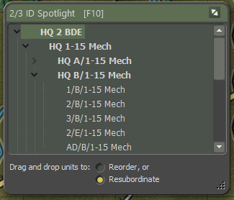

## Unit Resubordinate

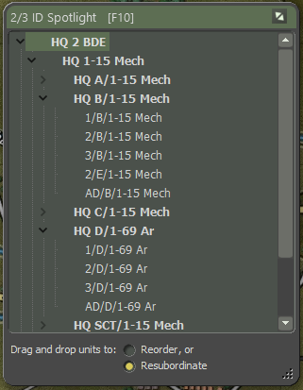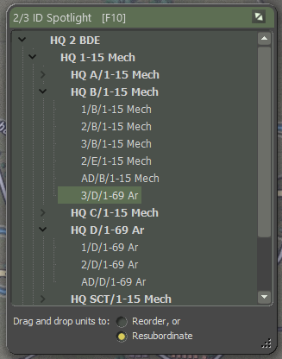

To move a unit from one command to another you need to click on the unit to move, in this case **3/D/1-69 Ar**, and then drag the unit out and up to the new HQ you want it to be a part of and release the mouse button. In this case, we are subordinating it to **HQ B/1-15 Mech**. After releasing the button, the units should appear at the bottom of the new HQ’s formation as seen in the right image.

Once a unit is attached to a new HQ, it will use that HQ for communication and resupply based on the new HQ’s command ranges. Adding more units to a new HQ also increases the amount of generated radio traffic and adds to the chance of the enemy locating that HQ.

## Unit Reorder

Once you resubordinate a unit into a new command, you may wish to move it into a different place in the subordinate order. Using the Reorder function can make those changes.

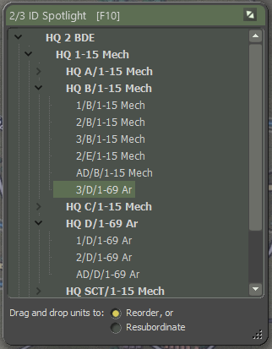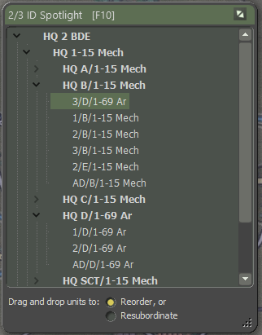

At the bottom of the Spotlight Panel, check the Reorder function. Then click and drag the unit you want to move and release it on the unit you want to be above.

# Issuing Orders

You control your forces by giving orders to your units. Be aware that a certain period is needed by the staff to formulate and transmit your orders. The unit will need time to prepare for the new order which is a function of the type of order, the training, readiness, and the tactical situation of the unit to which it is issued.

Orders take as long as they take to run to completion, and this may not coincide neatly with the Orders Phase intervals. Orders persist to the next turn if you do not issue new ones. If you keep interrupting orders with new orders, the delay time will increase as orders have to be rescinded and then new orders will be generated for the units.

## Open the Unit Menu

Orders can be given to a unit by right-clicking on the unit icon on the map and selecting an order from the displayed Unit Popup Menu. Some orders require selecting to set them (Screen, On Call, Hold, Resupply, etc.). Others require the player to designate waypoints or target points (Moves, Assault, Barrage, Hunting, etc.). With these last orders, you must finish the order by selecting one of the options in the Orders on Arrival dialog that pops up when you are done selecting waypoints for the move.

If you decide during the issuing of a move or bombardment order that you want to do something else, you can click the Esc key to stop the order. Accepting an order and then issuing a new order can also be done. This case does not add additional time to the command delay as the order is not yet in process.

In the image below, you can see the Orders Block of the Unit Popup Menu. The listed orders may be in two sections of the dialog and show up based on the type of unit with Orders that are proper to use for the particular unit type.

For more detailed information about plotting movement, see Section 22 below.

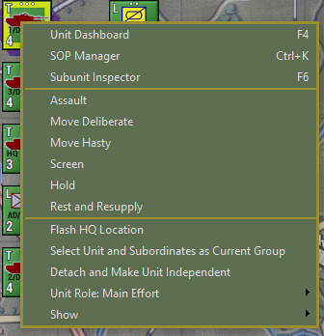

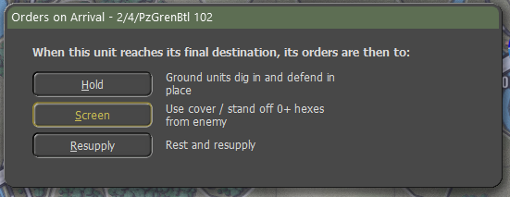You can also open the Unit Popup Menu by clicking on the hyperlinked Menu option beneath the unit counter in some reports and displays. This is useful for Off-Map Assets like artillery and air units.

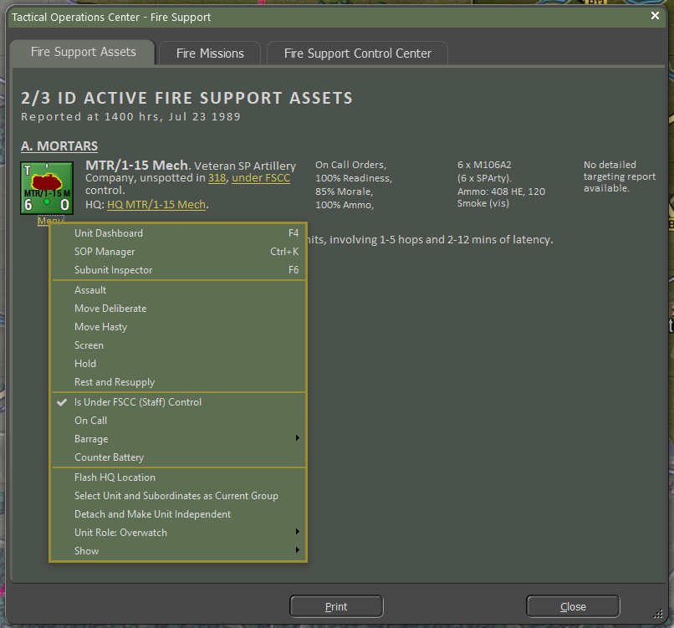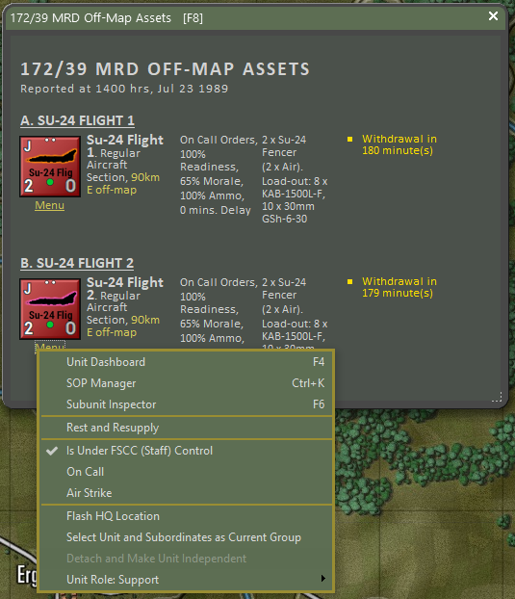

## Primary Unit Orders

* **Assault** – Move in a spread-out formation using both road and off-road movement to be ready to attack an enemy.
* **Move Deliberate** – A more defensive move than Assault, but still can travel on or off-road.
* **Move Hasty** – Faster than Assault and Deliberate moves, but trades speed for defensive coverage uses. It sticks mainly to roads.
* **Screen** – A non-moving state of seeking moderate cover and ready to attack or move if required.
* **Hold** – A non-moving state of seeking the best cover in the hex and some cases, digging in for improved defensive protection if the unit is in the hex for 30 minutes. This is the best choice for defending locations.
* **Rest and Resupply** – The unit is in a state of rearming, refueling, and resting to recover readiness and morale. This only works if the unit is not in combat. Aircraft and Helicopters will return to base to rearm and refuel.

## Indirect Fire-Specific Orders

* **Is Under FSCC (Staff) Control** – This toggle allows you to have the Staff AI provide fire missions for the unit or place it under your direct control. Not really an order but affects how orders are done for this unit.
* **On Call** – The unit is ready for new orders, either movement or barrage.
* **Barrage** – These are orders to fire certain types of munitions at a set of targets on the map.
* Suppression Fire – Low rate of fire of high explosive (HE) rounds that has limited kill power but does inflict readiness loss to targeted units.
* Neutralizing Fire - High rate of fire of high explosive (HE) rounds maximizing kill power and inflicting readiness loss to targeted units.
* Saturation Area Fire - This option is found only on multiple rocket launchers. It allows all the unit’s rockets to be fired off in rapid succession and strike a much larger target zone. If this mission is chosen, you can only select one target point and the rounds will land in the target hex and the surrounding six hexes. This is a devastating attack that can cause severe losses to man and machine. Units firing a saturation attack automatically go to zero ammo and must resupply before shooting again.
* Smoke – Fires rounds that deploy a smoke screen of various types that obscure vision and sensors.
* Scatterable Mines (FASCAM) – This ammunition deploys a hex-wide minefield in the targeted hexes.
* Improved Conventional Munitions (ICM) – These rounds deploy several submunitions capable of destroying both armored and soft targets.
* Nuclear Munition – These are single rounds with a tactical nuclear warhead that can cause massive area-wide damage and nuclear contamination.
* Chemical Munition – These rounds can drop persistent or non-persistent chemical attacks into hexes. Non-persistent strikes will dissipate over time.
* **Counter Battery** – Your units are set to fire on located enemy artillery units. While on Counter-battery they will not shoot other missions.

## Engineering Specific Orders

* **Remove (Blow) Bridge** – Allows an engineer to blow a fixed bridge if they are in an adjacent hex.
* **Lift Mines** – Allows an engineer to clear lanes in a minefield for units to pass safely through.
* **Remove Engineered Obstacle** – This allows an engineer to remove obstacles to create lanes for units to pass through.
* **Demolish Positions –** Allows the engineer to destroy improved position in a hex.
* **Lay/Recover Bridge –** Allows a Short-Span Bridging vehicle to place or retrieve a temporary bridge over a hex-side water obstacle.

## Helicopter Specific Orders

* **Hunt** – This makes the helicopter move from point to point looking for enemy units to engage while doing its best to use terrain to mask its movement.

## Aircraft Specific Orders

* **Is Under FSCC (Staff) Control** – This toggle allows you to have the Staff AI provide fire missions for the unit or place it under your direct control. Not really an order, but affects how orders are done for this unit.
* **On Call** – The unit is on station and waiting to be called back in for a strike.
* **Air Strike** – Order an aircraft to attack a given hex with its carried ordinance. Depending on the type of aircraft and weapons, targets may be restricted to specific types.

## Unit Orders Delay Factors

Orders take time to transmit, absorb, and implement. Some are fast and some will take time. For many orders, there is a preparation time before the order can commence and then a period during which the order is executed. If the unit is On Call or is already performing the same kind of order requested (i.e., Move to Move, Screen to Screen, just with different parameters) then the Orders Delay equals 2 minutes. Otherwise, the Orders Delay equals the standard Orders Delay (2 to 60 minutes, average 5 to 10 minutes).

Other delay factors include:

* If the unit is being rested, then the order delay is increased by 10 minutes.
* If the unit needs to relinquish a dug posture, then the Orders Delay is increased by 5 minutes.
* If the unit is not currently moving and the new order requires movement, then the order delay is increased by 5 minutes.
* If the unit is under fire, then the order delay is increased by 50%.
* If the scenario electronic warfare intensity is Medium then the Orders Delay is increased by 20%, if EW intensity is High then it is increased by 33%.
* If the unit is ordered to Assault, then the order delay cannot be less than 30 minutes.

These are base delays and will vary based on the training level of the forces, the readiness of the forces, and command and control losses.

## Involuntary Orders Changes

Not all units always follow orders under all circumstances. Self-preservation will take over long before the very last bullet is fired, or life is lost. There may be an involuntary change of orders if the unit reaches a stress threshold limit. This limit is calculated using the current morale, training, and readiness levels, losses, HQ proximity, and national factors for following orders and command flexibility. If the limit is exceeded, attacks will stall, and defenses will turn into retreats. Specifically:

* Assaults, Moves, and Resupply orders become Screens
* Screens, and Holds become Scoots for relative safety
* Specialist units (e.g., artillery, supply, etc.) revert to On Call or Scoot to safety
* Overwatch and Support units will stop advancing if their associated Main Effort and Line units are lost in battle.
* Units in a group move will halt movement to keep spacing and formation by role (recon front, main effort, and line, then overwatch, and support in the rear).

**NOTE:** Units doing an automatic Scoot will show an “F” for the order type when moving. Units that trigger a Withdrawal via SOP settings, will show a “W” for their orders. As a player, you cannot set these order types, they are reactions to whatever is going on in the game with the unit in question.

## Issuing Group Orders

It is possible to give orders to more than one unit at a time by the following means:

* Shift + Left mouse clicking on each unit you wish to issue a standard order to. These can be units from different groups and headquarters.
* Select All Subordinate units in a formation by selecting their HQ with Alt + Left mouse click.

This will highlight all subordinate units in that group.

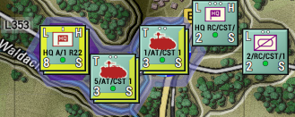

To issue any orders to the selected group, right-click on any of the highlighted units to see the Unit Popup Menu and select an order. If you select a movement order, the AI will provide intelligent pathing to keep the units in a cohesive formation and then spread them out at the final waypoint in defensive locations (if possible) to avoid stacking. You can select each unit and alter the placement of the waypoints as you see fit.

**NOTE:** Select the most used order for all waypoints that you want and then use each unit’s Dashboard to change the type of movement order at various waypoints. See Section 22.1.1 below

See more information in Section 22 below.

# Plotting Movement and Fires

One of the primary functions of a Commander is to direct your forces across the map to take or hold objectives. You will need to know how to order your forces and how to utilize artillery assets and airpower to achieve your mission goals and preserve your forces the best you can. The following information will show you how to move your units, issue orders, adjust and change movement types along the path, and issue artillery and air strikes on target locations.

## Movement

To order a unit or group of units (See Section 21.9 above) Right click on them to bring up the Unit Popup Menu. From there select a movement order. In this case, a Deliberate Move. Next, select up to six waypoints to path the unit to the location you want it to end up in.

The AI is smart and will intelligently path the units based on the terrain and your SOP selections (See Section 23 below). Once you have selected the path you can click on the Commit button in the Plotting Mode dialog that popped up when you started placing waypoints. If you wish to stop and cancel the order, you can click the Cancel button.

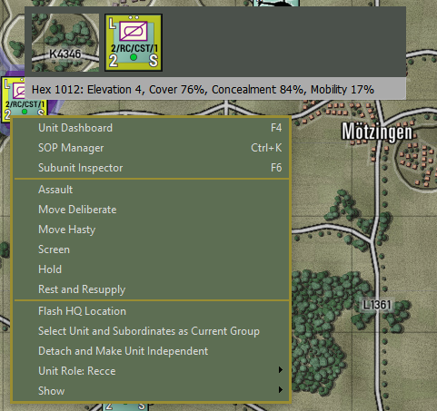

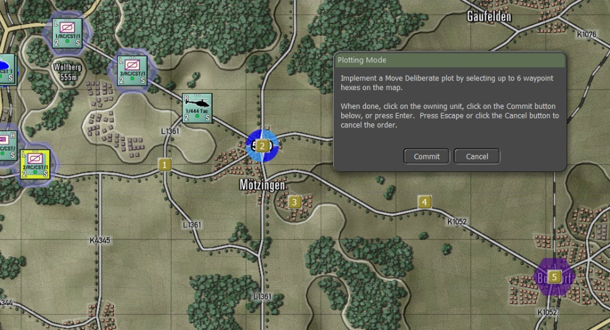

After pushing the Commit button, an Orders on Arrival dialog will pop up and you can set the final order state of the unit. The options for this box vary to match the type of unit and any special orders it has access to.

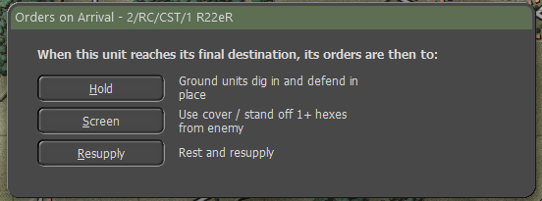

In this case, we will select a Screen order. Now the final path is shown for the unit.

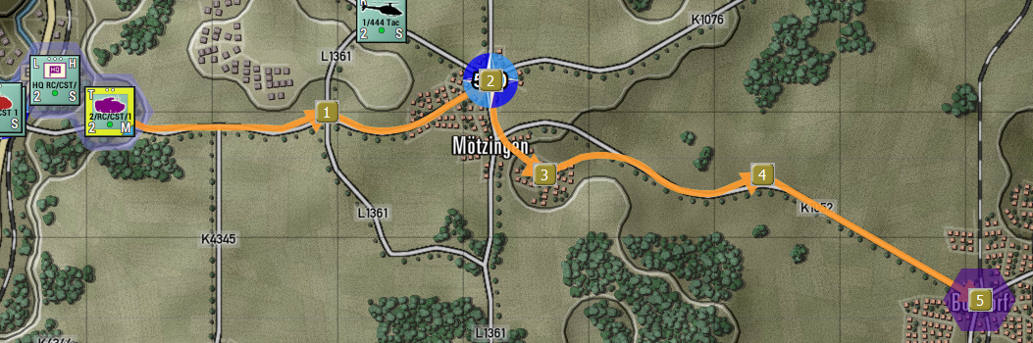

At this point, if you need to adjust the path, you can click and drag the Waypoint Marker to a new hex location. In this example, we will move Waypoint #2 to the south to the road junction. To make this a better move we also need to move Waypoint #1 one hex to the south to make the path choose the road heading south-east.

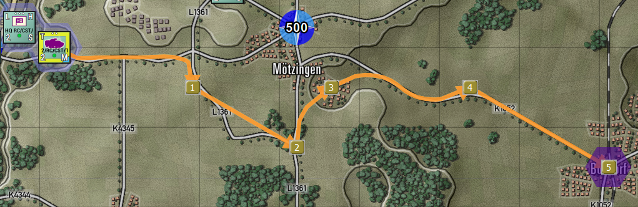

At this point, you also have the option to Right-click on any waypoint and pop up a Waypoint Editor menu.

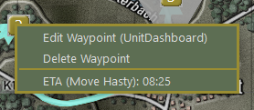

Selecting the Edit Waypoint menu option will open the Unit’s Dashboard on the Orders tab to allow you to make several changes to the order as detailed in the following sections. You can remove the waypoint by selecting the Delete Waypoint menu option. This will also delete any SOP setting for that waypoint. At the bottom is an estimated arrival time of the unit to that waypoint and the type of move to that waypoint.

Hovering over a Waypoint with the mouse will bring up a hint showing the Unit Name, Waypoint Number and Movement Order, and the start and arrival time of the unit to that waypoint.

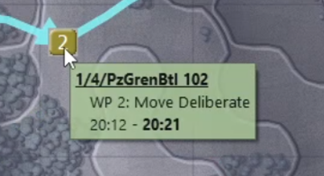

### Chaining Different Movement Orders

After plotting a set of waypoint movements, you have the option to go into the Dashboard for any unit (must be done per unit even if a formation or group move is issued) and change the standing order. Below is the initial plotted set of move orders for our unit.

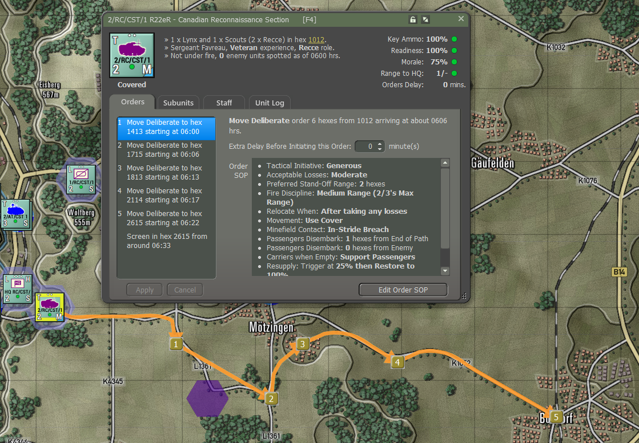

To view and change an order, select the waypoint order you want to change and right-click on it to bring up a menu of optional orders. In this case, let’s select a Move Hasty order so the unit moves the first part of this move quickly.

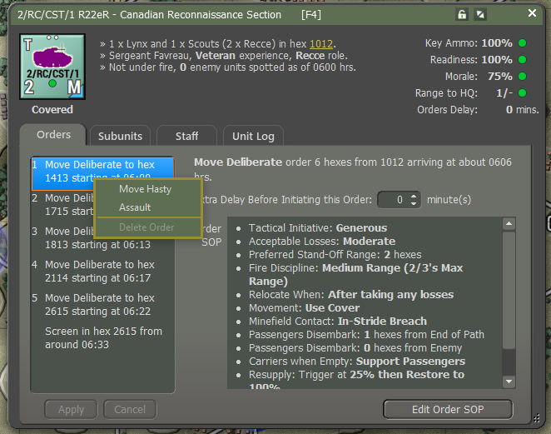

After changing the order, the waypoint order shown changes, the arrival times change for all waypoints as the first time is shorter, and the counter changes from a Deliberate Move marker (blue triangle) to a Hasty Move marker (Black Triangle).

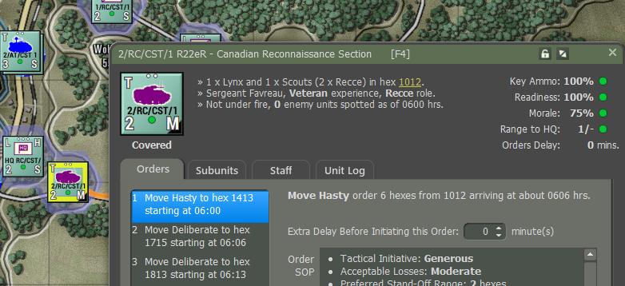

For some attacks, you may want to have the opening waypoints that are in friendly territory to be hasty and then move to Deliberate Moves when enemy contact is possible and then shift to Assault if you are taking a contested objective. You can also change the terminal (final) order at this point as well.

### Altering Waypoint Timing

In some cases, you as the commander may want several units to arrive in an area at the same time or close to it as events can alter that timing. To change the final time of arrival in the last waypoint, you have the option to set a delay time for each selected order in the Dashboard. As you alter the times with a delay you can set your point of timing. From there you can alter other units to have the exact arrival time by adjusting arrival at your scheduled time.

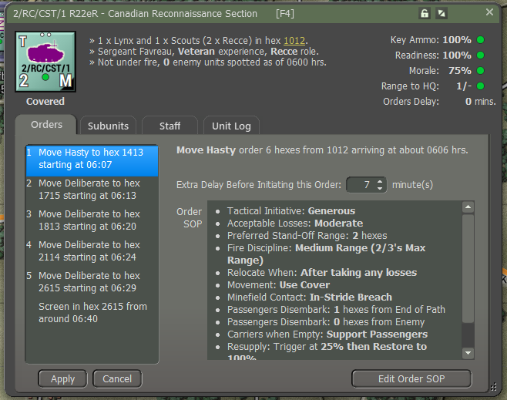

In the case above adding 7 minutes of delay to the start of the first order shifts the time to start the Screen in the destination from 06:33 to 06:40.

### Lost Transport Indicator

Another quality-of-life addition to the unit counter is the Lost Transport Indicator. When a unit (mechanized or motorized – vehicles and squads/teams) can no longer move its troops due to losses of the transport subunits, the Leg movement indicator (L) turns orange to note this condition. This helps to show the difference between a dismounted unit that shows the “L” indicator when troops are out of the transports in a non-movement order.

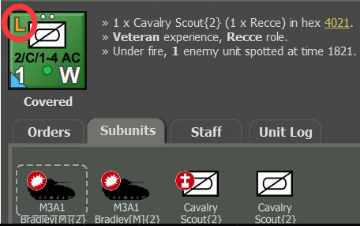

## Fires

The other aspect of plotting orders is setting up fire missions. This covers both on and off-map indirect fire units like mortars, guns, and rockets if any of these assets are available in the scenario.

To issue a bombardment order, open the Unit Popup Menu by either right-clicking on an on-map artillery unit or opening the Fire Support report and clicking on the Menu hyperlink. Once open, click on the Bombardment option in the menu to open the mission menu with the attack options.

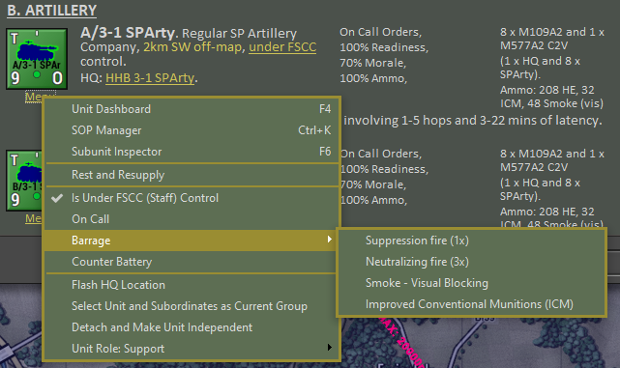

**NOTE**: The choices of mission types are based on the ammunition allocated to the firing unit by the scenario designer.

Once you have selected the type of fire mission, the Plotting Mode dialog will pop up and tell you that you can place up to six Target Reference Points (TRPs) on the map and within range of the unit (inside its indicated Maximum Range (shown on the map) and beyond any Minimum Range indicated for the unit. These locations are where the munitions will drop.

The only other possible coverage of a strike is with rockets that can do a Saturation Strike that is centered on the selected hex but also hits the ring of hexes around the TRP.

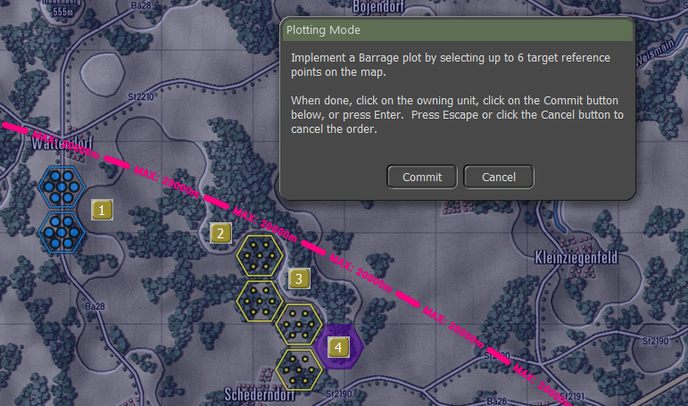

After hitting the Commit button, the hexes being attacked will be highlighted and fire lines from the firing battery will be shown on the map. The Dashboard will also pop up automatically (you can turn this off in the game options) so you can set various parameters of the fire missions and even change the type of fire mission.

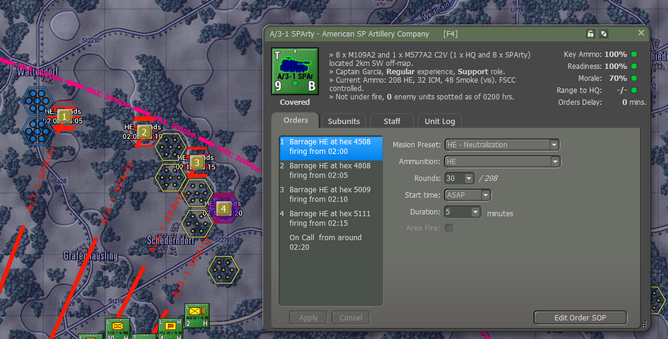

On the Orders Panel for a Fire Mission, you have the following options to adjust or change for the selected TRP:

* **Mission Preset** – This dropdown allows you to change the type of bombardment mission from the type set initially with the setting of the TRPs. If the mission is changed from the original via the Ammunition dropdown, then the Preset will be called Custom.
* **Ammunition** – There is the option here to select different types of ammunition. This is helpful in cases like HE rounds where a few different types may be available.
* **Rounds** – You can set the number of rounds to shoot on the mission. The total number of available is noted after the slash (/). You cannot shoot more rounds than you have.
* **Start Time** – You can set the time to ASAP which will fire as soon as the delay of the order is done (for opening salvos during the first turn set up, planned missions will start to fall immediately). There is the option to delay the mission several minutes if timing is vital to your plan.
* **Duration** – This sets how long the mission will last and sets the number of rounds per minute that get fired. In the example below that would be 2 rounds per gun in the unit per minute over 10 minutes. With eight tubes in this unit that is 16 rounds impacting every minute.
* **Area Fire** – If the artillery unit is a rocket launcher, The Area Fire option will be active and if checked, will fire a saturation strike (target hex and the surrounding ring of six hexes). This strike fires all rockets on the launching platforms.

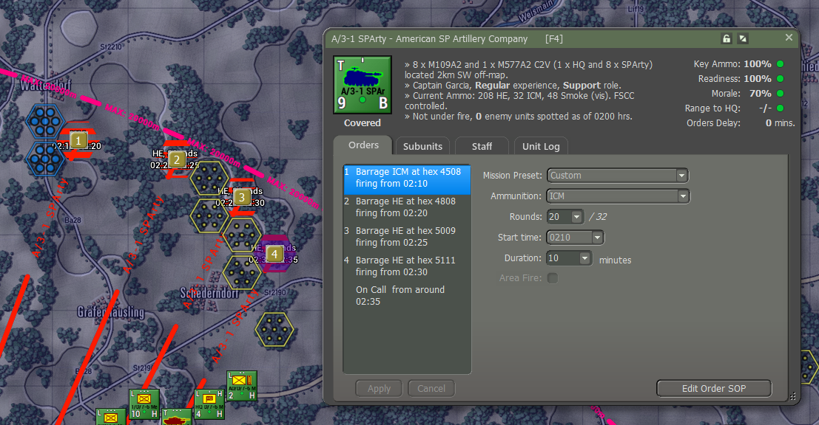

## Calling in Airstrikes

To call in an Airstrike, you need to have available aircraft in the scenario. There are two ways to check and then call in an airstrike. The first option is to open the Fire Support Report and look at the Fire Support Assets tab. In this case, Section B shows available Close Air Support (CAS) that you can call in. The second way is to open the Off Map Asset (OMA) dialog and look for what aircraft you have.

Aircraft may not be available until they arrive as a reinforcement to provide support and that will be noted in the dialogs. Most aircraft will also have a hard withdrawal time when they return to base and can no longer be used. Weather and time of day can also impact air operations. Some aircraft are not capable of night or all-weather operations over the battlefield. Aircraft have one other threat that you as the commander need to consider and that is the current Air Superiority level over the battlefield. If control of the air is owned by your side, your air strike has a much better chance of getting to the target and delivering ordnance on targets. If the airspace is contested or owned by the enemy, your air strikes run the risk of being run off or worse, shot down.

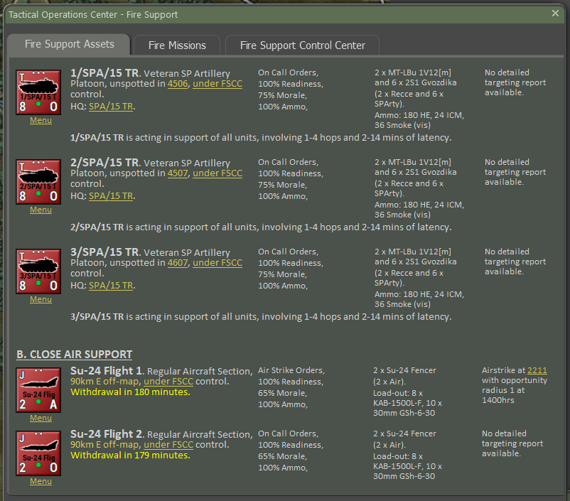

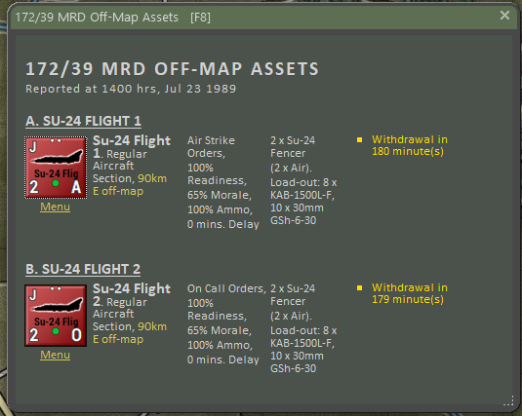

Selecting the hyperlinked Menu option will bring up the Unit Popup Menu and you need to go down to the Strike section that looks as seen below and select the Airstrike option.

If you want to order in-air units instead of the FSCC doing it when targets of value show up, you should click the Is Under FSCC (Staff) Control and turn the checkmark off. Selecting On Call will cancel any strikes and return the aircraft to its on-station location where it awaits a call to strike.

There is also the option on the menu (not shown) to Rest and Resupply, this will return the aircraft to the base to rearm and refuel and then return on-station for future use.

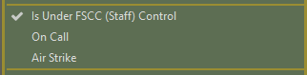

After selecting an Airstrike, the Plotting Mode dialog pops up and you can select a single hex to be the target of the airstrike.

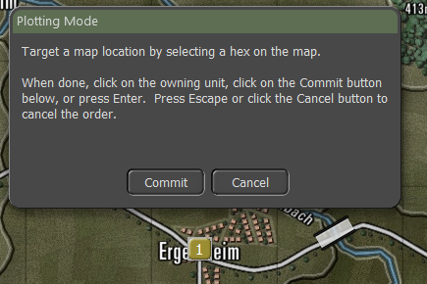

Select a target hex and click the Commit button to issue the order. Pressing Cancel will stop the order and return you to the game with the aircraft On Call.

Once the aircraft is ready to attack it will appear on the map near the target location and will attack the best target it sees in the area. The discretionary radius of target selection is set in the Nation Data and cannot be altered.

# Standard Operating Procedures (SOP)

One of the more requested features from earlier games was the ability to set Standard Operation Procedures in more detail for your units. We have that now and it is a very powerful tool for you as the commander to wield. This tool gives you the flexibility to adjust many different operational parameters of your units, per unit, per waypoint, and for new orders. Grayed-out parameters are not available for the selected unit.

These SOPs can be applied to the selected unit or easily copied to other units in the formation or of a similar platform type.

To open the SOP Manager, you can right-click on a unit or select Menu hyperlink from a report and select it from the Unit Popup Menu, select a unit and hit Ctrl+k on the keyboard, click on the Edit Order SOP button on the Orders tab of the Dashboard for the selected unit or open the dialog from the SOP Main Menu option.

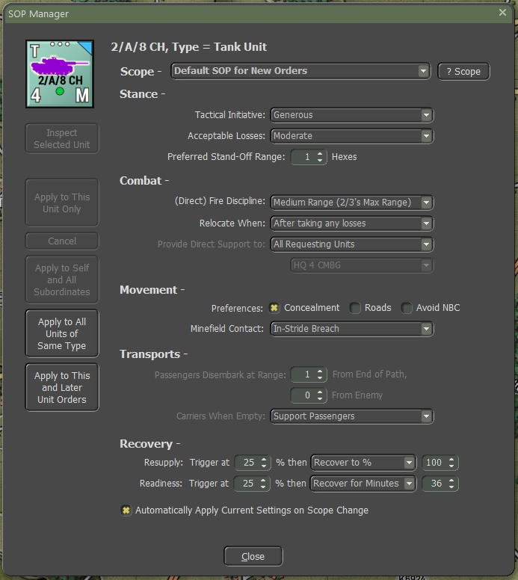

## Scope

The Scope sets which order (new, current singular order like Screen or Hold, or per waypoint of a move) the settings are applied to. Once all the settings are adjusted to the parameters you want for the unit(s) there are options on how to Apply them as noted in Section 23.7 below.

Selecting the “? Scope” button will pop up the following message providing information on how the Scope is used.

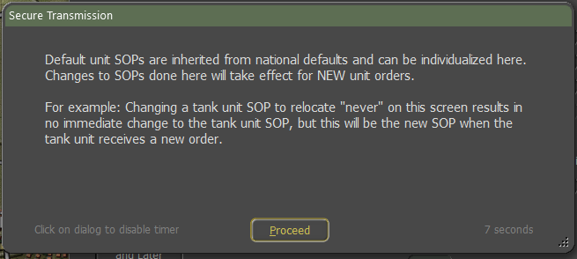

## Stance

* **Tactical Initiative** – This is the likelihood of a unit deviating from its orders or pathing based on the current situation it is in (under fire, outnumbered, etc.). These settings are None, Slight, Moderate, or Generous.
* **Acceptable Losses** – This is the unit(s) willingness to take losses before seeking a change in orders. This works with the Tactical Initiative above to set how a unit reacts. The settings for this item are Do or Die, Substantial, Moderate, or Minimal.
* **Preferred Standoff Range** – The number of 500m hexes you wish the unit(s) to be distant from any detected enemy units.

## Combat

* **Direct Fire Discipline –** This sets the range or ability to shoot at enemy units in direct fire. The available settings are Refuse fire, Hold until fired on, Point blank (0 to 1 hex), Short Range (1/3 Max Range), Medium Range (2/3 Max Range), and Maximum Range.
* **Relocate When** – This determines under what condition a unit will seek to scoot to a new location for better protection or to avoid enemy fire. The possible selections are After each fire mission, After all fire missions, While the enemy spotted, After receiving any fire, After receiving direct fire, After taking any losses, After taking direct fire losses, or Never. Some of these settings work better for certain types of units. The after-fire mission settings work better for artillery for instance.
* **Provide Direct Support to** – This setting is for Indirect Fire Units only and allows you to set specific direct support operations for your artillery assets. The default setting is support for All Requesting Units. This is equal to General support as noted in Section 25.4 below. Other options that support specific units are Units in the same formation or lower, Specified HQ or lower, or Refuse all requests (which stops the FSCC from using this unit in any supporting call for fires). In the selection box below is a listing of units to attach support to.

## Movement

* **Preferences** – When a unit moves from waypoint to waypoint there are a few options for how that travel can be done. The hasty move will prefer roads, and Deliberate or Assaulting move orders will mix roads with cross-country movement. You can set stricter movement preferences by checking the boxes for Concealment (more off-road and seeking better-covered terrain to move through, Roads (favor taking roads instead of cross country) and Avoid NBC (which will path units around NBC-contaminated locations on the map).
* **Minefield Contact** – This is the unit(s) response to entering a minefield. The options here are Ignore and Run (do not delay and accept the potential for more subunit losses crossing the field).

In Stride Breach (units slow down to follow a leader through the field hoping to avoid mines by traveling in the same tracks), or Stop and Reduce (units halt and either wait for engineers to remove enough mines to open a path through or do the work themselves at a slower rate).

## Transports

* **Passengers Disembark at Range** – There are two options for disembarking transported troops and teams from their carriers. The first option is setting a few hexes (500m) from the final waypoint. This is useful for assaults or recon efforts in hostile territory. The other option is setting a few hexes from a spotted enemy. This is useful if on the move and your troops encounter unexpected enemy contact.
* **Carriers when Empty** – Once transporting APCs (Armored Personnel Carriers) or IFVs (Infantry Fighting Vehicles) disembark their troops or teams, this setting tells the transporting units what they should do. For APCs, the better choice is to Hide Nearby (seek cover and do not engage the enemy) as these vehicles are usually poorly armed and armored. The other option is Support Passengers (seek good cover but engage enemy units with on-board weapon systems) to improve firepower against the enemy, but risks losing transports to enemy fire.

## Recovery

* **Resupply** – This option lets you set a limit for the unit’s Ammo level and when it hits the trigger level or below, the unit will go into resupply until it either Recovers to the set percentage over time or recovers for a set amount of time which restores an amount of ammo based on the amount of time set.
* **Readiness** – This option lets you set a limit for the unit’s Readiness level and when it hits the trigger level or below, the units will go into resupply until it either Recovers to the set percentage over time or recovers for a set amount of time which restores an amount of readiness based on the amount of time set.

## Inspect and Apply

There are six buttons on the left of the dialog that are used to do the following:

* **Inspect Selected Unit** – If you want to select and see the SOPs for another unit on the map, select a new unit on the map and then click the Inspect Selected Unit button to have the SOP Manager display its SOP values.
* **Apply to This Unit Only** – Applies all the changes made only to the selected unit.
* **Cancel** – Restores the original SOP values before any changes are made. Once You do an Apply, there is no way to revert changes via this option.
* **Apply to Self and All Subordinates** – This setting is helpful if you want to set all the units in a formation (HQ and subordinates). The higher the HQ, the more units will be changed down the order of battle chain. When applied a dialog will pop up showing all the affected units.

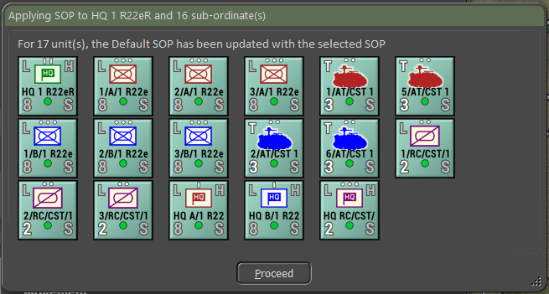

* **Apply to All Units of the Same Type** – This setting is useful if you want to set all the units of a selected type (like Tanks, APCs, HQs, etc.).

When applied a dialog will pop up showing all the affected units.

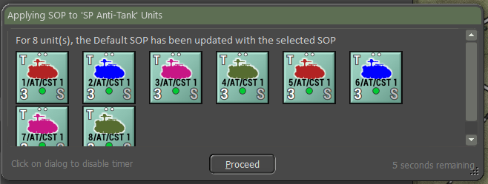

* **Apply to This and Later Unit Orders** – This option allows you to take the current SOP setting and apply them to all the orders in the Scope list.

At the bottom of the dialog is a check box to Automatically Apply Current Settings on the Scope Change. If this is active, any changes that are applied to the indicated scope will apply if you select a new unit and click the Inspect Selected Unit button. With it active if you switch to a new order in the scope selection, any changes will be applied to the previous order scope.

## Copy SOPs via the Spotlight Panel

There are a few more tricks with SOPs. Once you have an SOP loaded (and edited) in the SOP Manager, you can apply it to parts of the OOB Tree in the Spotlight Panel (toggle the view with F10 to see the OOB Tree as the Unit Details are showing). Select a unit to paste the current SOP setting in the SOP Manager and right-click. From the popup menu select the option you wish to “paste” to the selected unit.

The trick with the SOP Manager is to keep it open, go out, and paste the SOP where you need it. Think of it as a clipboard more than an editor for a single unit's SOP. You can apply the setting to any number of units in the Spotlight.

# Spotting and Line of Sight (LOS)

The ability to detect, that is distinguish between a military platform and its surroundings is heavily impacted by illumination, especially when not equipped with excellent Thermal Imaging or Night Vision equipment.

So, the gameplay panel gives you weather conditions and weather/meteorological visibility. The rings indicate this unit's ability to detect military units.

Spotting requires that the spotting unit have a clear Line of Sight (LOS) to the target and that the target be visible to the spotter at that range. Having a clear LOS to spot a target is required to shoot at it.

It is possible only to see a small number of subunits in a unit depending on the cover and concealment value of the hex that the enemy is in and if there are other factors like movement, smoke, or weather effects.

## Spotting Units

A unit has a maximum spotting range within which it can potentially see any enemy unit. This will generally equal the maximum visible range for the time of day and weather except when:

* The unit is firing or moving - its attention is presumed to be at least partly concentrated on that task and unit sighting is slightly reduced.
* The unit posture is Very Exposed; it is presumed to be feeling unthreatened and is not particularly attuned to its surroundings. The unit sighting range is slightly reduced.

Spotting is evaluated after every move, change of posture, burst of fire, and type of sensor capable of spotting enemy units. Spotting range is a function of weather, visibility range, posture, orders, readiness, currently moving, currently firing, special equipment like ground radar and thermal imaging, smoke, terrain, elevation, observation height, etc. Each sensor and means of spotting are checked versus each possible subunit meeting both the range of spotting and spottable range distance.

Units also have an individual “spottable range”. The spottable range is a function of unit posture, size, terrain, currently moving, currently firing, etc. Enemy units beyond this range cannot spot them unless special sensors are involved.

For example, a small non-firing infantry unit on a hilltop can see a long way but can be spotted from only a very short distance.

The current spotting and spottable ranges for each unit can be viewed by selecting the Show LOS (Ctrl-L) or Show Spottable From (Ctrl-O) function on the orders menu. Spotting states:

* **Undetected** – the unit counter is not revealed to the enemy in any way. There will be no indication that it is in a particular location at all.
* **Detected** – The contact may be as imprecise as a rising cloud of dust or a fleeting glimpse of unknown vehicles between some trees or buildings. The unit counter with nationality and question mark (?) but no other details will be revealed. This contact is not strong enough to count as a spotted target for artillery or other types of combat. The unit is not browsable in this state and does not show up in the tally of enemy runners. If Automatic Spotting is enabled, then all enemy units will be shown in this state at the minimum.
* **Classified** – The unit type has been revealed with a fair degree of accuracy. Some counter details are shown. An example of a Classified unit would be a tank company, an artillery unit that has fired and given away its location, an HQ that has been too busy on the radio, or a unit that has been previously spotted and has not yet moved away.
* **Identified** – The unit is close enough and has been seen long enough to determine the exact types of subunits in the enemy unit and most of the unit counter information is shown.

All headquarters and artillery units are deemed to automatically spot every enemy unit spotted by any friendly unit via radio communication and that allows the Staff FSCC to direct fires at known targets.

Units that disappear from LOS may become “lost” and need to be reacquired to be identified again.

## Line of Sight (LOS)

Due to a combination of elevation and terrain considerations the potential exists to have sweeping vistas in some directions and to be all but blind in others.

A view from one hex to another is considered blocked if there is an intervening elevation or if the accumulated visual clutter due to cover, wrecks, and smoke along the LOS drops the visibility below 10% for most units.

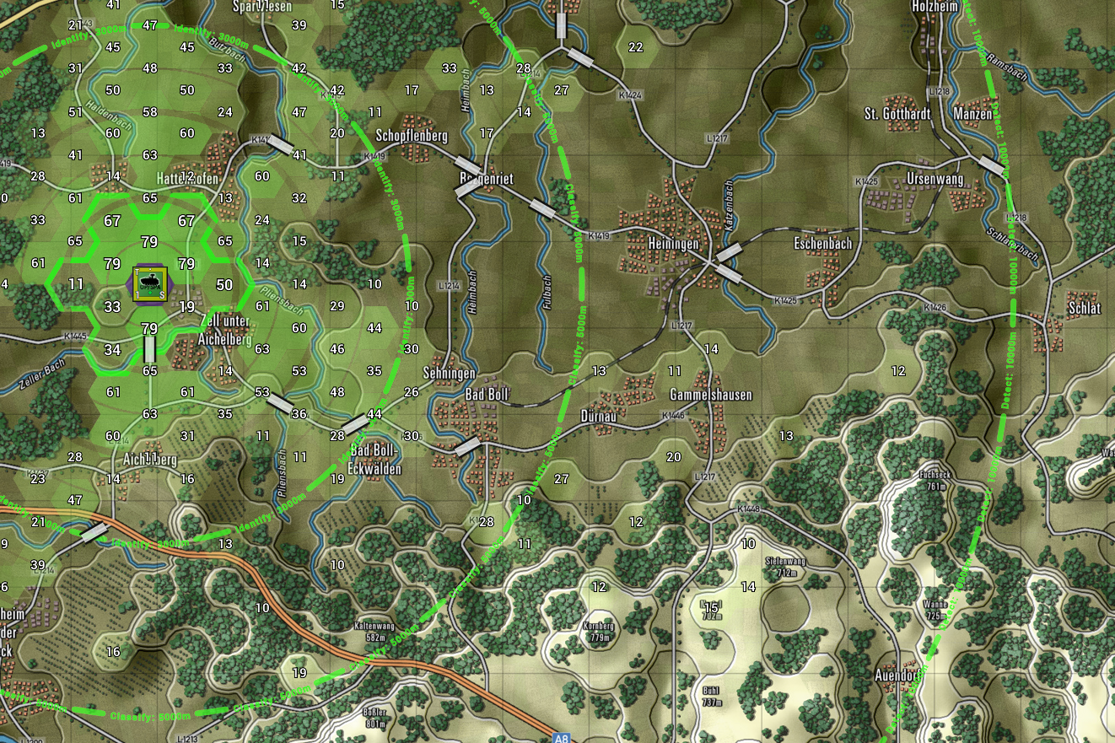

LOS is checked in two steps:

First, there is a hard check of elevations between each spotter and each subunit in the target unit. If a line from one hex to the other is broken by an elevation at or above the line at the location the LOS is blocked.

If the first check passes, the second test is to see if the accumulated visual hindrance from the terrain, smoke, wreck, etc. falls below 10% and is considered blocked.

Recon units and units with thermal sights have a bonus that improves their ability to see deeper into terrain or through smoke.

## Time of Day and Weather Impact

Visibility during the night is the same as during the day and is determined by the dust and water particles in the air.

On a clear night, you can see as far as the moon allows, and you might see distant flashes from guns firing. We cap visibility at 10km for Western Europe via the weather data.

Illumination at night is low (between 0% with no moon to 40% at full moon) vs 100% during the day and an in-between value during the dawn and dusk transitions. Even though the visual range may be several thousand meters at night, the visual spotting range is a function of the night illumination level. Without thermal or other means of illumination, optical spotting at 0% illumination is not possible.

For more information on Time of Day see Section 28 below. For more details about the types of Weather in the game, see Section 29 below.

# Combat Operations

Combat is the very focus of this game. Because of that, it is very detailed and may be confusing at first. In this section, everything that has to do with combat is explained. The different unit and ammunition types that are included in the game will make sure that a lot of different types of combat will occur during a scenario or a campaign. Even chemical (persistent and non-persistent) and nuclear weapons might be used.

## Unit Postures

During a battle, units will go through various changes in Posture. This is a measure of how visible and how protected a unit is based on its movement state and the local terrain. Posture states are listed below:

* **Very Exposed:** Unit moving/sitting in terrain with no real cover or concealment regardless of order. Very easy to spot. No additional protection from the terrain against any form of enemy fire.
* **Exposed:** Unit moving/sitting in terrain with minimal cover or concealment based on order. Moving units are easier to spot. No additional protection from the terrain against any form of enemy fire.
* **Covered:** Unit moving/sitting in terrain with useful cover or concealment. Spotting dependent on movement and terrain levels and thermal/radar signature is mildly degraded.

Depending on the terrain, protection from direct fire is a function of the cover afforded by the terrain.

* **Dug In** Unit sitting in terrain with a Hold order will spend 20-30 minutes digging into the covered terrain or units in an Improved Position location. Unit is difficult to spot and thermal/radar signature is reduced a moderate amount based on the cover of the terrain. Extra protection from the terrain against any direct enemy fire. Not effective at artillery or air strike damage.
* **Fortified:** Unit sitting in a fortification with extreme cover and concealment. Very difficult to spot and radar and thermal signatures are greatly reduced. Extra protection from the fortification provides more reduction against any form of enemy fire.

## Unit Facing

There is no control over the unit facing in the game. It is assumed that the units are smart enough to show a frontal aspect if the enemy is detected. If caught by surprise, a target unit at range may have some subunits get hit in the flank as they are not in a defensible position. At a range of one hex, there is an increased chance of getting a flank attack on a target unit as some of the subunits are assumed to be close enough and, in a position, where flank shots are possible. If both the attacker and defender are in hex, attacks have a better chance to be flank or rear aspect shots as cover and spacing allow for more advantageous engagements. Infantry attacking armored fighting vehicles (AFVs) in built-up terrain (cities and forests) have a bonus to these better aspect shots.

## Direct Fires

All combat occurs during the turn resolution phase. Spotting is checked for all units and then each unit with Assault, Hold, Screen, Move-Deliberate, Move-Hasty, or Direct Support orders looks for suitable targets among the enemy units that it can sight directly or indirectly in some cases. A combat event for each pairing of attacker and defender is created and entered in the main game event queue.

The combat event is resolved between the two units at the subunit level. The attacking unit calculates the quality and quantity of fire that it can effectively protect against the defender given the number of subunits that it has, the armaments that they mount and their effectiveness versus the target subunit, the range to the target, armaments base accuracy, attacker orders, crew quality, suppression from incoming fire, multiple targets, and special bonuses such as advanced gun sights.

This effective projection of fire is applied to the defending unit which will take losses about the quantity and intrinsic protection rating of its runners, defender orders, posture, usable terrain bonus, movement, stealth, range, and special bonuses such as armor (Chobham, advanced composite, laminated, or reactive). The defender is also penalized if he has not sighted the attacker - surprise is assumed for the first few shots - and if the range is one or less then there is a further penalty due to the assumption that more flanking shots are available when at such close range.

The attacker uses up munitions by the round or burst used to engage the enemy and is marked as “firing”. This “firing” status makes it easier for other units to spot it during the turn. Attacking also reduces a unit’s readiness by a small amount as the crew deals with the rigors of loading and firing weapons or scanning for targets. Units occasionally gain a boost to morale if they achieve kills without taking losses.

Defending units can take losses because of combat. These losses are tracked to individual subunits. Readiness and morale will both be degraded in these cases. Morale can take a bigger hit if the HQ is out of range or if a friendly unit within 1000 meters is wiped out.

Units are not mindless zombies that die to the last subunit. If losses in the unit are too great and readiness and morale are low, a unit will spontaneously give up its mission orders and try to retreat to a safer location by scooting.

## Indirect Fires (IDF)

Where direct fires have the shooter seeing the target, indirect fires rely on another unit to spot a target and provide targeting information for the indirect fire units to use to shoot with. The advantage of indirect fire is its much longer ranges and less exposure to direct combat.

Indirect fires are guns, rockets, and mortars that fire munitions (or are munitions in the case of rockets) over the battlefield.

These systems show up on the map as various explosion animations in the target hex based on the type of munitions used. In our earlier games, artillery fired in a piecemeal fashion with several rounds being resolved each turn they attacked. Now, each gun fires rounds, and the attack lasts over a duration as shells are fired until the mission is over. This means enemy units can move into and out of the hex(es) being attacked. In some cases, the fire will be adjusted to follow targets if they are under direct observation and there are timely communications with the observer and shooter.

Artillery fire missions can be of a few types as noted below:

**Direct Fire** – Some field gun-equipped artillery platforms can point themselves at an enemy and fire directly. The wisdom of this is highly debatable but it can be done. Interestingly, Soviet tactics put great store in this technique and 122mm and 152mm SP howitzer assets can be attached to their assault formations to use direct fire against targets. While it is certainly much quicker than trying to organize on-call fire the cost to the lightly protected artillery would be horrendous. They used this technique extensively in the second half of WW2 with the SU-76 (76mm guns mounted in light tank chassis) and the 2S1 and 2S3 vehicles are the Cold War inheritors of that tradition. All other force structures might want to consider this a measure of last resort.

**Pre-Plotted Fires** – These fire missions represent pre-registered targets for the artillery units to shoot at the start of a battle. For the AI player, the artillery barrages need to be set up in the Scenario Editor to start right at the start of the battle. For the player, this kind of strike needs to be plotted in the Setup Phase before the start of the battle and will start falling right when the first turn is executed.

**Direct Support** – These are artillery assets that are dedicated to supporting a selected unit or set of units. These assets will not take on fire support requests from other units or provide counter-battery fires and are ready to perform fire missions only for the enemy units spotted by the units placed in direct support. These missions usually have slightly shorter command delays than the General Support operations.

**General Support** – These are artillery assets that will take requests for fire from any friendly unit on the map and process them based on target type, urgency, and availability via the FSCC. Standard command delays exist for this type of support.

**Counter Battery** – These assets are set to fire on located enemy artillery units that are in the range of the counter-battery unit. This includes both on and off-map assets and targets.

### Fire Support Control Center (FSCC)

Fire support mission requests are made either through player intervention during the orders phase or automatically through their staff FSCC (AI) during the turn resolution phase. Line units will automatically generate fire support requests during the turn resolution based on their sighting activities as the turn unfolds. Fire support requests are also generated by the staff when ordered to prepare a fire support plan as part of the AI planning cycle.

Fire support requests are rated for target type, priority, and weight of fire, type of munition needed, and are queued in descending order of importance (priority multiplied by weight of fire requested). Fire support requests are discarded if the target is lost or too much time passes between the initial call and the unit being able to shoot. This is done so as not to waste ammunition shelling the empty ground.

During turn resolution, the FSCC is called to match fire support requests to available air and artillery assets. To be “available” an artillery unit must have an On Call, Direct Support, or Counter Battery order and otherwise be ready to fire (i.e., not wiped out, not moving, not already assigned an FSCC mission, etc.) or be an On-Call aircraft.

Other missions are served first by eligible artillery units with Direct Support orders, then by General Support units, and finally by units with counter-battery orders if they are available.

Available air and artillery units are assigned to the mission until the requested weight of fire has been accumulated. The necessary combat events are created in the game event queue and the selected units will fire. The fire support request is marked as done and the rest of the list is processed until the supply of available artillery units is exhausted.

Artillery units that have manually been assigned a Barrage mission will fire as ordered and revert to On Call when done shooting all missions. At that time, they will be available to service FSCC or player requests. If an artillery unit runs low or out of ammunition, it will go on a resupply order to replenish its stocks. Depending on SOP settings, artillery units will scoot after shooting to avoid potential enemy counterbattery fire.

### Observed Versus Blind Fire

When shooting with indirect fire assets, they can fire on known observed targets or on locations where targets were detected by electronic means or lost visual contacts where there is no observer to the fire. Observed fires will have a better chance to hit and the ability to shift hexes if the target moves into a new hex. Blind fires will be much less effective for the same volume of fire when there is no one to adjust the fire to the targets.

## Air Defense (AD)

There are both dedicated anti-air units and some units with weapons capable of engaging air targets in the game. These platforms are defined as follows:

**Surface-to-Air Missile Units (SAMs)** – These units use surface-to-air missiles with radar, IR, or optical guidance to track and engage enemy aircraft and helicopters. These units have a limited number of missiles and usually have air search radar or advanced optical systems to find targets.

**Flak Units (AAA)** – These units rely on cannons or machine guns to engage air targets with a wall of lead or proximity fuse explosives. Ammunition for these units is tracked in bursts of fire. These units can have air search radars and other optical means to find and track targets.

**Air Defense Limited (ADL) Units** – Some units have machine guns, auto-cannons, or in some cases Anti-Tank Guided Missiles (ATGMs) that can be used to engage air targets in a limited capacity. For these units to shoot at an air target they must be the target of an air strike engage a hover helicopter or engage a helicopter approaching them in a roughly 30-degree cone (these weapons cannot effectively track a moving crossing target).

Some platforms may have a mix of these systems to use.

## Air Strikes

When an airstrike is called in the air strike controller will automatically select the best value target location for the air strike within the discretionary radius allowed (they will default to the stated target if other targets only tie it for value). The target value is based on the number of visible targets and less apparent air defense strength. If the target location is empty of targets when the air strike arrives, the attack is aborted, and the aircraft returns to its on-call station.

An airstrike attack starts with the sound effect of the approaching jet(s) and the following sequence of events happens:

* The target location will flash, and the attacking aircraft will appear over the target unit.
* All eligible defending units (Air Defense (AD) units and units with air defense capable weapons) located within range of the target location will attempt to detect the attacking aircraft.
  + Air defense units are much better than standard units with anti-air weapons. Units with Air Defense Capable weapons must have the aircraft approaching it directly to engage.
    - Those AD units that happen to spot the fast-moving attackers will fire during the approach.
  + If the aircraft is a Level Bomber flying at higher altitudes above the battlefield will only be engaged by weapons that reach the target altitude.
  + Both aircraft and air defense units have a few electronic and other systems used to degrade the performance of the enemy.
    - Combat hints will alert the player to radar detections, AD attack evasions, and finally loss of aircraft if one or more is shot down. If an aircraft is shot down, then an appropriate sound effect is played.
  + Pilot readiness plays heavily into their ability to detect AD fire and avoid it. If you push your pilots on repeated passes the fatigue may lead to a mistake and a loss of the aircraft and crew.
    - On the ordnance delivery pass the bomb special effects are rendered in the impact location and combat losses are immediately applied to all units located there. Friendly and enemy units are both equally at risk if they occupy the impact location.

When the mission is over the aircraft will be given Resupply orders if it is out of ammo or it will return to its on-call station awaiting another strike order. Aircraft given a Resupply order will return to base to rearm and refuel and will be available again after 30+ minutes.

## Helicopter Hunting

One of the new orders in the game is the Hunting Order for helicopters. This order allows you to set several waypoints (up to six) that the helicopter will fly between looking for enemy units to Spot (Recon Helicopters) or engage (Attack Helicopters). The helicopters will continue to move from hex-to-hex masking with cover where possible. Helicopters under fire will attempt to scoot away from the attacking units. When an armed helicopter runs out of munitions it will fly back to the nearest FARP (Forward Arming and Refueling Point).

## NBC Warfare

These weapons are extremely powerful and not to be taken lightly. Weapons of mass destruction come in three types: Nuclear weapons, Persistent Chemical weapons, and Non-persistent Chemical weapons.

**NOTE:** The game does not include biological weapons on the battlefield.

**Nuclear weapons** - A nuclear strike (which has a very awesome animation) is resolved as a series of separate attacks against all units caught within the blast range. For game purposes, we assume a tactical nuclear capability of approximately a 10kt yield with a 2 km blast radius. Subunits will be eliminated based on distance from the blast center by their intrinsic protection rating, NBC rating, cover, and posture. Units also suffer massive losses in both readiness and morale even if they survive the blast and are automatically contaminated with radiation. Contamination can cause additional losses over time if not dealt with in a short time after the attack. All bridges, smoke clouds, minefields, and chemical contamination within the blast zone will be eliminated.

The ground will be contaminated with two hexes from the blast center for the rest of the game. Units moving through the contaminated zones run the risk of additional losses and get contaminated. All helicopters within a 5 km radius will be eliminated by the blast’s shock wave. To decontaminate units, they must enter a Resupply order and spend time being cleared of the hazard.

**Persistent Chemical Weapons** - A persistent chemical strike consists of various nerve or blood agents that can quickly incapacitate or kill exposed troops. Units caught in a persistent chemical attack can suffer losses based on their NBC rating take a considerable loss of readiness while getting into protective gear (MOPP suits) and suffer additional morale loss from the attack. Persistent chemical strikes leave markers on the map for the rest of the game. Any units moving through are attacked and contaminated. Like nuclear contamination, chemical contamination can be removed by a resupply order. Contaminated units fight with reduced combat effectiveness caused by the protective gear.

**Non-Persistent Chemical Weapons** - A non-persistent chemical strike consists of various nerve or blood agents that can quickly incapacitate or kill exposed troops. Units caught in a non-persistent chemical attack can suffer losses based on their NBC rating take a significant loss of readiness while getting into protective gear (MOPP suits) and suffer additional morale loss from the attack. Non-persistent chemical strikes leave a gas cloud on the map that will dissipate over a short period based on the weather conditions. Any units moving through the gas cloud are attacked.

## Electronic Warfare (EW)

Electronic Warfare is the art of spectrum warfare. This is the use of electronic equipment to jam or spoof radio communications or jam search radars. This work is done by assets above your command level but may benefit your forces if your side is working to disrupt the enemy. On the other hand, if the enemy is disrupting your forces, command delays will increase as your communication efforts are hampered by enemy action.

In a scenario, these levels are set by the scenario designer, and you can review the levels in the Intelligence Report. The enemy's EW interference is noted on the Command Panel as well.

## Air Superiority

Air Superiority is a rating of whose force controls the airspace over the battlefield. When your forces on the air, your air strike can get on the map with weak opposition from enemy fighters. If the enemy owns the skies, there is a greater risk of losing air strikes on the way to their mission targets and even on-map helicopters can fall victim to an air-to-air missile from a fighter. All these actions are abstracted with messages popping up on the screen when interdictions occur in the game.

In a scenario, these levels are set by the Scenario designer, and you can review the current level in the Operations Report or note the level under the weather panel display on the Game Panel.

# Combat Soft Factors

One of the key factors that impact combat operations is those things known as Combat Soft factors. These are the soft data items that represent the human elements found on the battlefield. The three key elements used in the game are Readiness, Morale, and Training.

## Readiness

Readiness is a number from 1 to 99 (best) representing the ability of the unit to perform as required. Readiness is lost during combat and movement actions. Readiness is recovered when a unit sits in place without being fired on or if it resupplies. The rate of recovery per hour for the unit is shown. If a unit’s readiness goes critically low, it will be noted in the Staff Alerts.

## Morale

Morale is a number from 1 to 99 (best) representing the mental state of the unit. Morale is lost in combat by taking losses or being close to friendly units that take losses. Morale is recovered slowly by resting and resupply and occasionally by obtaining kills against other units. If a unit’s Morale goes critically low, it will be noted in the Staff Alerts.

## Training

An identifier representing the average amount of prewar training received. These training levels range between Untrained, Green, Average, Veteran, and Elite. The higher the unit’s level of training, the more likely it is to perform better on the battlefield, suffer less readiness and morale reduction from events, and recover faster from those losses. This training level is noted before the primary type of unit in many detailed information displays like the Spotlight Panel.

# Supply and Logistics

Supply is the Achilles heel of all modern armies. It is burned at a ferocious pace during operations and commanding officers are constantly mindful of ‘topping off’ their units. Given the basic scale and duration of the game, ammunition is likely to be far more of a limiting factor than fuel, rations, or other forms of supply.

The lesson of the 1973 Arab-Israeli war was that ammo gets used up far faster than expected; rates of 5 times greater than expected were not unheard of. It is an integral part of the command dilemma to be able to ration it out effectively.

In game terms, resupply is presumed to occur whenever a unit receives Resupply orders and there is a lull in the action, and the supply trucks and other vehicles can come forward and provide ammo and fuel to combat vehicles in place. Alternatively, individual vehicles drive a short distance to the rear to resupply and then return to their original location.

As stated earlier, for a unit to resupply, it must be clear of enemy units and combat. Units within the command radius of their HQ can get fully resupplied on ammo and gain more readiness and morale recovery. Units outside of the command radius get a small percentage of ammo replacement and gain a minor improvement in readiness and morale.

## Ammo Loadouts

One of the new features of the game is tracking ammunition down to a single round and by type for most weapon systems.

Where this new system is utilized is with gun systems that use different munitions and rocket pods. In the future other weapons will be converted over to having munition options as required.

Ammo loadouts are set by the scenario design for each unit and during combat those munitions are used per subunit based on the combat situation and available rounds.

The ammunition available for a unit and its subunits are noted in several places. It can be seen in the Subunits Panel of the Dashboard for each subunit and on the Ammunition tab in the Personnel and Logistic Report for the entire unit. See the images below.

For indirect fire units, the Fire Support Report Assets tab also notes the total load of munitions for the units.

More information is shown in the Ammunition report, it shows the number of rounds expended up to that current time in the battle.

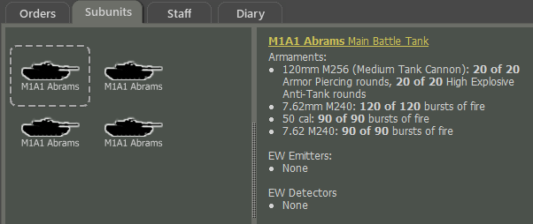

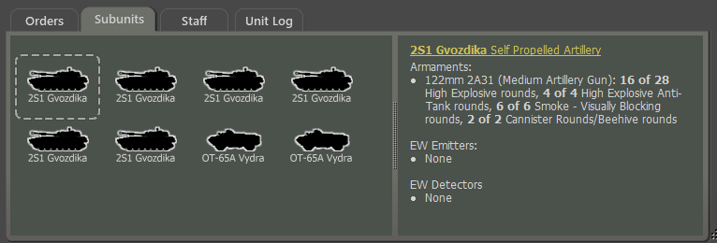

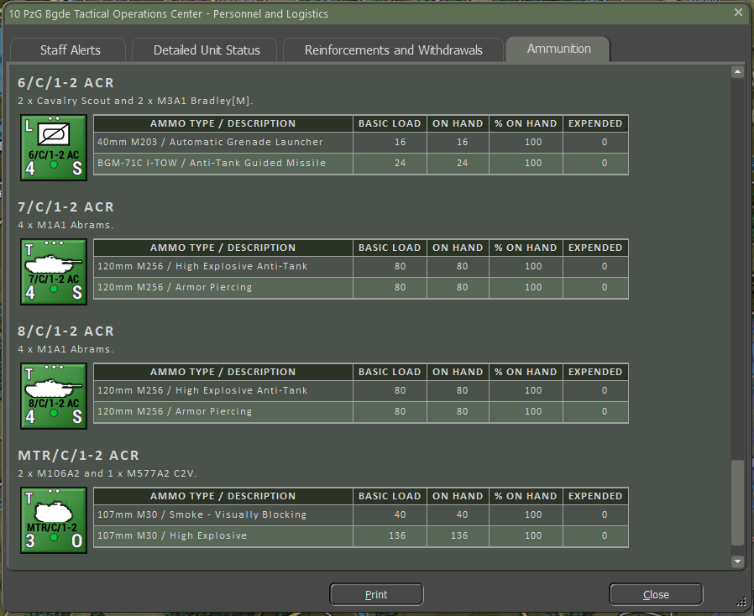

## Resupply

When units are issued a resupply order (see Section 21.2 above) ammunition levels for all weapons are placed back to full based on the scenario designer loadout levels.

## Automatic Emergency Resupply

If this is selected in Game Options, then any unit that runs out of ammunition is automatically restored to 30% ammo if it falls below 5%. Unit orders do not affect emergency resupply, and the unit may be moving or fighting at the time. This option may help new players.

## Why No Fuel Tracking?

Given the short time and relatively short distances covered in the game, we assume there is enough fuel for the operation on the map to take place. When units perform a resupply for ammunition and to recover readiness and morale, we assume fuel tanks are topped off as well. In the future, we may take a more detailed approach to fuel tracking, but for now, it sits beyond trackable concern compared to the other factors we do cover.

# Time of Day

***Flashpoint Campaigns: Cold War*** deals with four different times of the day. Dusk and dawn occur at the times of day appropriate to the region for the month of the year of the scenario.

During the game when a time-of-day changes, a popup dialog will show with the relevant information for the change. Also, during the game, depending on the time of day, the weather panel and map will have distinct changes in color to show the various times of day.

## Dawn

Dawn occurs roughly 90 minutes before sunrise. During this time there is a thermal inversion of surface temperatures that degrades thermal sight detection ranges and the accuracy of optically guided weapons. The map will show a gradually disappearing nightshade as the sun rises. Illumination will also increase as the sun comes up.

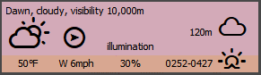

## Day

Day is the time between sunrise and sunset when the maximum possible visibility occurs. The map is shown free of any color adjustment during the day.

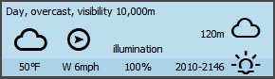

## Dusk

Dusk occurs roughly 90 minutes after sunset. During this time there is a thermal inversion of surface temperatures that degrades thermal sights and optically guided weapons. The map will show a gradual darkening as the sun sets (orange to dark). Illumination will also decrease as the sun goes down.

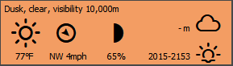

## Night

Night is the time from after sunset until sunrise. The maximum visibility is determined by the level of illumination based on the phase of the moon. Night operation of aircraft may be impacted if those aircraft are not capable of night operations.

**NOTE**: While visibility may be extensive in distance, objects cannot be seen visually without having illumination or using sensors that work without light (Thermal, Radar, IR systems).

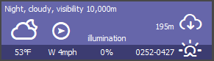

# Weather

Weather plays an important role and has a significant influence on visibility and can also impact the performance of certain weapons and sensors. The Weather in the game is dynamic and based on real-world weather data. A weather forecast is available in the Intelligence Staff Reports and you should review it to know when and for how long the weather may change. The following sections will give a summary of the available weather types currently in the game.

During the game when the weather changes, a popup dialog will show with the relevant information for the change.

## Clear

Clear weather means no precipitation and little to no clouds with extended visibility ranges based on the time of day, moon phase at night, and cloud cover. Clear weather has no adverse impact on weapons or sensors. At night the moon symbol is shown.

## Cloudy

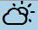Cloudy weather means a mix of sun and clouds with no precipitation and suitable visibility ranges for all methods of spotting. Cloudy weather may have an impact on close air support operations if the cloud deck is too low. At night the sun is replaced with a moon symbol.

## Overcast

Overcast weather means a blanket of clouds with no precipitation and very little to no sunshine. Overcast conditions still have reasonable visibility ranges for all methods of spotting. Overcast weather may have an impact on close air support operations if the cloud deck is too low.

## Light Rain

Light rain is scattered showers with minimal impact on visibility, weapons, and sensors. Visibility ranges will still be decent in these conditions. This type of weather does not impact the effectiveness of your fighting forces.

## Moderate Rain

Moderate Rain is a constant widespread rain that has a moderate impact on visibility. Moderate rain may impact the accuracy of some optically guided weapons and degrade the range of detection for thermal imaging sensors. This type of weather does have some adverse effects on your fighting forces and may halt air operations.

## Heavy Rain

Heavy Rain is a constant heavy downpour that impacts visibility. Heavy rain will impact the accuracy of some optically guided weapons and degrade the range of detection for thermal imaging sensors. It is essential to take these factors into account when the weather is abysmal on the battlefield. Heavy rain can stop air operations for specific aircraft.

## Snow

Even though the game is set in the spring/summer of 1989, you can make scenarios in the fall and winter, and in the case of winter, snow can be a condition. Snow impacts vision has an impact on weapons and sensors and can also impact aircraft and helicopter operations.

## Fog / Mist / Haze

Fog/Mist/Haze sits low to the ground dramatically reduces visibility ranges and impacts thermal sights and other sensors and weapons when present. Fog or mist has a better chance of occurring at night and dawn. It will burn off within a few hours after sunrise. Fog/Mist/Haze can occur in Clear, Cloudy, or Overcast weather states.

## Weather and Movement

While weather does impact operations, weapons, and sensors in the game engine, there are currently no impacts on ground movement based on terrain and weather. The Development Team does want to address this in a future update so seasons and weather change movement rates.

# Victory Conditions and End Game

The victory conditions for each player are specified in detail in the mission briefings. The most important way to ensure victory is to find and secure the victory point (VP) locations that have been placed on the map by the scenario designer. Blue locations are secured by Player 1, red locations by Player 2, and yellow locations have not been secured yet by either. An unsecured location becomes “secured” if a friendly ground unit passes through it. Air units like helicopters can fly over this location and engage or spot enemy units, but they cannot “take” an objective. The values of the different locations are shown in the map marker and the Scenario Information Staff Report.

Players also get victory points for knocking out or destroying enemy subunits. The value of each subunit is shown in the Subunit Inspector. The exact number of VP points is awarded whether the subunit is destroyed or just minimally damaged – either way, it is a mission kill and that is what is being measured.

## Game End and Mission Post-Mortem

The game is over when the end of the scenario time limit is reached or when the force strength of one side or the other drops below 30% and triggers “Sudden Death”. The length of the game in hours is defined in the mission briefing. Force strength is the percentage of active unit’s VPs over the total number of force VPs (so it starts at 100% and goes down as you accrue losses) for each side.

Once one of these end-game triggers is reached the Battle Over screen seen below is displayed and there is somber end-game theme music to listen to as you review the mission postmortem.

A representative of the General Staff Inspectorate provides a quick review of your combat actions/combat decisions. This person holds your fate in his hands and is also harried, short of sleep, and unlikely to take a finely balanced view of the nuances of your performance. The general will quickly evaluate your performance, telling you if you did an excellent job, you failed your mission, or something in between. This will be based on your victory points. Next, a Star Rating is shown with the filled stars indicating a basic “X” out of seven (7) rating for the mission. Next, the percentage of VPs awarded is noted and a listing of enemy subunits you claimed will be shown. Finally, the general will tell you in what shape your force is based on losses and fallouts and an estimation of recovery time to get back up to full combat strength.

Click the Proceed button to continue to the Scenario Information Report to see the Post-Mortem results.

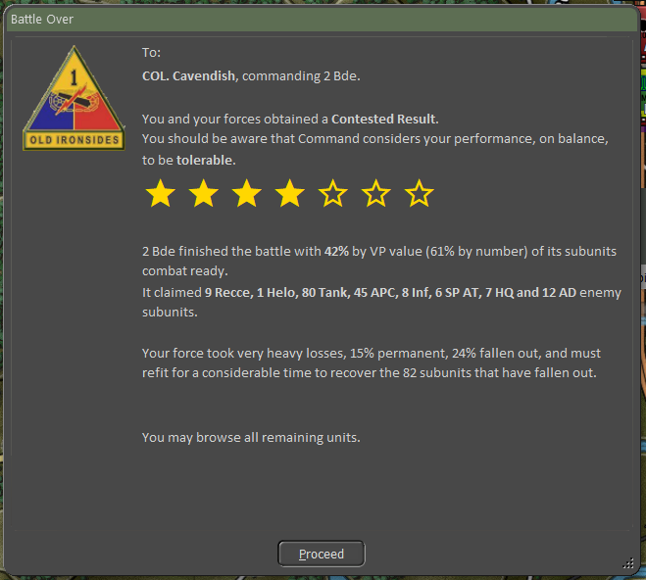

## Final Report

The Final Report (see below) is a repeat of the Battle Over screen and allows you to see that information again as well as note which Battle Plans each side used if it was under AI control.

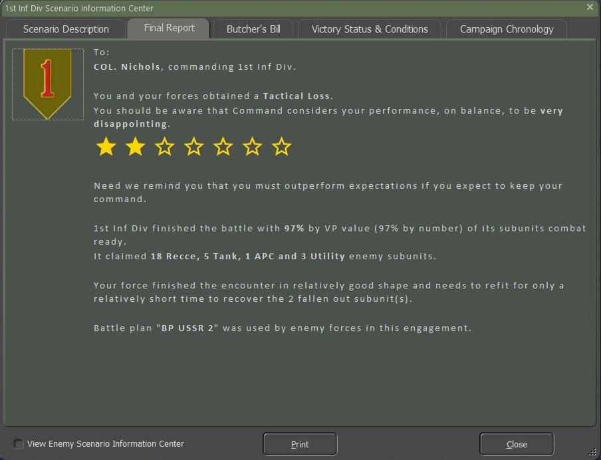

## Butcher’s Bill

The Butcher Bill is a tally of all the units lost (Destroyed or Fallen Out) during the battle. The information is displayed in several forms and compares your forces to those of your enemy.

Section A of the Butcher’s Bill has a graph showing the breakdown of subunits for both sides with the long faint bar showing the number of starting units of that type and the short darker bar showing units remaining of the type. Starting and ending numbers are also listed with each row.

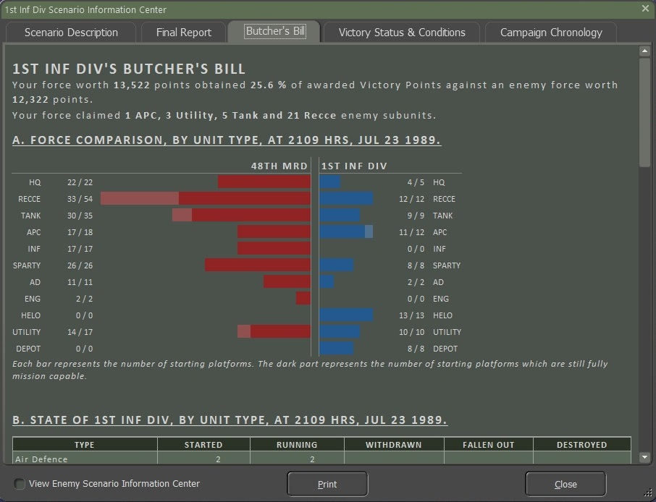

Sections B and C show the state of your forces by Unit Type and by Platform respectively in a tabled format.

Section B looks at each general Type of subunit, how many Started the scenario, how many are still Running at the end of the scenario, any subunits that have Withdrawn, the number of subunits Fallen Out (Damaged/Wounded), and finally the number of subunits Destroyed (Destroyed/Killed in Action). The final Totals for each column are shown at the bottom of the table.

Section C looks at each type of Platform in the battle, a Description of that platform, how many Started the scenario, how many are still Running at the end of the scenario, any platforms that have Withdrawn, the number of platforms Fallen Out (Damaged/Wounded), and finally the number of platforms Destroyed (Destroyed/Killed in Action). The final Totals for each column are shown at the bottom of the table.

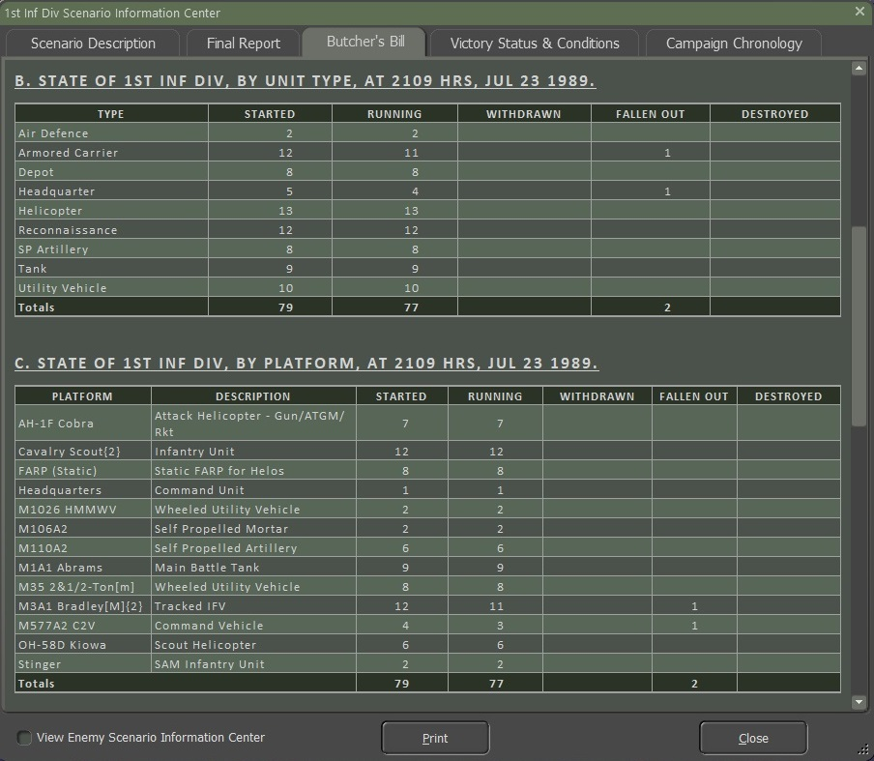

Sections D and E show the state of the Enemy forces by Unit Type and by Platform respectively. The information is in the same format as noted above for Sections B and C.

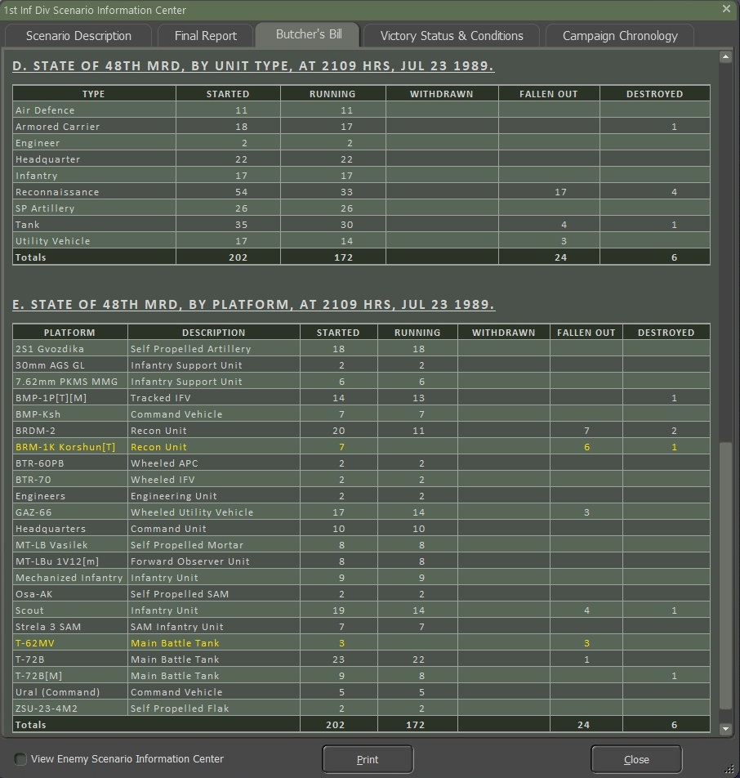

## Victory Status and Conditions

Section A provides a graphical and tabled representation of the final Victory Point Distribution and game result.

The colored bar at the top shows via the white bars where your score landed, and then some text noting the percentage of VPs gained and the result of the battle.

Next is a table showing the breakdown of starting forces and VPs awarded for both sides in the scenario that reaches the final VP distribution total.

Section A.1 shows the colored bar and the distributed VP values that match up to the various victory conditions for your force. These percentages are based on the starting VP conditions for the scenario and allow for unbalanced forces in a scenario but provide real victory conditions based on these ratios. Lastly, the Catastrophic Force Loss Threshold triggers Sudden Death.

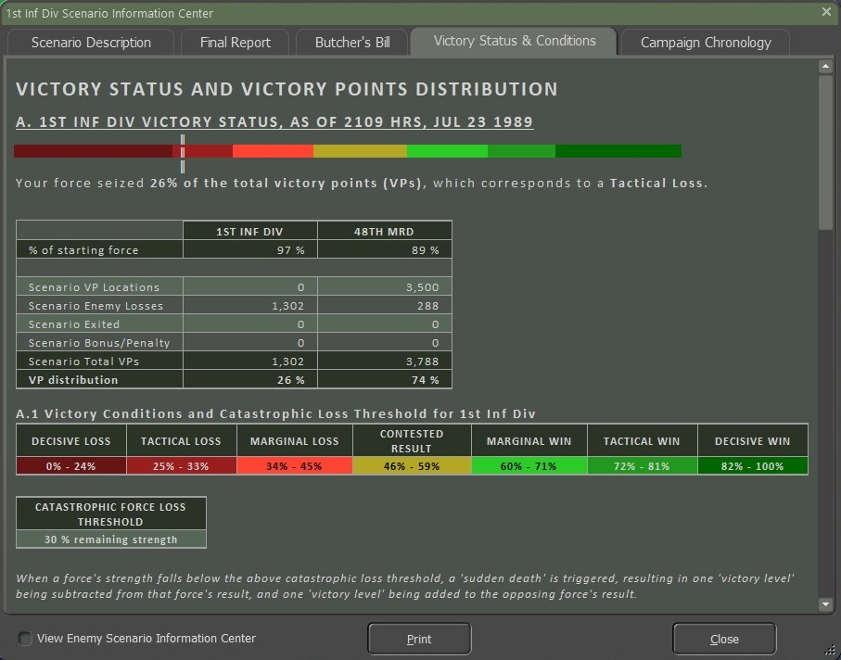

Section B provides a table of VP location ownership by side and contested and neutral (not owned) locations.

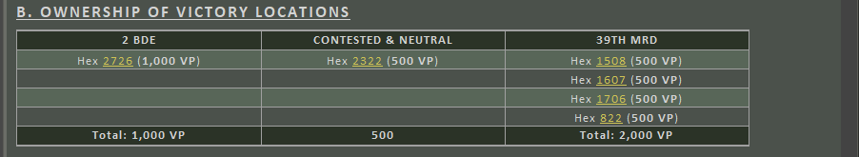

Section C provides details on how ownership of the VP location was determined based on local units and time remaining in the game.



## Sudden Death

Once a side has triggered “Sudden Death” by having their forces drop below the indicated Catastrophic Force Loss Threshold, the outcome of the scenario will be a foregone conclusion. By the time a force has been eroded down to 30% of its starting value, it has become combat ineffective in the grand scheme of the battle and is assumed to pull back remaining forces to be available in the future.

There is the option to continue playing until the end of the scenario time or until the point you wish to end the game via the menu.

**NOTE**: It is infrequent to improve on the Sudden Death evaluation as your forces are combat ineffective and usually will suffer more losses if the Sudden Death point is ignored.

# Campaign Game Play Overview

On the Main Menu screen select Start New: Campaign.  
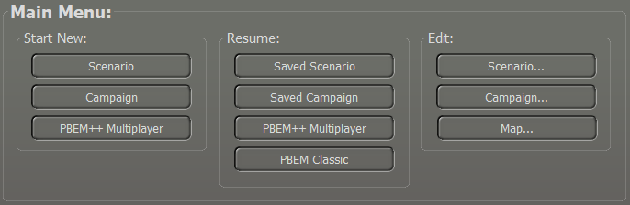

The available campaigns are listed with a campaign description positioned beneath. Select one and hit Proceed to continue.

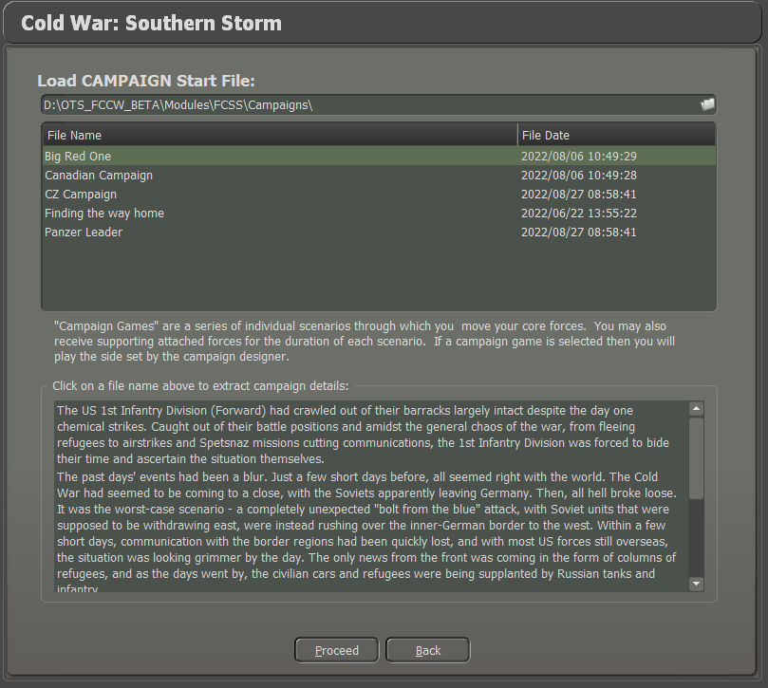

Set the gameplay options for the Fog of War as usual.

**NOTE:** You cannot pick which side you will play or what your opponent will be. You will play the side the campaign author has specified, and it will be against the AI.

Next, you can choose the Battle Plan for the campaign scenario if there is more than one or select it to be picked at random.

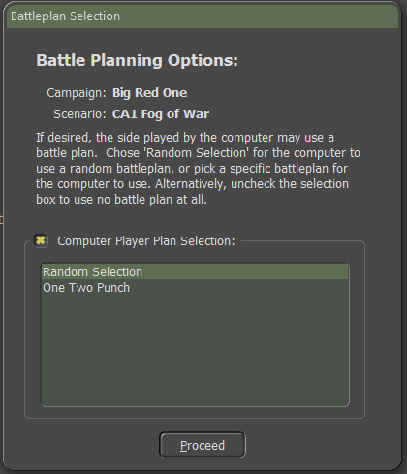

Clicking Proceed will load the scenario, and you can begin to play. The program title bar tells you the name of the campaign and which scenario you are currently playing.

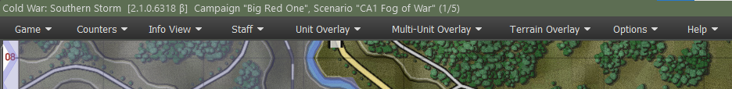

Play the scenario to a conclusion or end it early (if more than 2/3s has been played) via the top menu Game / End Game Now selection. After the standard Battle Over dialog, you will be asked to save the campaign in progress as a “. CAV” file. Select a file name and click on the Save button.

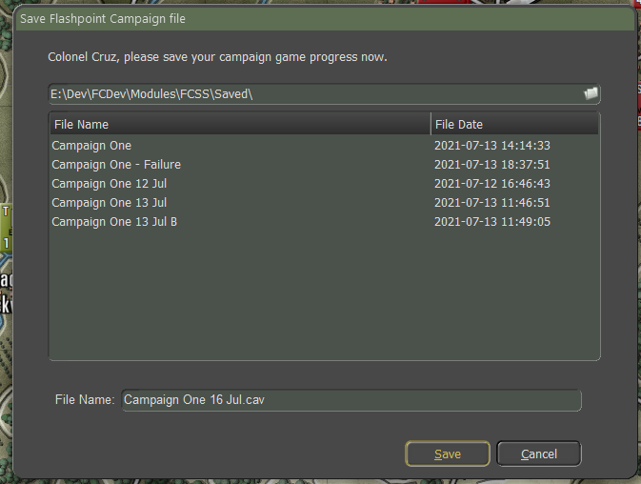

You will then see the following message:

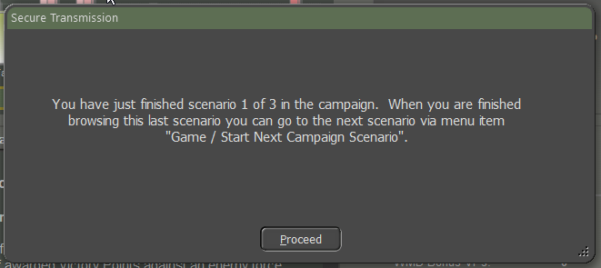

Clicking on Proceed will take you to the Staff Summary of the TOC Scenario Information dialog for the usual post-mortem debrief. Note that there is a new tab in this dialog called “Campaign Chronology”. This report will show you the accumulated campaign information to date. It contains:

* The campaign description
* For each scenario you will see:
  + The scenario briefing
  + The game time the scenario ended and the distribution of VPs, both for the scenario and the campaign so far
  + The staff evaluation received for that scenario
* When the entire campaign is complete, a final summary evaluation will be appended for you to review.

When the player has finished the scenario post-mortem, use the Game / Start Next Campaign Scenario menu option to go to the next scenario.

The new scenario will load, and the player’s core forces will be imported and placed in the appropriate setup areas.

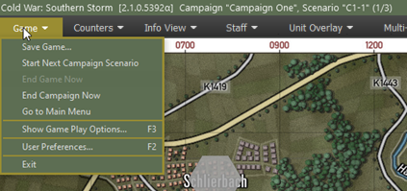The Force Recovery dialog will be shown to detail how much rest, recovery, and replacements your core force has received.

This report summarizes a lot of meaningful detail!

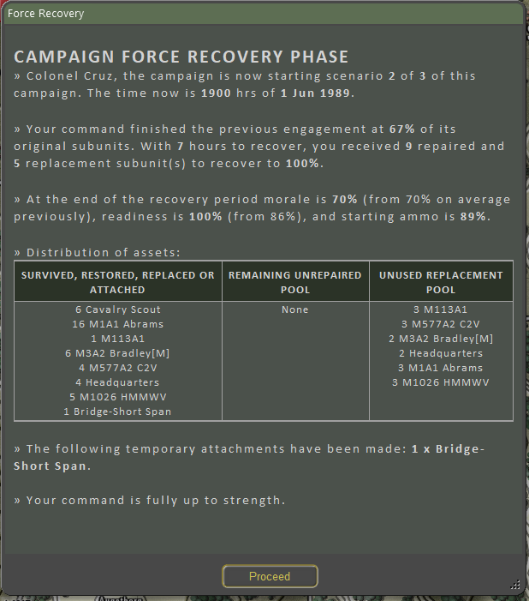

The player will now receive the mission briefing for the scenario and play can start. When this scenario is complete, the same process will be used to start the third and final scenario.

When this final scenario concludes, a campaign summation screen will be shown:

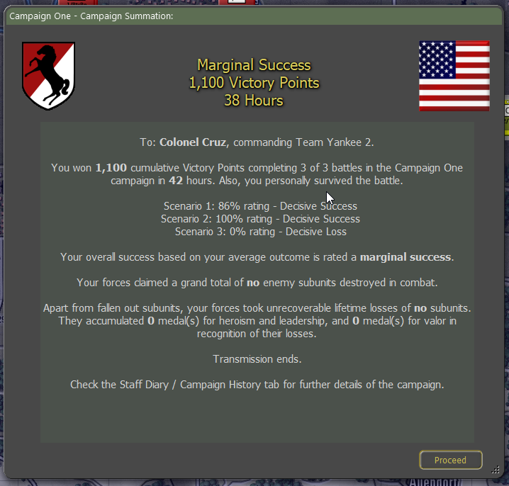

The game end-state can then be browsed in the usual way. The TOC Scenario Info Campaign Chronology will now be complete.

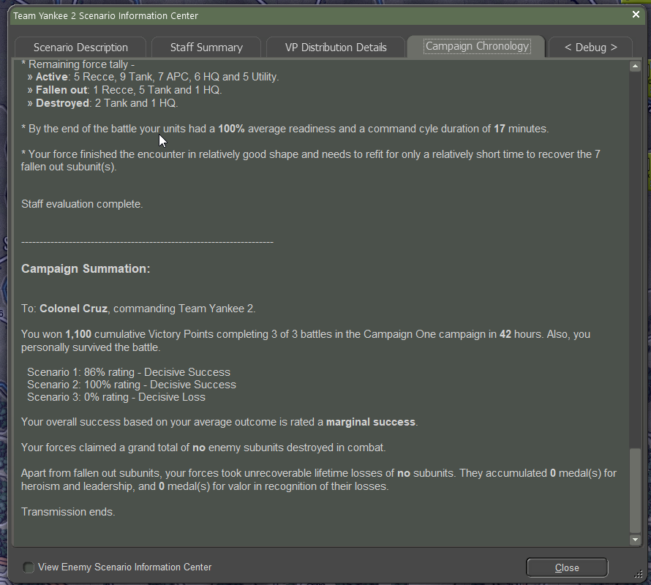

From here you can select the close button return to the Main Menu and start another battle or campaign.

# Designer Notes

The following section contains some designer notes and thoughts on various topics covered in the game. These items pair well with the information in the Battlefield Primer (FM02) and add more background to the various features and capabilities of the game engine.

## Infantry

Infantry units perform best when dug in and in areas with plenty of cover. In built-up areas like cities, infantry can take down unsupported tanks. In the open, infantry becomes very vulnerable to all types of fire. Digging infantry out of high cover can be a real chore and usually requires the use of artillery and your infantry to remove.

## Planning

However accurate it may be that plans don’t survive contact with the enemy, maneuver must be carefully pre-planned. The operational commander can expect to feel more like a traffic cop than a battlefield commander of WWII vintage once maneuvering has begun. However, this is as it should be. Victory can depend on units getting to the same place at the same time. Traffic jams (only one company-sized maneuver element fits easily in one map location) are gifts to opposing air and artillery forces. Hostile helicopters love giant traffic jams and are incredibly effective in destroying them.

In addition to the requirement to pre-plan, players must remain flexible to meet the rapidly changing situations common in modern combat. The reason for this necessity is a lack of information. You are unlikely to know precisely where the enemy is, what they have, or what their objectives are during setup while you are making plans. A good plan will incorporate accurate guesses as to these points, will not depend too crucially upon those guesses, and will include methods to improve your intelligence on the enemy while denying him similar intelligence. Field reconnaissance will often result in the loss of the units performing the recon, so it is best to arrange that recon is not performed inadvertently by valuable non reconnaissance units.

## Mobility

Combat occurs “over the ground”, not “for the ground”. Despite the perils of tactical movement, units need to be constantly engaged in operational movement. Once the enemy has identified them in a particular location they can all too easily be fixed in place with suppressive fires and kept out of the battle.

There are few “must have” locations to defend, so the objective is to find and defeat the enemy combat units, not seize, or hold mere ground.

## Tempo

Modern combat occurs around the clock. Multiple echelons are necessary to sustain the necessary level of commitment. Each in turn works its way to the front, engages, and then disengages to rest and replenish. The idea is to seize the initiative, set the tempo of combat at a level higher than the enemy can sustain, and then dislocate him with fresh units when his forces inevitably crack. In the circumstances, a fast but sloppy solution trumps a well-ordered but slower solution. The other implication is that there is no time to learn on the job. All units must be fully trained in peacetime because there will be no time once the shooting starts.

## Initiative

Players should not wait until they engage the enemy before exercising their command initiative, by then it will be too late. You should make most of your decisions and give many of your orders before even starting to play. Things like combat doctrine and reporting structures should not usually be changed during play. This reflects reality. In Cold War combat a lot of destruction happens very quickly. This means there is no time for a battalion or brigade commander to assess the situation, decide, and choose a course of action once the shooting has started.

## Recon and Intel

This is a game in which to be located by your opponent is often fatal so you will either wish to stay well-hidden or to keep on the move. The latter will usually be necessary. In moving it is good to remember, especially for large forces on roads, that there are stacking limits. You cannot get much more than a single large, full-strength company into one location. We have had attacks break down in play testing due to traffic jams. Locating one of your traffic jams is an enemy dream. Every remote delivery weapon (and a few direct-fire ones) will end up trying to clear out that traffic problem for you, so avoid creating backups. Ideally, the main task for your ground units will be to mop up on such a location, having already had the air force and artillery do all the dirty work.

This is more effective and a lot safer than wading into a head-on-ground engagement oneself. Unfortunately, it is not always possible for events to work out so cleanly. So, you will probably have to engage the enemy with your ground forces at some point. When you do so, keep in mind that snoopers tend to get shot at. Determining opposing strength locations with your HQ or main elements is not good practice. That is what reconnaissance is for. You will often find that they merely present you with a flaming datum, better than your staff vehicle.

## Survival

Complete units should not melt away in just a couple of minutes except in catastrophically adverse circumstances. Rarely should the voluntary loss rate exceed one vehicle per minute. All combatants are assumed to have residual survival instincts and will modify their behavior once they come under fire. They will not press on suicidally but instead will suffer a mission abort once the rate of loss passes a certain threshold - which can be aggravated by the loss of HQ vehicles. They will retire to the nearest safe location and reorganize for another attempt. Exception: the less realistically trained the troops are, the more ‘dash’ (voluntary risk assumption) they can be expected to show. Virtually all troops in the Soviet-style will fall into this category initially.

## Artillery

Artillery support is crucial but limited. Demand will far outstrip supply. A frontal attack on an unsuppressed defense no matter what the odds will likely result in ruin. Artillery must be used to prepare the way and then support the attack. The dilemma is that artillery has notable supply limitations and cannot be used lavishly except for the very highest priority tasks. Five minutes of moderate firing per location ought to be considered lavish. During the attack smoke will be laid and obvious danger points suppressed, but the barrage will be limited to two-minute concentrations as needed unless resupply is assured. On the modern battlefield, quality of fire support counts more than quantity, and the destruction of units through fire alone should be considered most unlikely. Counter-battery fire is an important role and a substantial fraction (1/4 – 1/3) should be assigned to it. The same rules apply to air strikes, only more so.

## Lethality

This is the age of the empty battlefield. If you can see it, you can probably kill it. Western-style units will stay hidden unless forced otherwise by movement orders. During movement, they will seek to use all available cover and move in short high-speed dashes to minimize exposure. If adequate cover is unavailable, smoke will be used lavishly. As in times past, the best movement route is the most covered route, not the shortest route. Warsaw Pact units put a higher premium on cohesion and predictability. They will be much less likely to take advantage of available cover in most circumstances.

## Ammunition

Ammunition is relatively bulky, heavy, and scarce. Most units can fire off everything they carry in 10 minutes or less and yet they need to be able to go eight hours or more. This militates against high-volume low-payoff exchanges. Assume that the intensity half-range is 500m. Units will generally shoot at 4x intensity at targets within that range, at 2x from 500 to 1000m, and at 1x beyond that. There is also a sniping/harassment level of fire that can occur at extreme ranges to keep the other side honest, but this need not be simulated at the company level. Both sides have stockpiled enormous quantities of ammunition and other supplies, but experience has shown that it is used up at far higher than expected rates. Expect severe supply difficulties within 30 days for both sides and potentially crippling shortages of critical items within 10 days. This cannot be a long war.

## Dispersion

In the age of ultra-lethal weapons, dispersion is the key to survival. Historically, troop densities have dropped every time that weapon lethality increased. The concentration of units is an invitation to wholesale destruction, yet attacks must concentrate to a degree to achieve success. Move dispersed, attack concentrated!

## Line of Sight and Line of Fire

Typical combat ranges may be a lot shorter than expected. Most improvements to direct-fire weapons have been to extend the range past three km, but in most cases, the line of fire will not be nearly that long. At one point the Soviets calculated that 50% of all combat would occur at 500 m or less. This puts a premium on delivering the first round fast and accurately rather than at an extended range. Tactical situational awareness leading to consistently getting the first shot in may well determine who lives and who dies. The best shot might not be the longest shot, or the one with the most sweeping field of view, but rather the most unexpected shot.

# Flashpoint Campaigns Credits

## On Target Simulations

* Lead Programmer and Head Honcho: **Robert "Ironman" Crandall**
* Data, Programming, Graphics, and Sound: **Jim "Cap’n Darwin” Snyder**
* Programming, Data, Models, and Research: **Jeff “Iron Mike” Sugden**
* Map Master, Programmer, AI, and Graphics: **William van der Sterren**
* Quality Czar and Testing Lead: **Charles “The Whip” Belva**
* Programming: **Kevin “SgtZDog” Zemon, Will Jackson, Alex Kriesel**
* Testing: **Tomasz Niedzinski**

## On Target Simulations Content Team

* Alexander “Stimpak” Schwarz, David “22sec” Whitt, Mike “MikeJ19” Johnstone, Joao Lima, Jurrie van der Zwaan, John “JohnO” Osborne, Jorgen “Jotte” Torgersson, Jo van der Pluym, Scott “WABAC” Gibbs and Steve “Mad Russian” Overton

## Cold War Beta Testers

* Names to be added before release

## Matrix Production Support

* **Erik Rutins, Maxim Klose-Ivanov**

# OTS on the Web

Matrix Games Forum: <https://www.matrixgames.com/forums/viewforum.php?f=10149>

Check Us Out on Discord: <https://discord.com/channels/911711314051739659/911711314257248331>

Check Us Out on Steam: *“Pending a page URL*”

**© 2025 On Target Simulations, LTD. All Rights Reserved. The images used and OTS Logo are property of On Target Simulations, LTD. All other logos and trademarks are the property of their respective owners.**